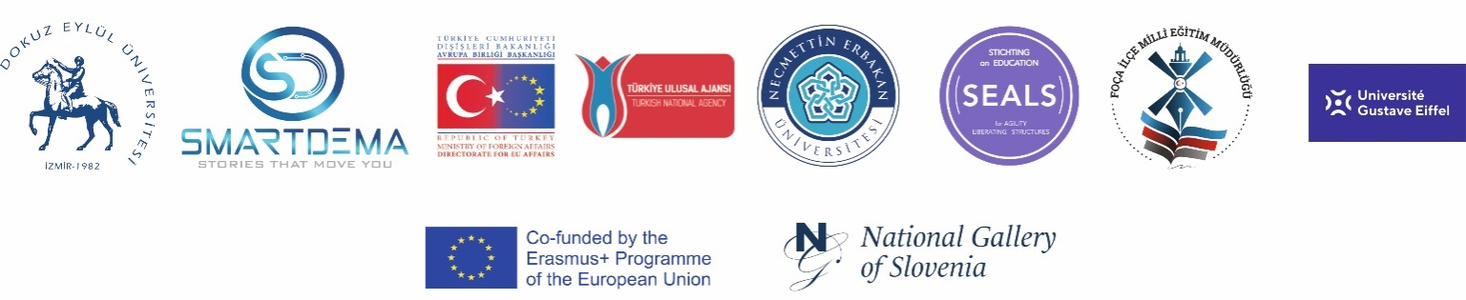

“SMART Tourism Destination increasing citizen’s sentiment of sharing local tourism related values through gamification using emerging mobile Apps and SMALL Data analysis- SMARTDEMA”
AGREEMENT n° 2020-1-TR01-KA203-092920

Foça National Directorate of Education
DESCRIPTION OF STORIES

More than 300 stories have been added into the application created under the name of Smartdema.
Stories mostly show the effects and feelings of cultural, historical and natural assets on people.
The experiences and memories have a very strong impact on the formation of stories.
The destinations in Foça are sometimes narrated with similar perspectives and sometimes with different perspectives.
While the Smartdema Project's Foça routes were being created, it was observed that the themes were generally shaped by positive emotions.

The fact that Foça's historical texture is relatively preserved and that it is a small and cute fishing town; Its sea, nature, mythological history, architecture, air, calm lifestyle, hosting a warm atmosphere that surrounds people with stray animals, and the calm and slow flow of life bringing ease of life are great.

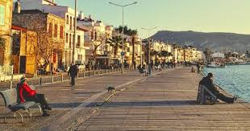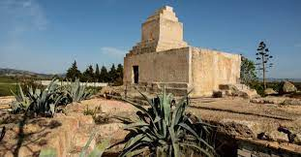

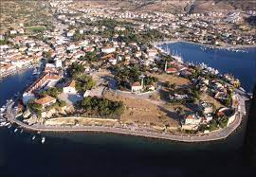

In the stories; While themes such as "peace, happiness, relaxation, enjoyment" are often handled in general, themes such as "sadness, longing" are also reflected in the stories by those who use them on certain routes , depending on their experiences.
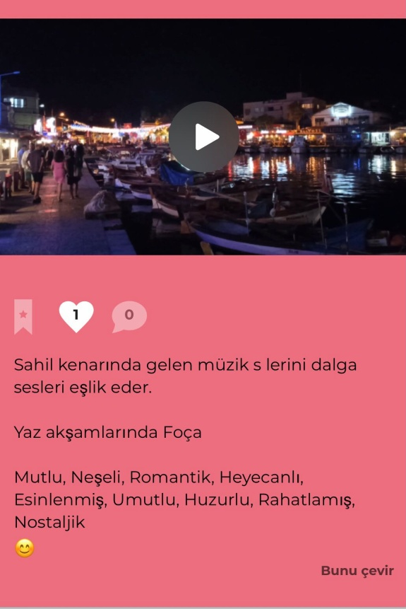

There are generally positive feelings and notifications about the flavor stops and routes in Foça. The abundance of food alternatives was reflected in the stories as satisfaction.
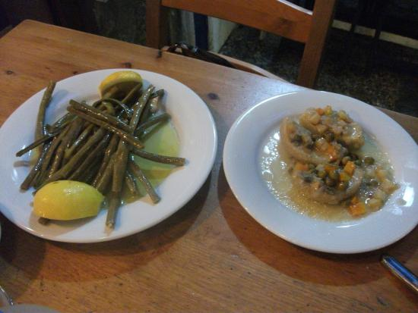

If we need to make a more detailed theme evaluation through routes and stories; for example, natural events on sea routes, sunrises and sunsets, along with the different states of the sea, the colors it takes, the plays of light often reinforce the themes of "peace, happiness, relaxation and admiration".These beautiful images of the sea were also seen to lead people to the themes of inspiration and romance.
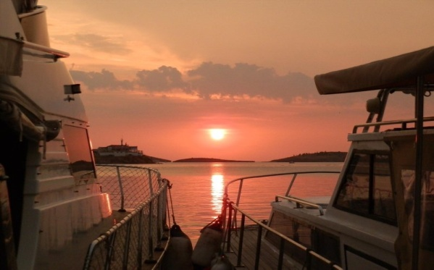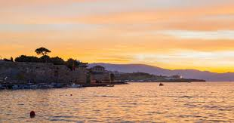

Historical windmills, one of the symbols of Foça, are among the routes that are most often covered in stories. We can say that those who watch the sea from these windmills, located on a hill in Foça, awaken the feeling of freedom and the theme of nostalgia comes to the fore as they witness the past. Users also stated that they are happy and peaceful on this route

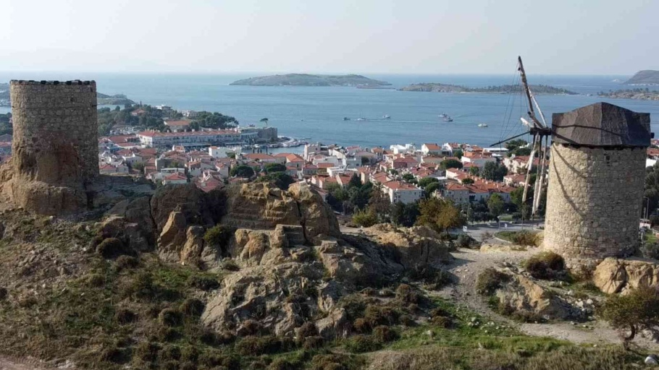

Another topic determined as a route in the stories is the historical Foça Stone houses. Stone houses, which are frequently the subject of stories, creates a sense of belonging in the narrators. The life of the people who lived in these houses in the past and witnessed the old times arouses curiosity in users minds and this curiosity leads them to dream that their heroes are themselves. Thus, the theme of peace comes to the fore along with the theme of nostalgia.

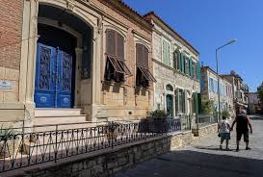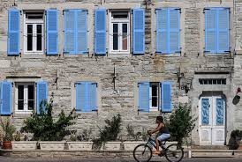

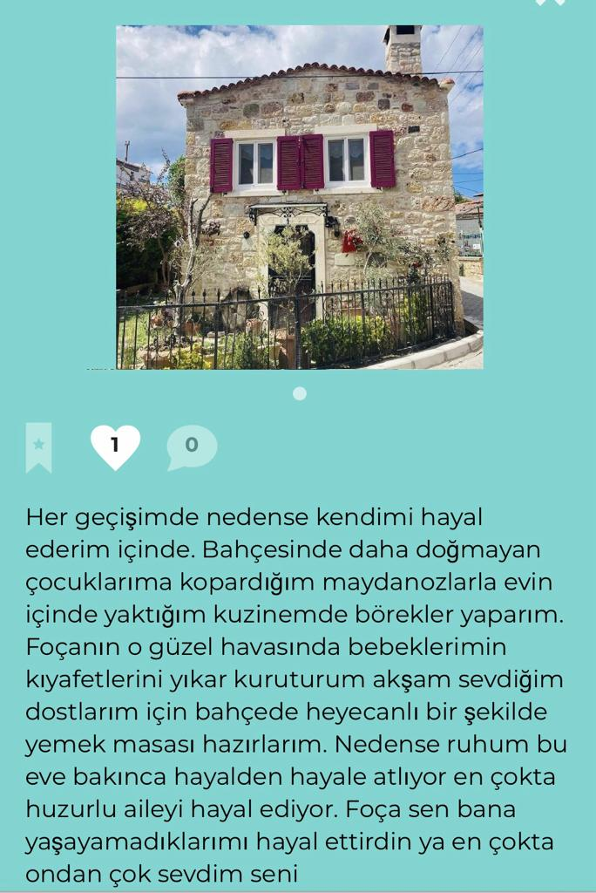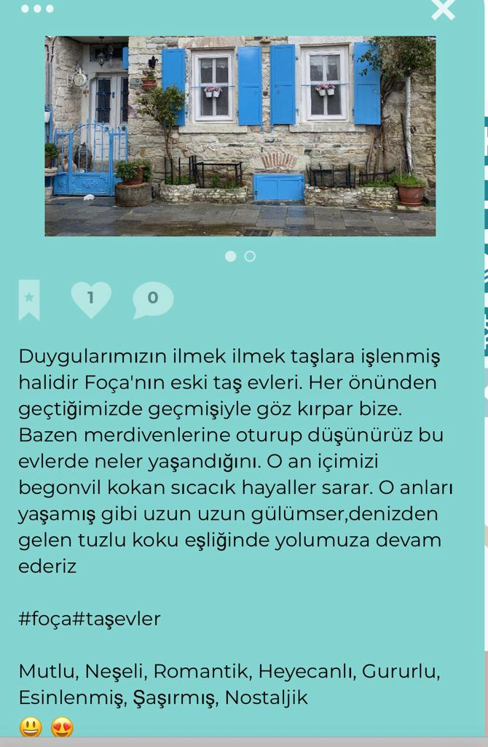

Marseille Square, whose story dates back to BC, is among the most marked routes. This place, whose fame goes beyond the borders of Foça and whose story goes back to France, reveals both the desire to sail the vast seas,the theme of freedom and the theme of curiosıty,surprise,romance in the narratives of the users.

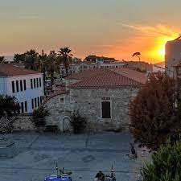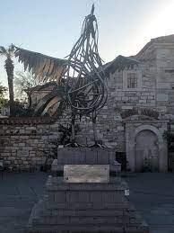
The courage of Captain Prontos and the love of Princess Gipitis impress the users. The Welsh Rooster Statue is also handled together with this story and the square.

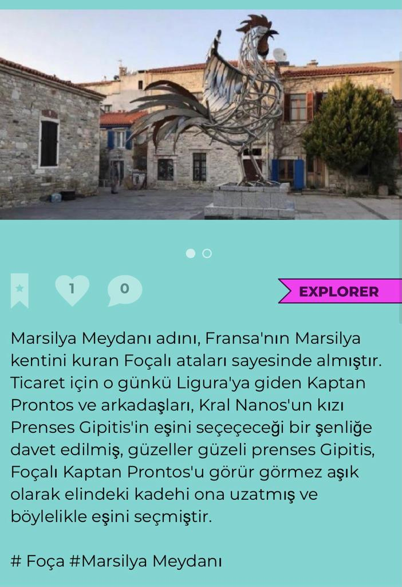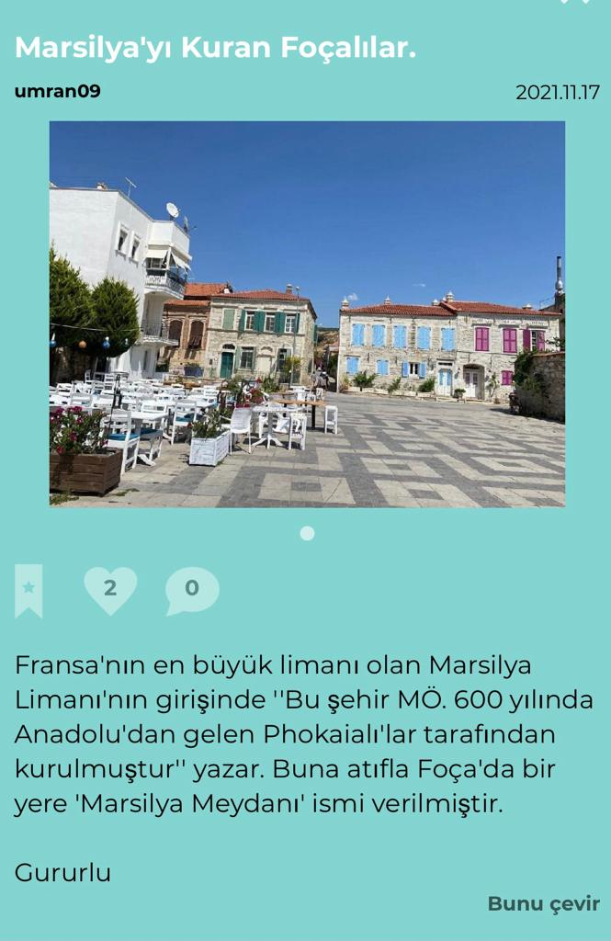
Küçükdeniz, which we can call the heart of Foça, is the place where the themes of happiness, joy, relaxation, enjoyment and peace are handled the most on the route of Smartdema. Users shared the beautiful memories of fishermen, boats, stray cats, beach restaurants and cafes here.

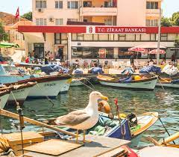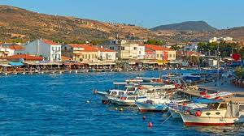

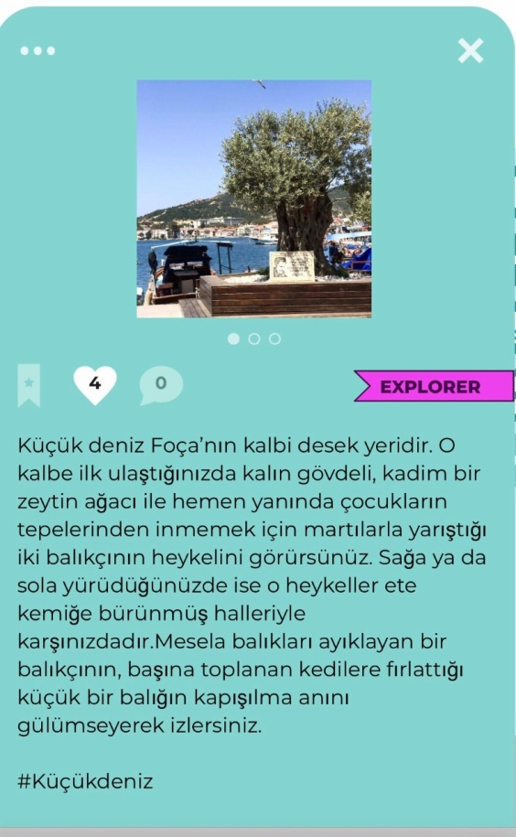

Again, the abundance of food variety is expressed in the flavor routes in Küçükdeniz; Positive feelings about fish, seafood, herb dishes, olive oil dishes and vegan flavors were expressed, and this was reflected in the themes as pleasure, happiness and relaxation.

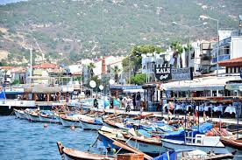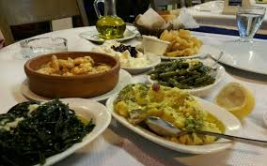

Karataş, on the other hand, is the route where the longing for Foça and the desire to come again and again are emphasized by reminding the legendary story of this stone. The sense of belonging to Foça is mostly processed in this route.

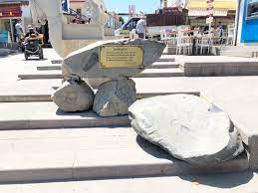

The mythological story of the Siren Cliffs evokes emotions such as surprise, fright, inspiration and curiosity in people's minds. Users describing this route feel inspired and enchanted.

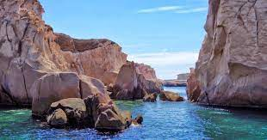

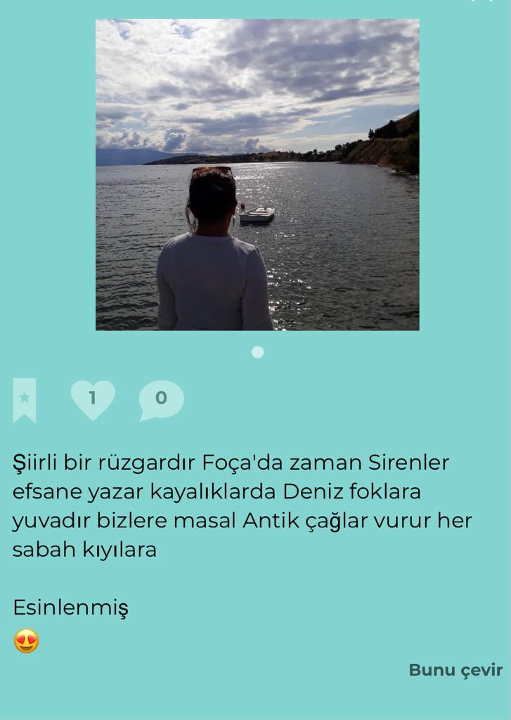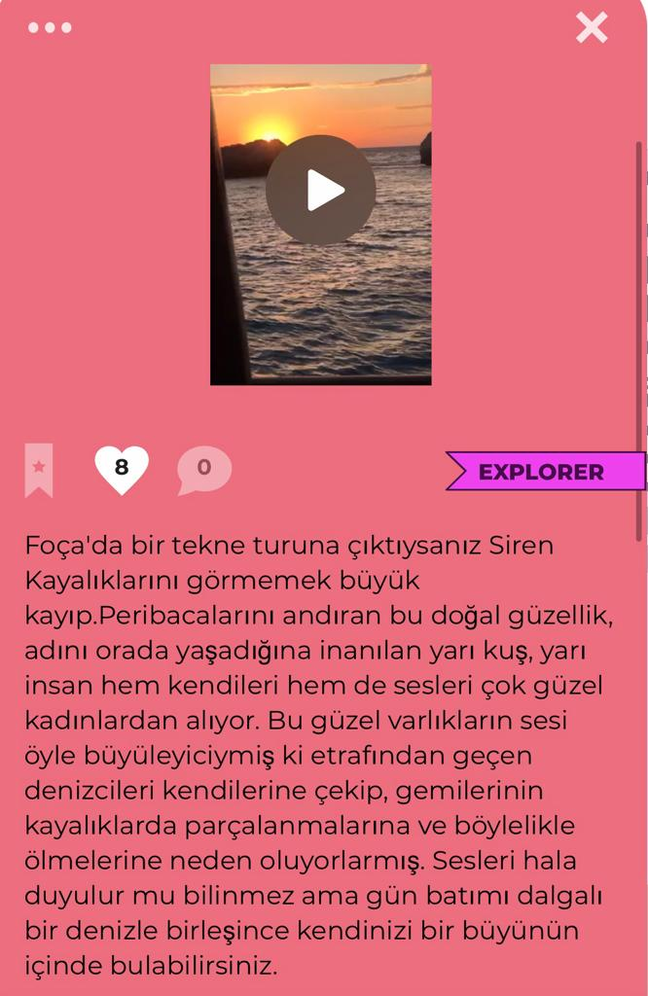

On the Cybele Temple route, we observe that the dominating themes of the stories are hope, inspiration and enthusiasm. Cybele, one of the ancient gods of Anatolia, took place in religious temples and temples by under the influence of Foça people in the years before Christ. It is possible to deduce from the narratives of the users that the goddess Cybele, who symbolizes birth, fertility and the continuity of life, is a source of inspiration for production and existence today.

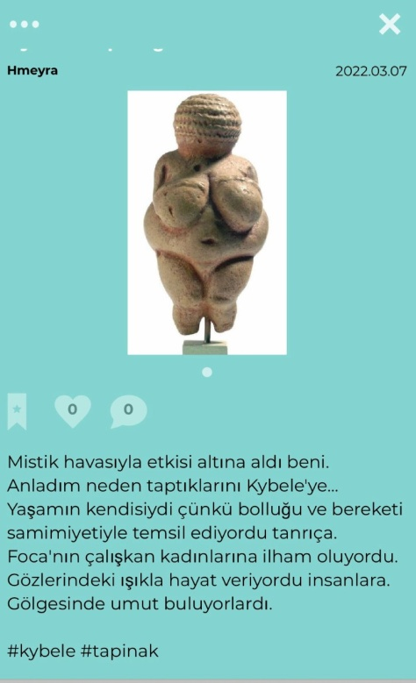

The Persian Ancient Tomb, the only building belonging to the Persians in this region, is one of the routes that arouses surprise and admiration both with its magnificent structure and its story. This mausoleum, built in memory of the King of Susa, who died in the war, and his wife, who committed suicide after his death, also brings romance to the fore as a theme on this route.

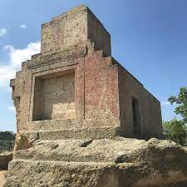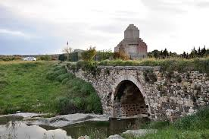

The Mediterranean Seals, which gave Foça its name, also found a place on the route, and were covered in the stories with the themes of curiosity and surprise.

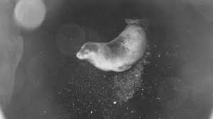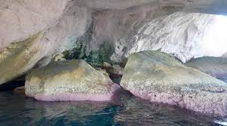

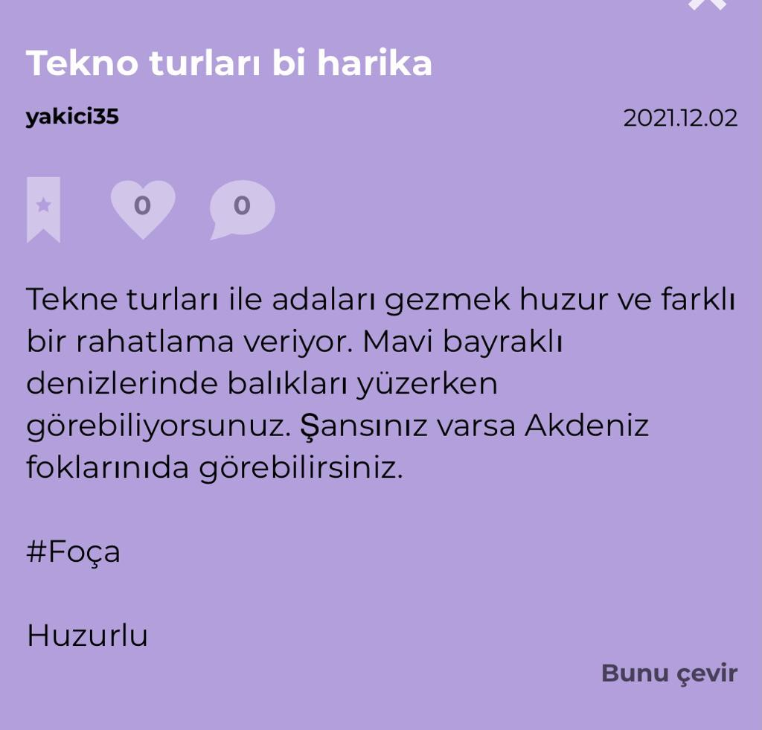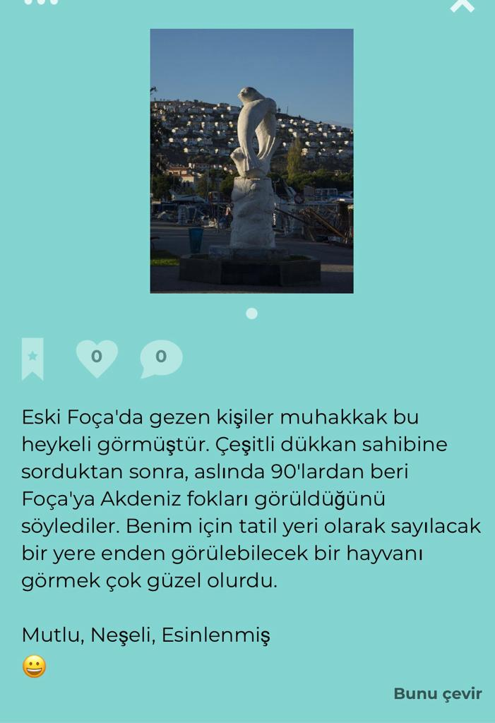

The Ottoman Cemetery appeared as a route that harbors sadness, and the intertwining of life and death was reflected in the themes; the fine work on the tombstones and the admiration aroused by the tulip motif are reflected in the narratives.

