THEMATIC STORIES – DEU POSTS
In the thematic stories category, stories were shared under 12 different categories. An average of 450 thematic stories were shared with the work of the first multiplier event, the second multiplier event, the nutritional healthy chef and university activities, and the SmartDema project team held by Dokuz Eylül University.
These posts are classified into the following categories;
- Historical places route
- Izmir Museums Route
- Izmir Nutritional chef route
- Izmir Religion route
- Cycling route
- Sightseeing route
- Walking route
- Culture Route
- Izmir Local Cuisine Route
- Nature route
- Art Route
- Leisure route
When the content analysis of the thematic stories is examined, it is seen that ‘very positive’ and ‘positive feelings’ are shared at a high rate. People are more likely to share positive feelings about themselves and the positive aspects of the places they have visited. There are also 73 neutral comments. As a result of these shares, the sentiment map was formed as follows:
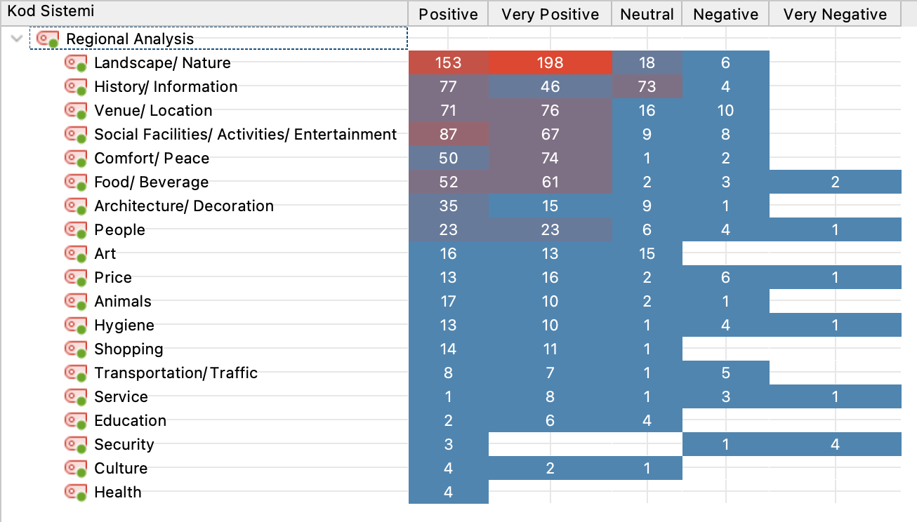
Table 1. Code Relationships Browser

