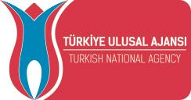
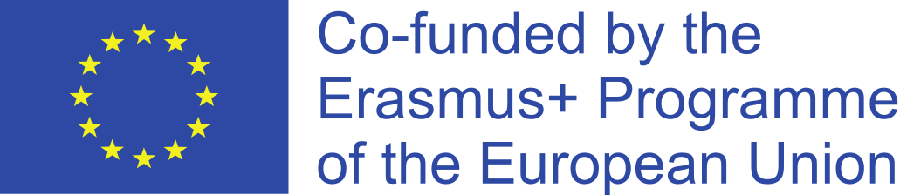
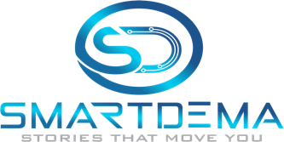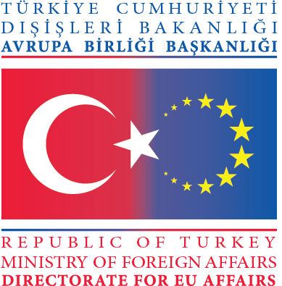

ERASMUS+ HIGHER EDUCATION
EU PROGRAMME FOR STRATEGIC PARTNERSHIP IN THE FIELD OF EDUCATION, TRAINING, AND YOUTH

2020-1-TR01-KA203-092920

DISSEMINATION PLAN
SMART Tourism Destination increasing citizen’s sentiment of sharing local tourism related values through gamification using emerging mobile Apps and SMALL Data analysis-SMARTDEMA

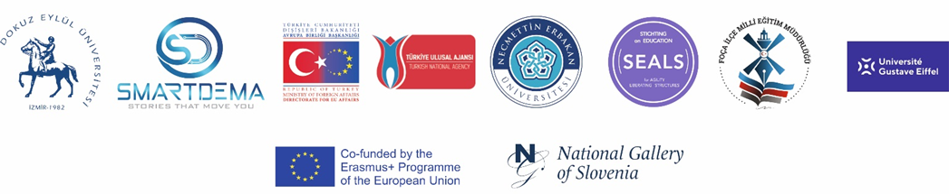

Introduction
SMARTDEMA is a Strategic Partnership for Higher Education within Key Action 2 of the Erasmus+ Program. SMARTDEMA supports the transformation of the city and the actual teaching tourism model at Destination Management. It implements new learning skills and digital assessment and introduces concepts of innovation, ICT technology, sustainability and accessibility to guarantee the present and future of tourism. The project proposes an innovative implementation of ICT tools and new tourism experiences and increases citizens’ sentiment of sharing local tourism-related values co-creation with geo-referenced stories. The project designed and created a custom-made free download mobile App named GEO-DEMA and implemented training on sentiment analysis and SMALL Data software analysis to perform new SMART TOURISM-related services as part of the SMARTDEMA profile. A series of thematic maps are created based on the stories (DATA) created by the citizens (own sentiment of shared valued), and the insights of the visitors (DATA) collected in the App while unravelling the digital stories. This is the SMART-CITIES TOURISM concept. SMARTDEMA is addressing those issues with a focus on smart destination management tools.

This Dissemination Plan describes the scope and objectives of the dissemination activities to amplify the project results and engage new stakeholders. The purpose is to strengthen the relationship among partners, regional authorities, education centres, schools and galleries to help SMARTDEMA fulfil its mission. The partners aim to empower different stakeholders, promote SMARTDEMA methodology, engage each community of actors, collaborate with them, ensure the legacy of their actions and create new ways of promoting smart destination management education. For all these goals, this dissemination plan and campaign strategies are crucial. Each partner is a dissemination leader, the role of whom is to represent the project in each country, gathering representatives of each stakeholder that will follow the project and validate the main results of it, together with a strong contribution in disseminating its results.

DOKUZ EYLUL UNIVERSITY (DEU) | COORDINATOR (TURKEY)
NARODNA GALERIJA (NATIONAL GALLERY OF SLOVENIA) (NG/NGS) | PARTNER (SLOVENIA)
FOCA ILCE MİLLİ EGİTİM MUDURLUGU (FOCA MEM) | PARTNER (TURKEY)
STICHTING FOR EDUCATION ON AGILITY LIBERATING STRUCTURES(SEALS) | PARTNER (THE NETHERLANDS)
UNIVERSITE GUSTAVE EIFFEL | PARTNER (FRANCE)
NECMETTIN ERBAKAN UNIVERSITY (NEU) | PARTNER (TURKEY)
Partner organisations of the project are the following:

Objective
According to the European Commission, “Dissemination is a planned process of providing information on the results of programmes and initiatives to key actors. It occurs as and when the result of programmes and initiatives become available. In terms of the Erasmus+ Programme, this involves spreading the word about the project’s successes and outcomes as far as possible. Making others aware of the project will impact other organisations in the future and contribute to raising the profile of the organisation carrying out the project. To effectively disseminate results, an appropriate process at the beginning of the project needs to be designed. This should cover why, what, how, when, to whom and where disseminating results will take place, both during and after the funding period.” Also, as the European Commission states, “The first goal of dissemination and exploitation is to spread projects' results. The second goal is to contribute to implementing and shaping national and European policies and systems. Beneficiaries should develop their own way of achieving this goal. Developing ideas for dissemination and exploitation is important for every project funded by the Erasmus+ Programme. However, the type and intensity of dissemination and exploitation activities should be proportional and tailored to particular needs, and types of projects developed. This includes whether the project is process-oriented or aimed at producing tangible deliverables; if it is stand-alone or part of a larger initiative; whether it is developed by large or small-scale participating organisations, etc. Participating organisations should discuss the aims and objectives of the activities/plan and decide on the best activities and approaches, as well as share the tasks among partners taking into account the particular specifics of the project.

For structured cooperation projects such as Strategic Partnerships, Knowledge Alliances, Sports, Collaborative Partnerships and Capacity-building projects, good quality dissemination plan should include measurable and realistic objectives, a detailed timetable and provide resource planning for the activities to be undertaken. Involving target groups in activities also helps to maximise the use of the project’s results. It is important to set the strategy right from the beginning, as this is the main way that will foster communication with the target audiences. Such a requirement is not foreseen for mobility projects. However, project organisers are invited to communicate the learning outcomes reached by participants in such activities. They should also encourage participants to share with others what they have gained from taking part in the mobility activity. Finally, the dissemination part of the Programme is also supposed to raise the quality of the Programme by stimulating innovative projects and sharing good practices.

Communication is a broader concept. It includes information and promotion activities to raise awareness and enhance the visibility of the project’s activities in addition to the dissemination and exploitation of the project results. However, very often, it is difficult to make a clear distinction between these areas. For this reason, planning an overall strategy framework covering both fields can be a more efficient way to make the most of the available resources. Dissemination and exploitation of results should form a crucial part of any communication activities taking place during the project’s lifetime.”

Stakeholders
Each participating organisation selects its own group of stakeholders, which is in line with its own organisation’s objectives and strategies. Stakeholders are parties (i.e. institutions, organisations and individuals) who are interested in or affected by the project.

According to the Project description, SMARTDEMA objectives are the following:

The project objectives are:
1. Generate a Seamless integration of the tourism ecosystem to deliver a new mobile experience involving the educational sector and citizens to co-create a unique mobile experience to attract new visitors.

2. Design and implement a new Destination Management training - SMARTDEMA - based on SMART TOURISM at the University level but impacting an extensive local stakeholder map. The new training is a “mindset change” in education and learning because Destination Management starts from the production of a unique service experience that does not exist today in Izmir and Ljubljana. It is virtual SMART Destination Management based on content created by the citizens for the tourist.

3. Build a link between Universities, Foca District National Education Directorate and citizens to develop local geo-referenced stories enabling the visitors to experience cultural shared related values.

4.The implementation of SMALL DATA analysis training to make Destination Management with specific thematic maps enabling to visualize new DATA
5. Develop and create the mobile Apps features and multilingual interface used to create a mobile content generation in the native language facilitating its use for the visitors and improving the user experience.
6. Design and implement two new Virtual professions (as 50% of the SMARTDEMA training) in Turkey and Slovenia to manage through the App the gamifying experience of the cities. The Virtual Destination Manager (VDM) in Turkey and Slovenia the Virtual Nutritional Healthy Chef (VNHC) in Turkey.

- Creating innovative open educational resources to contribute to lifelong learning
- Helping students and staff to develop new skills and competencies and improve their ICT skills
- Developing and providing new learning/training opportunities for users
- Using innovative pedagogies (educational methodologies and approaches) for training
- Exploring smart ICT to design new services and digital tools

Why should this project be carried out transnationally?
The partnership decided to construct complementary project activities composed by;
-Partners who design training content
-Partners who implement the training
-Partners who involve local actors in the tourism sector to prototype national and international visitor experiences.
-Partners who do SMALL DATA Analysis
-Partners who create and design maps of information
-Partners who have shared valuable experiences transforming cities through new services, pros and cons. E.g. of this is Disney (Université Gustave Eiffel connected) changed the city services and the mindset of a small town related to Higher Education. The Rebranding transformation of Amsterdam (Dutch partner-related) is moving from a city of “cannabis and Red District Light” to a sustainable and circular economy ecosystem.

Other stakeholders include:
- Partner organisations
- Official employment agencies in each country (associated partners)
- NGOs (associated partners)
- Higher Education Institutions
- Education Directorates
- Schools
- Entities in charge of tourism and smart destination policies.

Summary of the Dissemination Strategy
The project partners have agreed on the following ways of disseminating the project and its results:
- show all project results and products on the website and promote the project on social networks;
- stakeholders will be informed about the project and subsequently prepared to use the results and continue exploiting, developing, updating and adjusting the project results to their needs;
- partner entities will strategically publish articles, blog entries and updates on different social networks;
- the partner entities will distribute the products developed in the project to the target groups;
- all results will be presented at conferences or events organised by the project partners;
- share the results and promote the online training platform between the specialised working groups and the interest groups;
- present the results of the project at the multiplier events of the project in Turkey, France and Slovenia;
- present the final results of the project at the second multiplier event as the closing event of the project in Turkey;
- present the results of the project to local policy-makers, as appropriate.

Dissemination Strategy of Partner Organisations

SMARTDEMA

Dissemination Plan & Strategy for All Partners
The project addresses its results to universities, teachers, schools, professionals in the field of destination management, as well as students. In order to reach more people from the target groups, the results are and will be disseminated inside and outside the participating organisations during and after the project.

- Inside the participating organisations, the dissemination plan includes sharing the experience with the staff NOT involved in the project at meetings organised at least twice per project year. Apart from that, all results will be distributed among the staff, and when and if possible (depending on the subject), they will integrate some or all of them into their curriculum. The project results will best fit issues such as destination management, tourism innovation, cultural heritage, and smart tourism. Teachers and academics who undertake the training activity will organise meetings with their mates in order to share their experiences and involve them in similar activities even after the project ends. These meetings will take place after each training activity.

- Outside the partner organisation, the dissemination activities target local and regional educational and tourism authorities, destination managers, NGOs, professionals in the field, other educational institutions, and schools. Participating in the project, academics will prepare research papers and present them at national and international conferences, and they will publish the results in the format of articles in prestigious journals in order to maximise the effects of the project results. Teachers will organise seminars presenting the project results in front of their colleagues from other schools. Information leaflets showing the project’s achievements will be prepared and distributed to other institutions, local and regional authorities, and NGOs in the partner regions.

- Nationally, the dissemination aims to reach institutions interested in introducing smart destination management instruments in their activities and looking for suitable materials. It also seeks to reach the governmental institution that is responsible for educational policies and school curricula. Based on the project outcomes, they could create a school curriculum or improve or change the existing one by adding new content.

- On the international level, the project targets schools, NGOs, educational institutions in the field of career orientation and entrepreneurship, educational authorities, etc. All mentioned above could take advantage of the results and outcomes and introduce new curricula, add new content to their existing courses, and use them as a basis for the creation of new materials in the field.

Dokuz Eylul University (DEU): focuses on the concept of Destination Management and potential innovation to be introduced.

Stichting on Eduagility (SEALS): It is responsible for its dissemination, coordination and control as it has worked in many other projects as the responsible partner from dissemination planning. SEALS has expertise in creating authentic project websites with quality slogans, logos and visual identity.

The Université Gustave Eiffel: focuses on the importance of SMALL DATA analysis and their experience on Open Digital Badge on VET systems. Both SMALL DATA analysis and Open Digital Badge are in place at the Université Gustave Eiffel, enabling close cooperation on the subject. Apart from that, a core contribution was defined on the French side. Their expertise on the impact of Disney in the city and how the digital stories were put in place for the transformation of the tourism ecosystem attracting new visitors.

Narodna Gallerija (National Gallery of Slovenia): brings the inclusion of the city from another perspective and their experience in connecting with other networks where the concept of storytelling developed in thematic parks is now being adopted in Museums, Galleries and open cities.

Foca District National Education Directorate (Foca MEM): express the importance of the role of the teachers in supporting the creation of the digital stories and how they can disseminate at the national level the experience through other directories of education has an impact on cascade involving thousands of teachers and through the families.

All partners will report their activities and dissemination results to the project coordinator (PC) every six months. Before each project meeting, a complete report on dissemination activities may be prepared and presented to all partners during the project meetings. Teleconferences between the PC and the partners to coordinate work and resolve issues are foreseen every six months. Reports on these activities are included on the project website, on the Google platform and in the reports to the European Commission.

The responsibility for the dissemination of the results lies upon each of the partner institutions. Each team nominates a person or staff who will be in charge of making the results of the project public and will work closely with the person in charge of the project implementation. Depending on the dissemination activities, different people can be appointed.
- academics will be responsible for writing articles and research papers and preparing information leaflets about the project and its results.
- IT teachers and specialists within the project teams who have the necessary expertise will be in charge of regularly uploading the materials on the project website and any channels relevant to the project's aims.
- a team of university students with talents in the field of Art and IT will participate in creating the project logo, which will identify it and be placed on all products and outcomes of the partnership.
- students with talents in the field of Art will be responsible for organising exhibitions showing the storytelling activities and preparing drawings about them. They will be supported by Art teachers and academics from schools and universities.
- All resources and outcomes of the project will be published on different platforms. They will be fully accessible to anyone interested in smart destination management and digital storytelling.

One responsible staff from each partner organisation will be responsible from:
- Advertise the event in the local press and on their own websites
- Invite a local personality as the moderator
- Prepare a clear agenda
- Prepare publicity material for the event (posters, brochures, copies of newsletters)
- Keep a list of attendance
- Take photos of the event
- Take a video of the event and post it on Project’s social media platforms.
- Make a summary note with the main points raised and the main conclusions & recommendations of the meeting.

Dissemination activities, tools, timing, responsibilities and budget are clear in the plan and in bilateral agreements signed between partners and the project coordinator so that each partner has to pay attention to all these assigning them responsibilities. Each project team member is responsible for carrying out at least one dissemination activity and schedule meetings to report back and ensure commitments are being met. To reach these goals, this plan is considering and developing the following components considered in the action plan, to be taken by each partner as part of their regular communication activities.

a) Identifying key messages and target audiences
b) Developing the branding of SMARTDEMA
c) Producing dissemination materials
d) Using the project website as a dissemination platform and social media tools
e) Promoting and raising awareness about the SMARTDEMA project through events and networks
f) Carrying out a social media campaign focused on digital storytelling in smart destination management.

Time and budget requirements for dissemination are quite important for effective dissemination involves resources and planning, thinking about layout, printing, translation, equipment, and space rental costs when allocating a budget for dissemination activities. Evaluation is most effective when it is built in from the start. For evaluating the success of dissemination efforts, selecting measurable criteria for each dissemination activity focusing less on efforts and more on outcomes

The main project website is managed by Stichting on Eduagility (SEALS), and the website includes information about the project, the cities, the measures and regular news updates for each of the measures. Implementation guides, evaluation reports, training programs and other public deliverables are added to the website as soon as they have been developed. Documents, e.g. reports and other deliverables, are uploaded by the Stichting Eduagility (SEALS) to the project pages as well as adding project news and events items. NEU will provide guidelines on adding content and reviewing content before posting it online. To ensure a consistent look and feel across all SMARTDEMA outputs, project logos, visual identity templates, and roll-up banners will be designed by NEU and made available in various file formats.

At the project level, SMARTDEMA Facebook, Twitter and Instagram profiles are used, and all project successes, outputs, news and events are promoted through these channels in terms of project management. NEU has been in close contact with the account holder of these accounts; NEU is ensuring regular social media updates via the social media calendar, which NEU has set up for this purpose. Each partner will manage social media via their local channels (see local dissemination plan) and is encouraged to send NEU interesting news items for posting at the project level. The project partners will keep a record of their communication and dissemination activities related to SMARTDEMA (Info Days, presentations at conferences, seminars, etc.) and of the results (press articles, TV reports, etc.). Moreover, the project partners provide this information, including which promotional material has been used during the dissemination activities (press releases, newsletters, brochures, factsheets, etc.). They will deliver these in their 6-month reports.

The results, the training program, the GEO-DEMA App and all other project productions will be shared through the project’s official website and other social networks like Facebook and Twitter. The results will be shared by email on the mailing list of every organisation involved to ensure that the project’s results will remain available and be used by others. The project’s results will remain accessible on the website and become a tool (also after the end of the project) to maintain open contact among organisations involved in the project. The tools built during the project will be used during the daily work of the organisations involved in the project in a synergic way of collaboration with the organisations not involved in this project.

A number of activities are foreseen for dissemination of the project results since its start. They are as follows:
- leaflets with information about the project and the participants will be published;
- project logo will be created during the first project meeting, and all results of the work during the implementation will have it;
- regular articles in local media will introduce the project results at different stages of implementation;
- the project website will be the major platform for disseminating all results. All outcomes will be uploaded gradually, reaching a wider audience in the partner countries and outside of them.
- Erasmus+ Dissemination platform will be used for introducing the results of the project;
- publications a professional website will be made to share the achievements with a larger group of experts in the field, teachers, and specialists;
- organising a special day dedicated to the achievements of the students. During that day, the participants will give information about the project, promote results and explain the benefits of the project itself.
- the eTwinning platform will be used to share the materials with other teachers;
- partner schools will organise exhibitions of students’ works resulting in different activities.
- participating schools will organise workshops and seminars presenting the project’s outcomes in front of the local and regional public.

Proper dissemination and public awareness campaigns, workshops and meetings with local, regional and national stakeholders will have to be organised within every one of the six sites in order to inform the main stakeholders as well as the general public of the advantages and the societal benefits of the implementation of the selected actions and measures of Destinations. The main objective is to inform and involve local/national stakeholders and the broader public during all phases of the project, particularly in the benefits and output of the project on a local scale as well as in its entirety.

Local dissemination activities will be conducted along three major axes:
- the involvement of all local stakeholders as well as the civic society in a continuous exchange of views and discussions to influence their attitudes towards the project's objectives.
- the organisation and participation in local/regional events to disseminate the project objectives and results.

Project dissemination will identify key stakeholder groups and ensure that the project is disseminated to the widest possible audience. In fact, open use of data and knowledge systems will be created, and dissemination will be continuous throughout the project. To make known the findings and recommendations of the SMARTDEMA project known as widely as possible, especially to policy-makers and stakeholders and with the project partners at the EU and international levels. This means implementing a wide range of dissemination activities to increase awareness of various stakeholder categories. This will publicise the results and the needs for the SMARTDEMA project to policymakers, stakeholders and end-users. This objective suggests identifying a clear stakeholder audience, defining a contact list to whom the information about SMARTDEMA will be shared, and developing distinguished and targeted communication approaches with different categories of stakeholders. This will engage stakeholders to provide feedback on the project’s deliverables, which will feed into the project at its various stages and help deliver usable project results.

Ensure that SMARTDEMA target audiences are aware of the project work and its relevance to them and others. SMARTDEMA dissemination strategy provides the basis for engaging with different audiences through stakeholder identification, analysis and interaction. The goal here is to generate an impact that will last beyond the end of the project, where SMARTDEMA results will be known to those who could benefit from them.

To arouse discussion among stakeholders of SMARTDEMA’s findings and methodology. SMARTDEMA dissemination strategy will arouse the interest for interaction within the stakeholders to interact with one another and discuss the project’s findings and the methodology. Hopefully, this will enable close collaboration between them to offer better solutions for key project target groups in the circular economy.
Stakeholder identification is the first and probably the most important task in effective dissemination and stakeholder engagement. The genuine dissemination of the project is addressed to the whole of society to the extent that it can influence any vector, to provide information and raise public awareness. SMARTDEMA defines stakeholders as those who are interested in or affected by the broad concept of the project. However, the immediate target of the project is business communities and scientific communities and stakeholders in this field. More specifically:
- National Education Directorate
- HEIs
- Municipalities
- Public bodies
- Start-ups
- Investors

Project website.
One of the main dissemination tools will be the SMARTDEMA project website. It will be the main source for external communication, and information will be available to all the different categories of stakeholders and project target audience. (Indicator: website visits, deliverable/document downloads, comments and requests for information received).
Email.
The primary means for stakeholder outreach will be by email. It will be used for the engagement of particularly the highly critical and relevant stakeholders. (Indicator: email responses).

Media communications/press releases.
The partners will prepare narrative information for the project phases and results, which will be issued as press releases (Indicator: number of press releases, media used, size of a distribution list).

Social Networks. Online social platforms will be used. Narodna Galerija (National Gallery of Slovenia) will share information on social platforms. (Indicator: number of followers, page views/comments).

The evaluation of the success of each of the dissemination activities will be done considering the context and objectives of each evaluation. The following indicators are considered:
-Number of attendees/participants to the events in which the project activities/outcomes are presented.
-Number of meetings with target stakeholders
-Number of media reached locally and internationally and collection of press reports.
-Number of visitors to the website.
- The number of posts
- The total views and clicks
- People engaged
- Number of visualisations and downloads of material on the website.
- Number of subscribers to the newsletter.
DISSEMINATION ACTIVITIES - NATIONAL GALLERY OF SLOVENIA
PHASE ONE: Survey and groundwork
Date: March – April 2021
Target group: general public
Impact: 787 likes on the Instagram and Facebook posts, 2 dedicated newsletters, included in 4 other newsletters
To promote the beginning of the project and its initial survey, the NGS prepared a series of posts on its Instagram and Facebook profile. Most people reacted to Instagram content, with the original post gathering 406 likes. The post described the basics of the SMARTDEMA project and included a link to the survey. It was followed by two other posts, with all three including popular shots of the Gallery and its works of art.
PHASE TWO: App testing and content
Date: November 2021 – March 2022
Target group: general public, schools
Impact: 232 likes on the Instagram and Facebook posts, 1 dedicated newsletter, included in 18 other newsletters
The Gallery disseminated the app through newsletters as well as through social media. They included it in our creative call for schools, emphasized its unique features (posts emphasizing emotions) and made it a regular feature of our newsletters which reach c. 2000 people.

PHASE THREE: Multiplication Event
Date: June 2022
Target group: heritage and tourism professionals
Impact: 157 likes on the Instagram and Facebook posts, 1 dedicated newsletter, included in 1 other newsletter, 6 participants in the event
The Gallery advertised the multiplier event on our regular channels and attracted professionals from 6 organizations and institutions.

PHASE FOUR: Sunday Multiplication Events
Date: June – August 2022
Target group: international visitors to the National Gallery of Slovenia
Impact: SMARTDEMA app was presented to 66 people from 26 different countries
Dissemination was done in real life, with a gallery attendant engaging, explaining and guiding the visitors on how to use the app. The visitors were also presented with short written instructions and QR links to the app and the accompanying survey.

The project will be disseminated either in electronic form or in hard copy. The easiest and most popular means of dissemination are electronic platforms and online newspapers/portals.
In the first case, the sites and social media to be used are:
- https://www.smartdemaproject.org
- https://smartdema.es/index.php?sec=actual
- SMARTDEMA Project promotion in official webpage of Necmettin Erbakan University https://www.erbakan.edu.tr/basin/haber/6104/avrupa-birliginden-universitemizin-ortakoldugu-projeye-destek
- https://www.facebook.com/smartdemaproject/
- https://www.instagram.com/smart_dema
- https://www.twitter.com/smart_dema
- https://twitter.com/universitemdeu/status/1346083295780630535
- https://ifis.univ-gustave-eiffel.fr/actualites/actualite?tx_news_pi1%5Baction%5D=detail&tx_news_pi1%5Bcontroller%5D=News&tx_news_pi1%5Bnews%5D=4005&cHash=8fcacdd212a3c6060472af6f1f3f06e5
- DISSEMINATION SMORE LINK: https://www.smore.com/ubftg-smartdema-project
- Online Lecturing in the World Tourism & Hospitality event about the SMARTDEMA Project under the title of Place Attachment and Tourism Marketing organized by the University of Ryukyus in Okinawa, Japan.

LIST of DISSEMINATION ACTIVITIES ON SOCIAL AND LOCAL MEDIA

Sharing the SMARTDEMA project info in Facebook page
https://www.facebook.com/smartdemaproject/photos/pcb.108707761204223/108692874539045
https://www.facebook.com/smartdemaproject/photos/pcb.108707761204223/108692881205711
https://www.facebook.com/smartdemaproject/photos/pcb.108707761204223/108692917872374

SMARTDEMA Project promotion in the official webpage of Dokuz Eylul University
https://haber.deu.edu.tr/foca-halk-hikayeleri-mobil-aplikasyonla-anlatilacak/

SMARTDEMA Project description has appeared in a number of national press and online media channels.
https://www.sabah.com.tr/izmir/2020/12/11/dokuz-eylul-universitesinden-turizme-dijital-katki
https://www.milliyet.com.tr/ege/foca-hikayeleri-dijital-turizmde-6377485
https://www.haberturk.com/izmir-haberleri/83047867-dokuz-eylul-universitesinden-turizme-dijital-katkifoca-halk-hikayeleri-mobil-aplikasyonla
https://www.iha.com.tr/izmir-haberleri/eunun-projesi-desteklenen-8-projeden-birisi-oldu-2766646/
https://ifis.univ-gustave-eiffel.fr/actualites/actualite?tx_news_pi1%5Baction%5D=detail&tx_news_pi1%5Bcontroller%5D=News&tx_news_pi1%5Bnews%5D=4005&cHash=8fcacdd212a3c6060472af6f1f3f06e5
https://www.egeolay.com/foca-da-turizm-hikayeler-yoluyla-canlanacak-hayat-bulacak/141233/
https://www.demokratege.com/foca-da-turizm-hikayeler-yoluyla-canlanacak-hayat-bulacak/345/
https://www.kanalben.com/izmir-haberleri/foca-da-turizm-hikayeler-yoluyla-canlanacak-h579748.html
https://www.medyaege.com.tr/focada-turizm-hikayeler-yoluyla-canlanacak-173370h.htm
https://www.haberinioku.com/foca-da-turizm-hikayeler-yoluyla-canlanacak-hayat-bulacak/192232/
http://www.aydin24haber.com/dokuz-eylul-universitesinden-turizme-dijital-katki-578030h.htm
https://www.sabah.com.tr/izmir/2020/12/11/dokuz-eylul-universitesinden-turizme-dijital-katki
https://www.canakkalehaber.com/dokuz-eylul-universitesinden-turizme-dijital-katki/12164/
https://www.egeajans.com/izmir/dokuz-eylul-universitesi-nden-turizme-buyuk-katki-h89505.html
http://www.karsmanset.com/haber/dokuz-eylul-universitesinden-turizme-dijital-katki-399790.htm
https://www.gazetepoyraz.com/haberler/kultur-sanat/foca-halk-hikyeleri-mobil-aplikasyonla-anlatilacak-detay.html
https://www.imarhaber.com/dokuz-eylul-universitesinden-turizme-dijital-katki/34337
https://www.egepolitik.com/foca-da-turizm-hikayeler-yoluyla-canlanacak-hayat-bulacak/64263/
https://foca.meb.gov.tr/www/foca-ilce-milli-egitim-mudurlugu-olarak-ortagi-oldugumuz-smartdema-erasmus-ka203-projesinin-ikinci-toplantisi-gerceklestirilmistir/icerik/1806
https://foca.meb.gov.tr/www/smartdema-projemizin-posterleri-okullarimizda/icerik/1820
https://foca.meb.gov.tr/www/projemiz-kapsaminda-foca-kulturu-ve-tarihi-ile-ilgili-olarak-ilcemizde-esnaf-uzmanlarla-gorusmelerimiz-devam-etmektedir/icerik/1819
https://foca.meb.gov.tr/www/smartdema-erasmus-ka203-projesi-hazirliklari-devam-ediyor/icerik/1815
https://foca.meb.gov.tr/www/smartdema-projesi-okul-mudurleri-toplantisi/icerik/1916
http://foca.meb.gov.tr/www/smartdema-projemiz-icin-emekli-ogretmen-ve-yazar-cevat-yildirim-ile-ilce-milli-egitim-mudurlugumuzde-bir-toplanti-gerceklestirilmistir/icerik/1822
https://foca.meb.gov.tr/www/halk-egitim-merkezi-kursiyerlerine-smartdema-projesi-tanitim-ziyaretleri-gerceklestirildi/icerik/1936
https://foca.meb.gov.tr/www/ilce-milli-egitim-mudurlugu-olarak-ortagi-oldugumuz-smartdema-projesinin-tanitim-toplantisi-gerceklestirilmistir/icerik/1855
https://foca.meb.gov.tr/www/foca-ilce-milli-egitim-mudurlugu-olarak-ortagi-oldugumuz-smartdema-erasmus-ka203-projesinin-bilgilendirme-ve-tanitim-faaliyetlerine-devam-edilmektedir/icerik/1817
https://foca.meb.gov.tr/www/2020-1-tr01-ka203-d92920-smartdema-projesinin-fransa-toplantisi-basladi/icerik/1955
https://foca.meb.gov.tr/www/smartdema-projesi-kapsaminda-focanin-kultur-varliklari-ogrencilere-tanitildi/icerik/1965
https://foca.meb.gov.tr/www/reha-midilli-anadolu-lisesinde-smartdema-projesi-kapsaminda-yazi-atolyesi-duzenlendi/icerik/1976
https://foca.meb.gov.tr/www/ilce-kurum-mudurleri-toplantisi/icerik/1980
http://foca.meb.gov.tr/www/smartdema-projesi-kapsaminda-halim-focali-mtal-glutensiz-ve-vegan-mutfak-etkinligi-yapildi/icerik/1985
https://foca.meb.gov.tr/www/erasmus-smartdema-projesi-slovenya-toplantisi/icerik/1992
https://foca.meb.gov.tr/www/smartdema-projesinin-son-ulusotesi-toplantisi-amsterdamda-gerceklestirildi/icerik/2051
https://foca.meb.gov.tr/www/ataturk-le-foca-da-bir-gun-konulu-sergimiz/icerik/2057
https://foca.meb.gov.tr/www/tubitak-4006-ilce-bilim-fuari-festivalinde-smartdema-projesi-tanitildi/icerik/2048
https://ne-np.facebook.com/Worldturkhaber/videos/izmir/757080055209643/
https://www.medyaege.com.tr/smartdema-projesi-ile-turkiyeyi-tanitiyorlar-190638h.htm
https://rayhaber.com/2021/10/dokuz-eylul-universitesi-akilli-destinasyon-yonetimi-ab-projesi-toplantisi-tamamlandi/
https://www.focali.com/akilli-destinasyon-yonetimi-toplantisi-foca-da-yapildi/7022/
https://www.medyaege.com.tr/akilli-destinasyon-yonetimi-toplantisi-focada-yapildi-180343h.htm
https://www.izmirkenthaber.com.tr/akilli-destinasyon-yonetimi-foca-da-yapildi/56503/
https://www.izmirtime35.com/turizmde-dijitallesmenin-yeni-adresi-smartdema-63177-haberi

To make SMARTDEMA Project more visible and accessible for all, the information and a brief description are now available through the official website of the DEU where everyone can easily reach the App.
https://turizm.deu.edu.tr/wp-content/uploads/2022/03/SMARTDEMA-WEB-Sitesi-Tanitim-Yazisi-EN.pdf

The Project Coordinator Assoc.Prof.Dr.Emir Ozeren gave an interview on SMARTDEMA that was published in the official publication of DETTO (DEU Technology Transfer Unit).

https://dokuzeylultto.com/tr/yayinlar.html
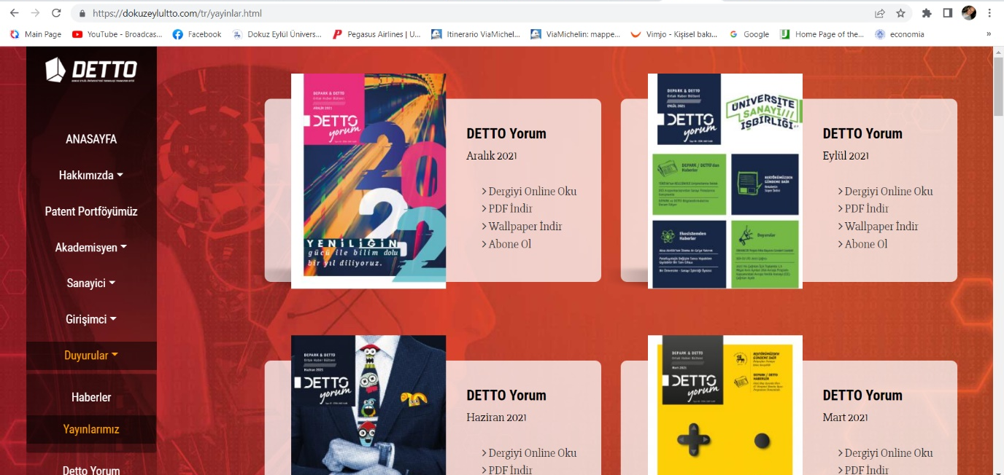

The Official Publication of DETTO
(DEU Technology Transfer Unit)
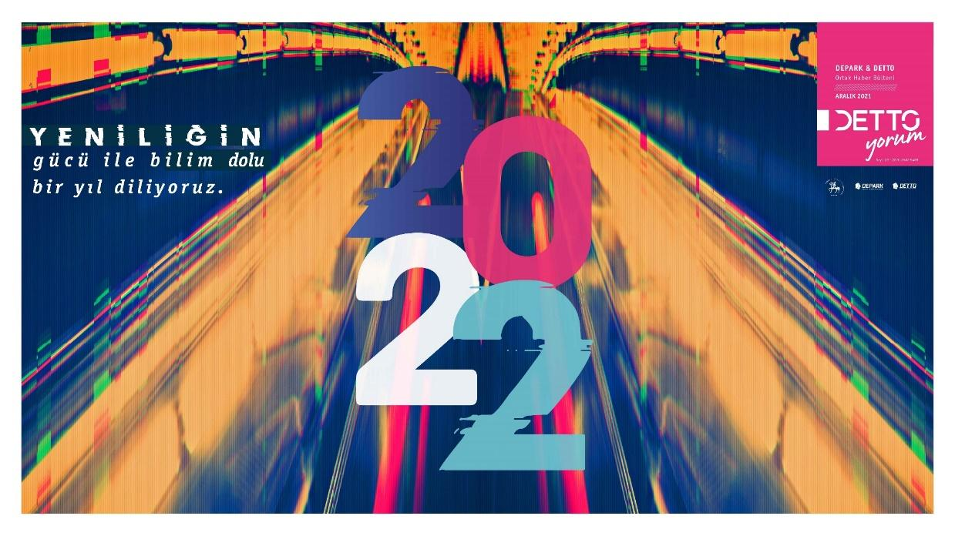

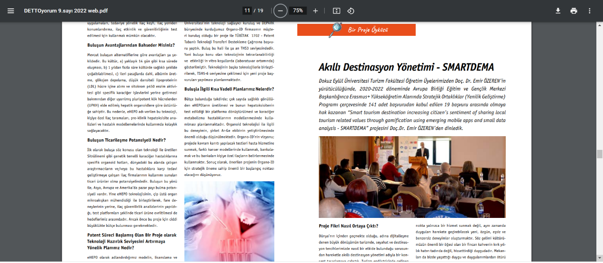

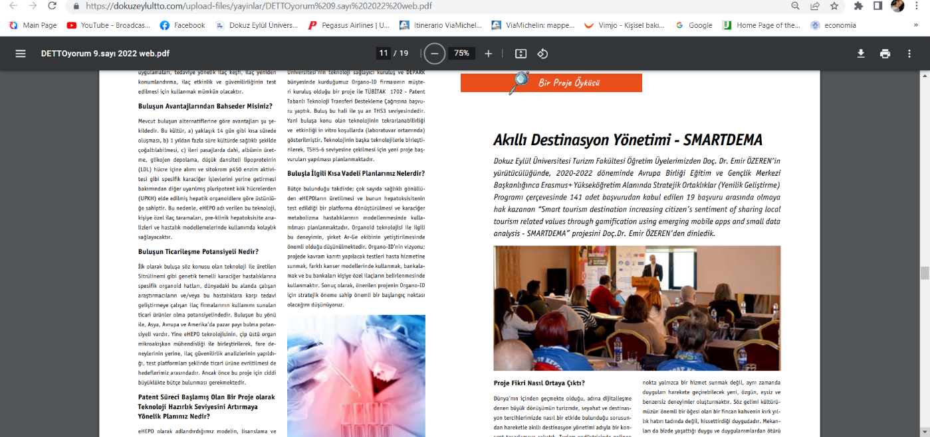

Additionally, the project will be disseminated to local stakeholders via dissemination workshops, national and stakeholder meetings (Foca and Ozdere), as well as through the multiplier events in Turkey, France and Slovenia. In all dissemination events, local communities, the public and relevant stakeholders will be informed of the free- use of the published materials. Moreover, it will encourage downloading the GEO-DEMA APP and placing digital stories geo-referenced on Google Maps. Leaflets will be prepared giving information about the training courses content, the Internet address and social media channels of the project on which they are available, and the free access will be underlined. Those leaflets will be available as hard copies and online. All the results and outcomes, including the training program, will be uploaded on the project website, which will remain open for full access. It will be supported even after the end of the project. Apart from that, information and links to the results mentioned above will be published on relevant sites for educators and in the eTwinning and Erasmus+ dissemination platforms.

Activity Calendar
RE | Activity | Partner responsible | Deadline
1 | Dissemination strategy draft | SEALS | 18/01/2021
2 | Partners’ initial dissemination strategy defined | All | 31/01/2021
3 | Revision of partners’ dissemination strategy (end of IO1) | All | 15/02/2021
4 | Report Dissemination activities (Excel file) | All | 31/02/2021
5 | Report & Recommendations of Dissemination activities | SEALS | 15/03/2021
6 | Report Dissemination activities (Excel file) | All | 31/05/2021
7 | Report & Recommendations of Dissemination activities | SEALS | 15/06/2021
8 | Revision of partners’ dissemination strategy (end of IO2) | All | 31/07/2021
9 | Report Dissemination activities (Excel file) | All | 30/09/2021
10 | Report & Recommendations of Dissemination activities | SEALS | 15/10/2021
11 | Report Dissemination activities (Excel file) | All | 31/01/2022
12 | Report & Recommendations of Dissemination activities | SEALS | 15/02/2022
13 | Multiplier Events | All | 31/05/2022
14 | Report Dissemination activities (Excel file) | All | 31/05/2022
15 | Report & Recommendations of Dissemination activities | SEALS | 15/06/2022
16 | Revision of partners’ dissemination strategy (end of IO3) | All | 30/06/2022
17 | Final Meeting+Marathon | DEU + All | 30/06/2022
18 | Report Dissemination activities (Excel file) | All | 31/08/2022
19 | Report & Recommendations of Dissemination activities | SEALS | 31/08/2022

https://ec.europa.eu/programmes/erasmus-plus/programme-guide/annexes/annex-ii_en
https://ec.europa.eu/programmes/erasmus-plus/programme-guide/annexes/annex-ii_en
Page 80 of the Application Form

