SMARTDEMA DISSEMINATION
Foca District of National Education Directorate (Foça İlçe Milli Eğitim Müdürlüğü)

Foça stories are in digital tourism!
Dokuz Eylul University Faculty of Tourism, with its project titled 'Smart Destination Management-SMARTDEMA', became one of the 19 projects accepted within the framework of the EU Erasmus+ Strategic Partnerships in the Field of Higher Education. Foça District Directorate of National Education is starting to work on this project in which it participates as a partner.

Link: https://www.milliyet.com.tr/ege/foca-hikayeleri-dijital-turizmde-6377485
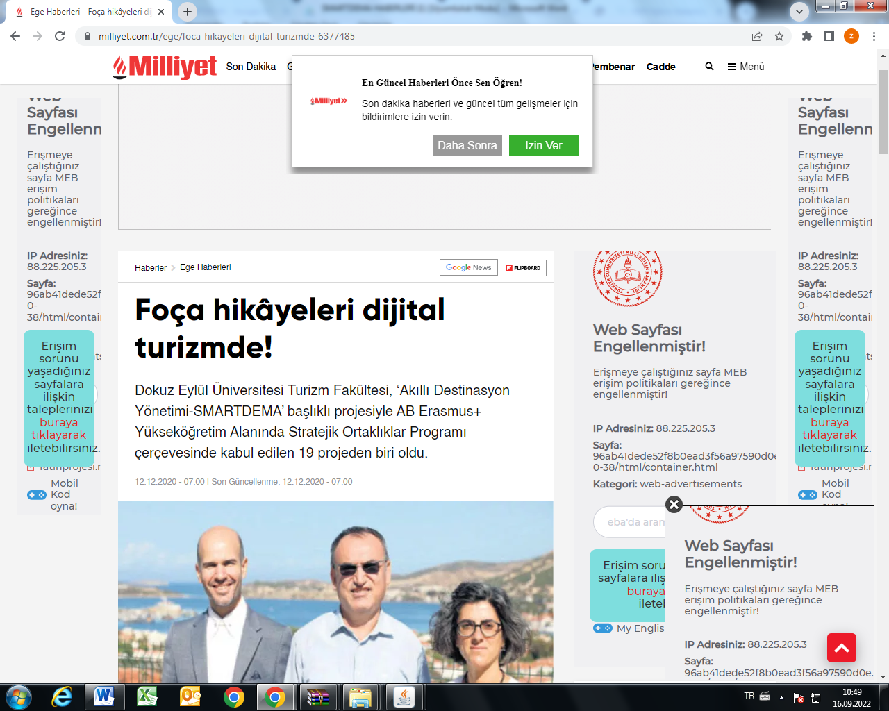

Dokuz Eylul University (DEU) Faculty of Tourism became one of the 19 projects accepted within the framework of the EU Erasmus+ Strategic Partnerships in the Field of Higher Education with its project titled "Smart Destination Management-SMARTDEMA". With this project, it is aimed to turn the unearthed folk tales of Foça into a mobile application and bring them into national and international digital tourism. With the promotional news, local and national people are informed about the project.

Link: http://www.aydin24haber.com/dokuz-eylul-universitesinden-turizme-dijital-katki-578030h.htm
Link: https://www.sabah.com.tr/izmir/2020/12/11/dokuz-eylul-universitesinden-turizme-dijital-katki
Link: https://www.canakkalehaber.com/dokuz-eylul-universitesinden-turizme-dijital-katki/12164/
Link: https://www.egeajans.com/izmir/dokuz-eylul-universitesi-nden-turizme-buyuk-katki-h89505.html
Link: http://www.karsmanset.com/haber/dokuz-eylul-universitesinden-turizme-dijital-katki-399790.htm
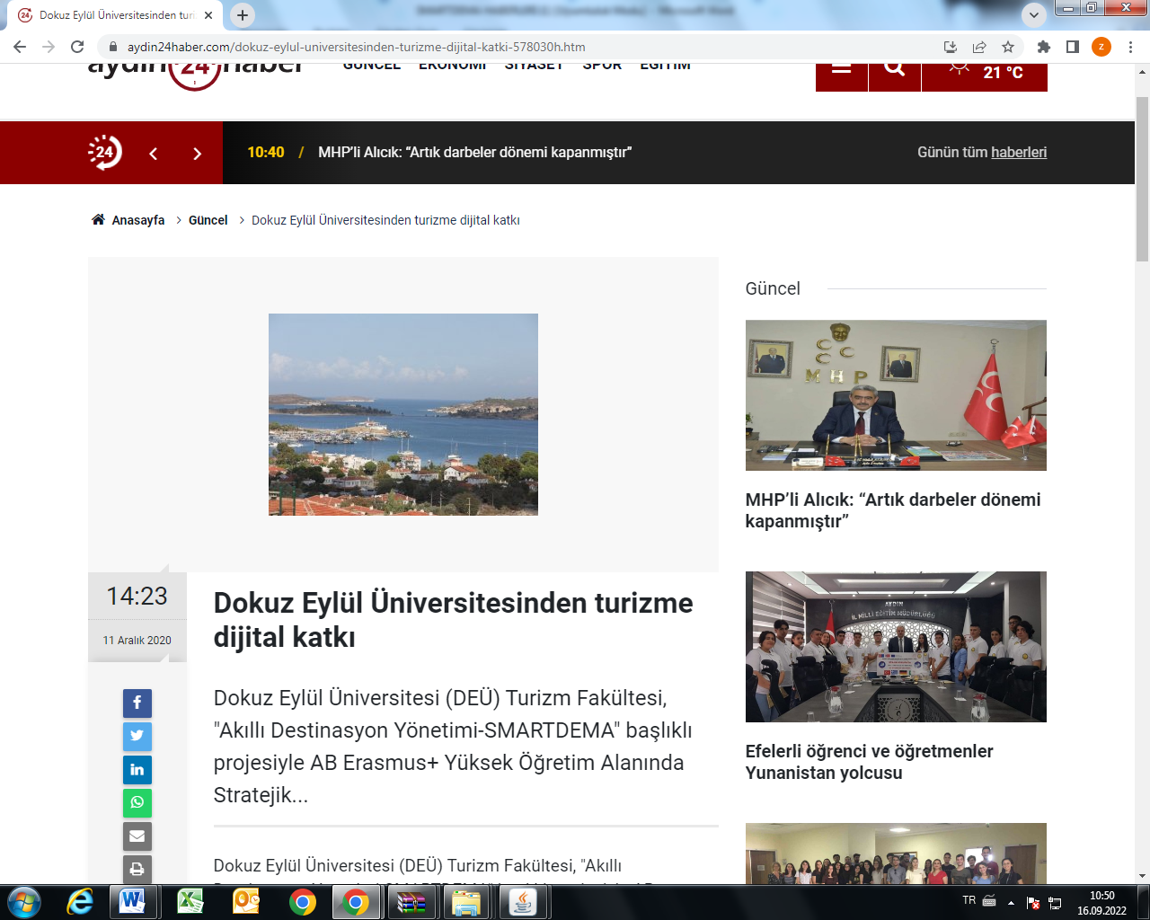

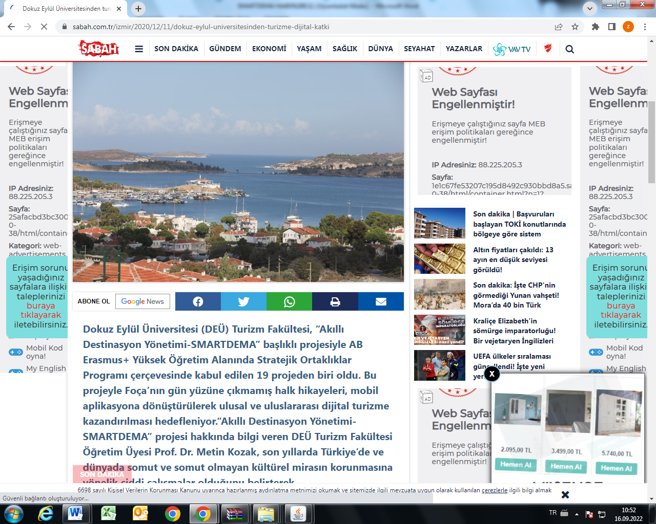

FOÇA STORIES WILL BE TOLD WITH THE MOBILE APPLICATION
Foça's folk tales will reach much more people with the mobile applications to be established, and detailed information about Foça's history, culture, vegan-gluten-free food alternatives will be included.

Link: https://www.gazetepoyraz.com/haberler/kultur-sanat/foca-halk-hikyeleri-mobil-aplikasyonla-anlatilacak-detay.html
Link: https://www.imarhaber.com/dokuz-eylul-universitesinden-turizme-dijital-katki/34337

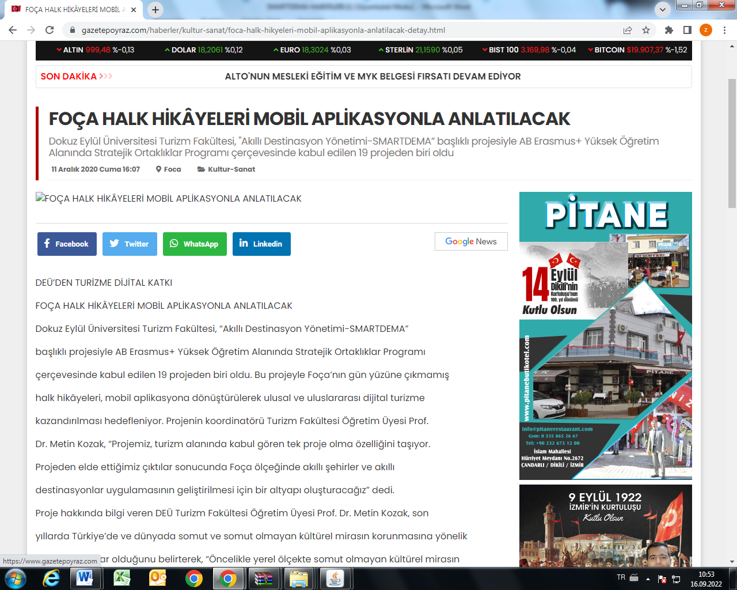

The second meeting of the SmartDema (Erasmus +KA203) project, of which we are a partner as Foça District Directorate of National Education, was held.

Link: https://foca.meb.gov.tr/www/foca-ilce-milli-egitim-mudurlugu-olarak-ortagi-oldugumuz-smartdema-erasmus-ka203-projesinin-ikinci-toplantisi-gerceklestirilmistir/icerik/1806
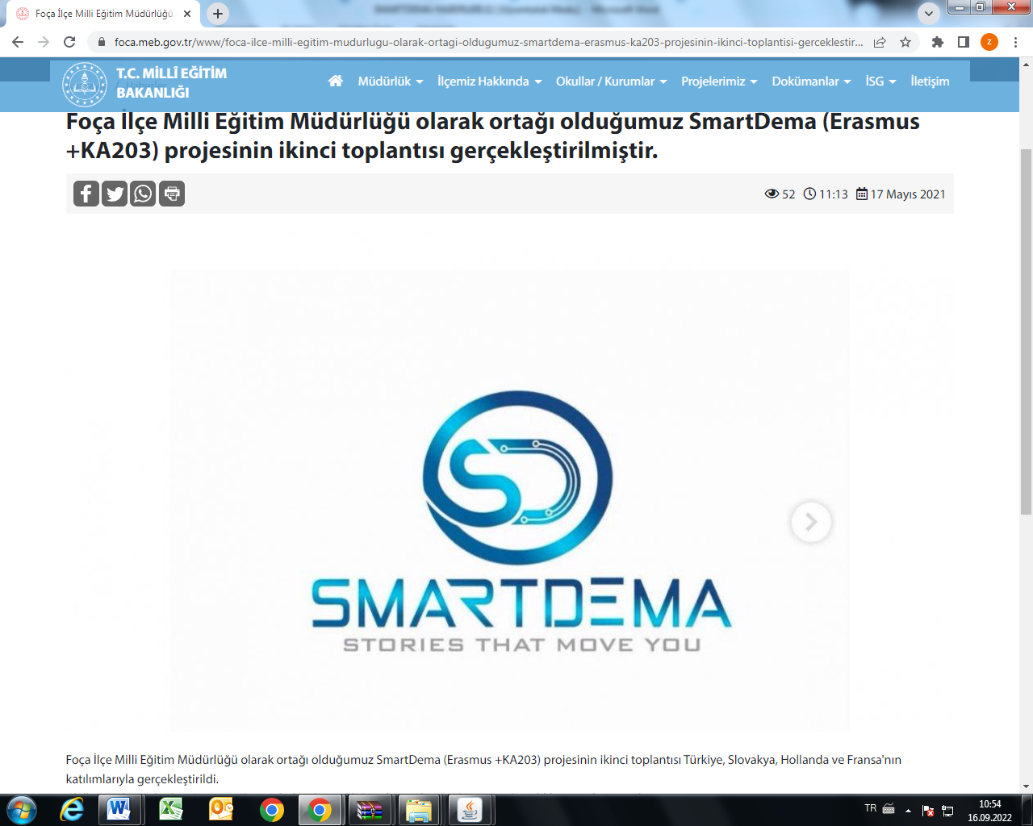

Tourism in Foça Will Revive Through Stories, It Will Come to Life

At the Özdere meeting that was held within the scope of the project on Smart Destination Management (SMARTDEMA), which was supported by the Directorate of the European Union Education and Youth Center within the framework of the Erasmus+ Strategic Partnerships in the Field of Higher Education (Innovation Development) Program in the 2020-2022 period and led by Dokuz Eylul University Faculty of Tourism, concrete and the digital application prepared to reveal the intangible cultural heritage through stories was introduced.

Link: https://www.egepolitik.com/foca-da-turizm-hikayeler-yoluyla-canlanacak-hayat-bulacak/64263/

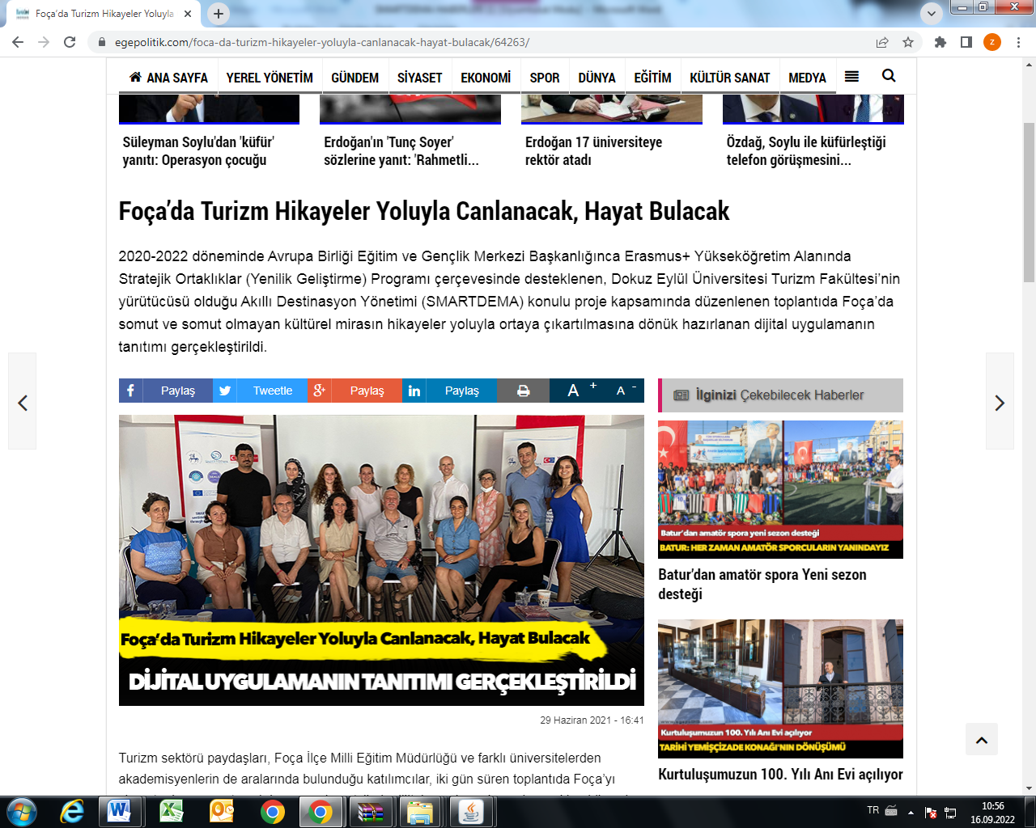
Posters of SmartDEMA Project were hung in all the schools at Foca.
Link: https://foca.meb.gov.tr/www/smartdema-projemizin-posterleri-okullarimizda/icerik/1820

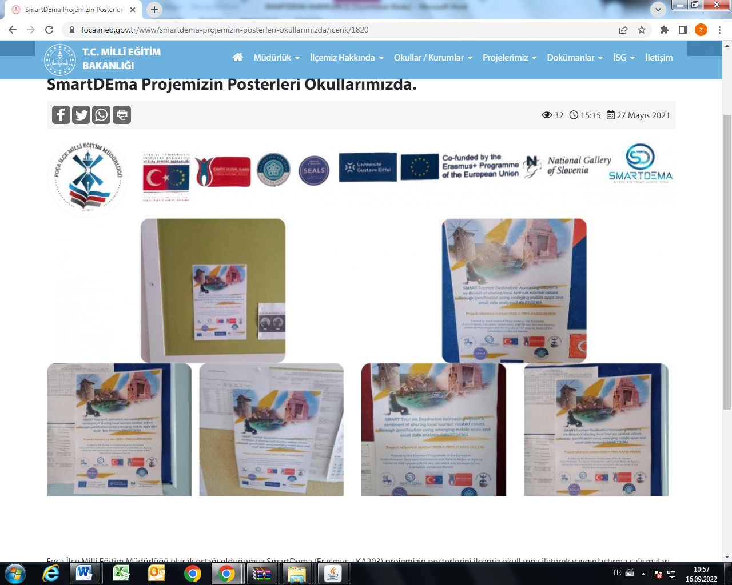

Within the scope of our project, interviews were held with tradesmen and experts in our district regarding the culture and history of Foça.

Link: https://foca.meb.gov.tr/www/projemiz-kapsaminda-foca-kulturu-ve-tarihi-ile-ilgili-olarak-ilcemizde-esnaf-uzmanlarla-gorusmelerimiz-devam-etmektedir/icerik/1819

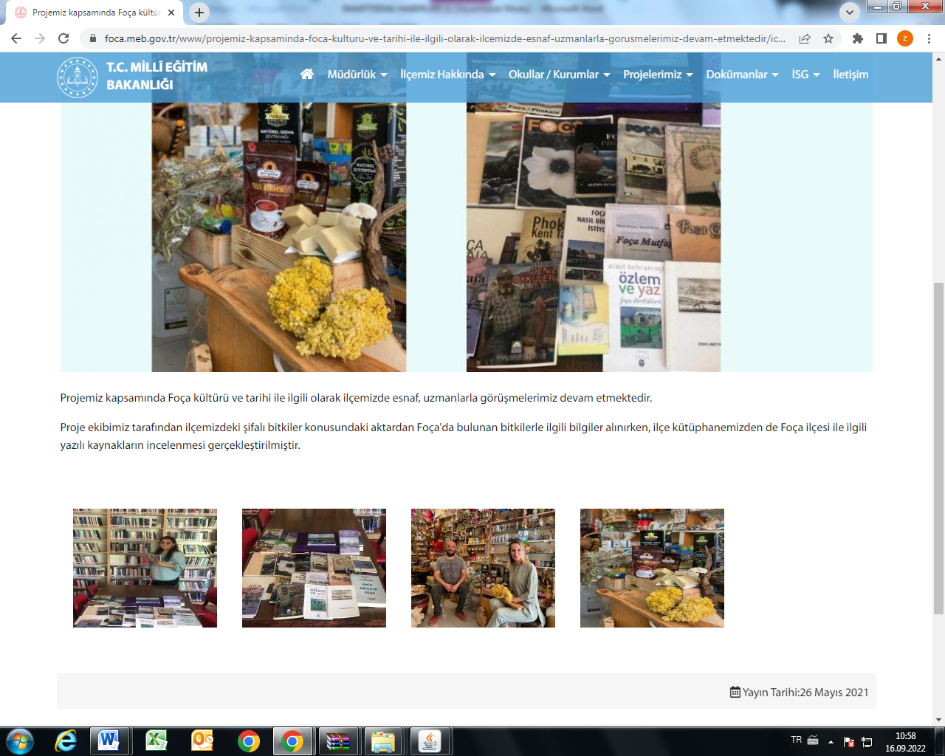

Another meeting of the SmartDema (Erasmus +KA203) project, of which we are a partner as Foça District Directorate of National Education, was held. Our project team, consisting of our District Director of National Education Süleyman Menek, Branch Managers Zülfiye Karadeniz, Tuğçe Irmak, Aybala Selcen Doymuş and Nurhayat Aksoy, exchanged information necessary for the creation of local stories that will be brought to digital tourism with a smart application.

Link: https://foca.meb.gov.tr/www/smartdema-erasmus-ka203-projesi-hazirliklari-devam-ediyor/icerik/1815
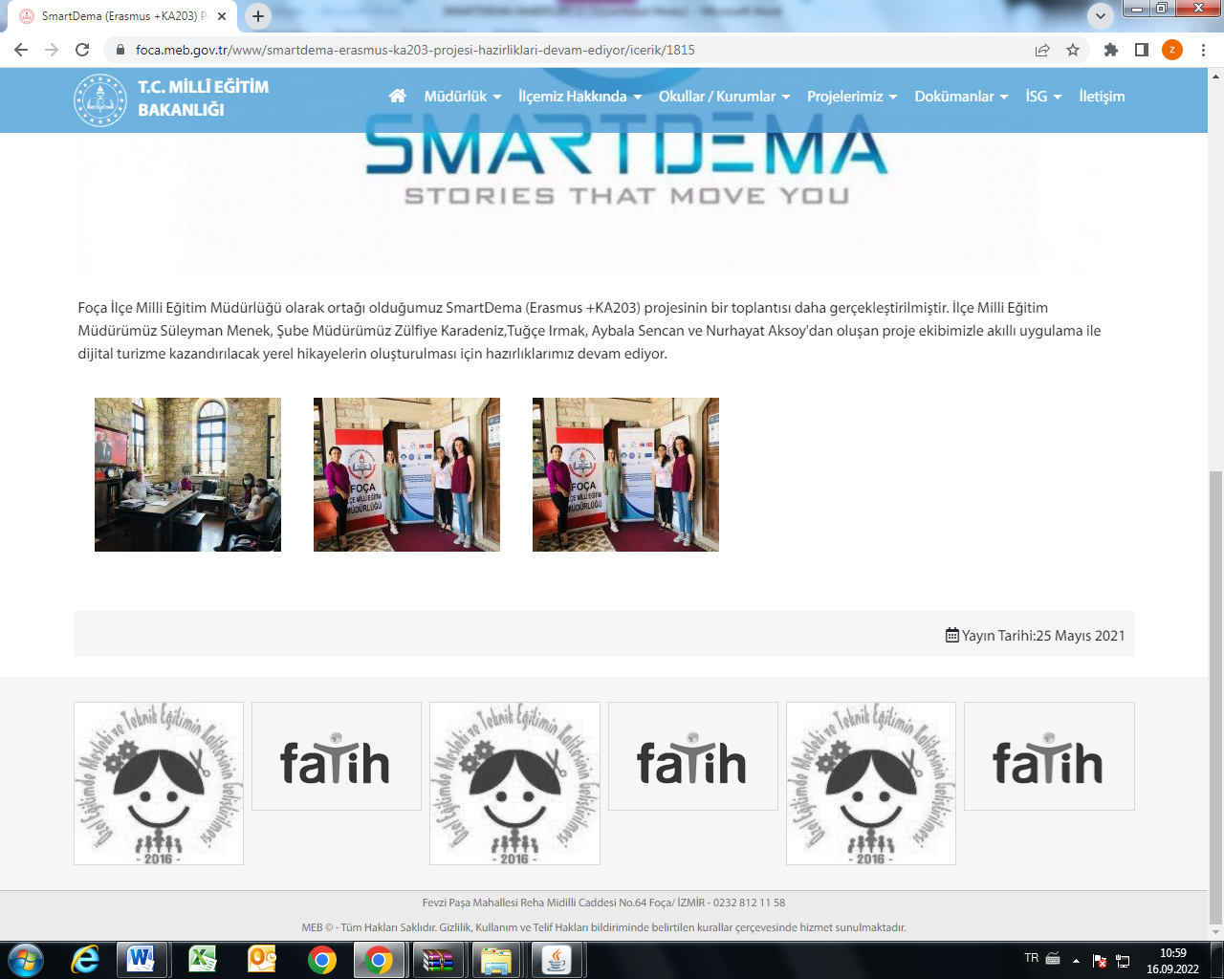

SmartDema Projesi Okul Müdürleri Toplantısı
Meetings were held with the principals of all the schools in our district as part of dissemination activities of the Smartdema project.
Link: https://foca.meb.gov.tr/www/smartdema-projesi-okul-mudurleri-toplantisi/icerik/1916

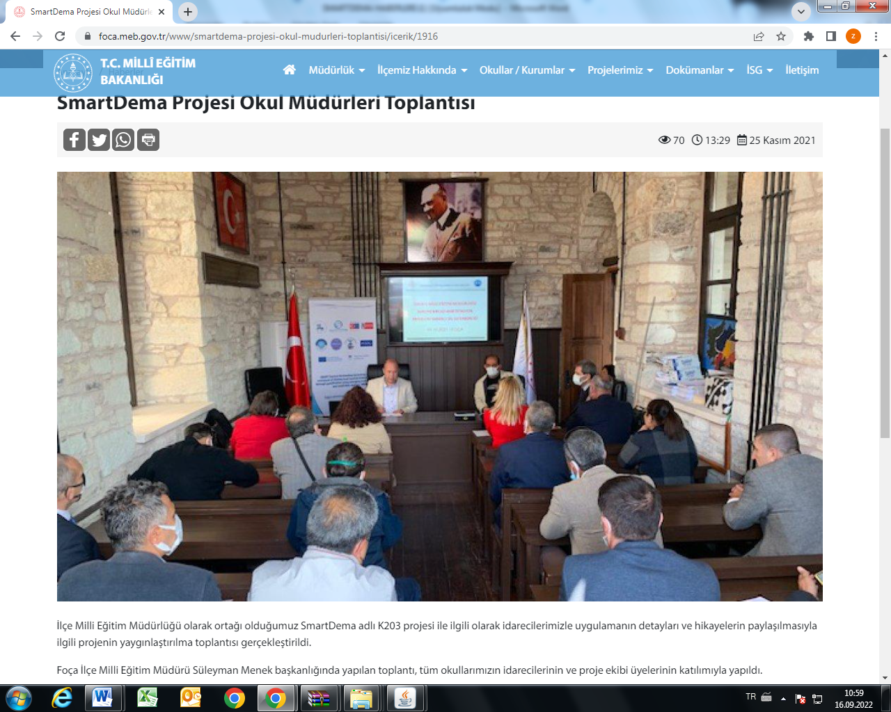

For our SmartDema project, a meeting was held with retired teacher and writer Cevat Yıldırım at our District Directorate of National Education.

Link: http://foca.meb.gov.tr/www/smartdema-projemiz-icin-emekli-ogretmen-ve-yazar-cevat-yildirim-ile-ilce-milli-egitim-mudurlugumuzde-bir-toplanti-gerceklestirilmistir/icerik/1822

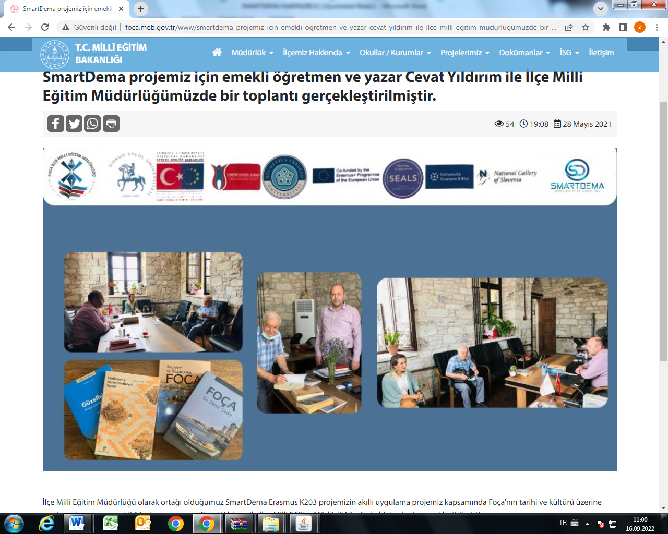

Dokuz Eylul University Smart Destination Management EU Project meeting completed. The meeting organized within the scope of the Smart Destination Management (SMARTDEMA) project, conducted by Dokuz Eylül University Tourism Faculty, was successfully held in Foça with the participation of project partners from 4 countries and DEPARK/DETTO.

Link: https://rayhaber.com/2021/10/dokuz-eylul-universitesi-akilli-destinasyon-yonetimi-ab-projesi-toplantisi-tamamlandi/
Link: https://www.focali.com/akilli-destinasyon-yonetimi-toplantisi-foca-da-yapildi/7022/
Link: https://www.medyaege.com.tr/akilli-destinasyon-yonetimi-toplantisi-focada-yapildi-180343h.htm
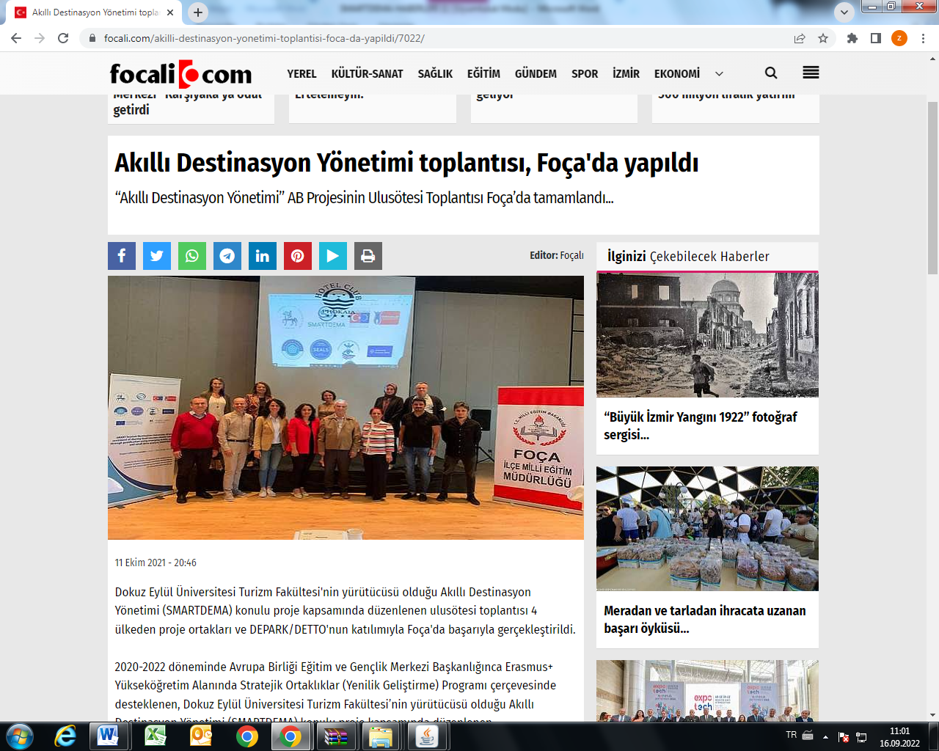

"SMART DESTINATION MANAGEMENT" WAS DONE IN FOÇA
The meeting organized within the scope of the Smart Destination Management (SMARTDEMA) project conducted by Dokuz Eylül University Tourism Faculty was successfully held in Foça with the participation of project partners from 4 countries and DEPARK/DETTO.

.
Link: https://www.izmirkenthaber.com.tr/akilli-destinasyon-yonetimi-foca-da-yapildi/56503/

SmartDema Project Visits were made to the trainees of the Public Education Center.

Link: https://foca.meb.gov.tr/www/halk-egitim-merkezi-kursiyerlerine-smartdema-projesi-tanitim-ziyaretleri-gerceklestirildi/icerik/1936

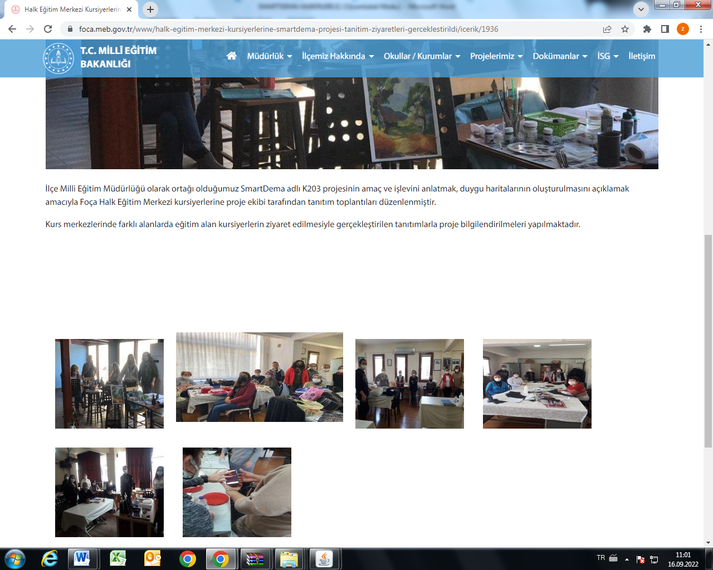
Introductory Meeting of the SMARTDEMA Project, of which we are a partner as the District Directorate of National Education, was held.
Link: https://foca.meb.gov.tr/www/ilce-milli-egitim-mudurlugu-olarak-ortagi-oldugumuz-smartdema-projesinin-tanitim-toplantisi-gerceklestirilmistir/icerik/1855

Information and promotion activities of the SmartDema (Erasmus +KA203) project, of which we are a partner as Foça District Directorate of National Education, continue.

Link: https://foca.meb.gov.tr/www/foca-ilce-milli-egitim-mudurlugu-olarak-ortagi-oldugumuz-smartdema-erasmus-ka203-projesinin-bilgilendirme-ve-tanitim-faaliyetlerine-devam-edilmektedir/icerik/1817
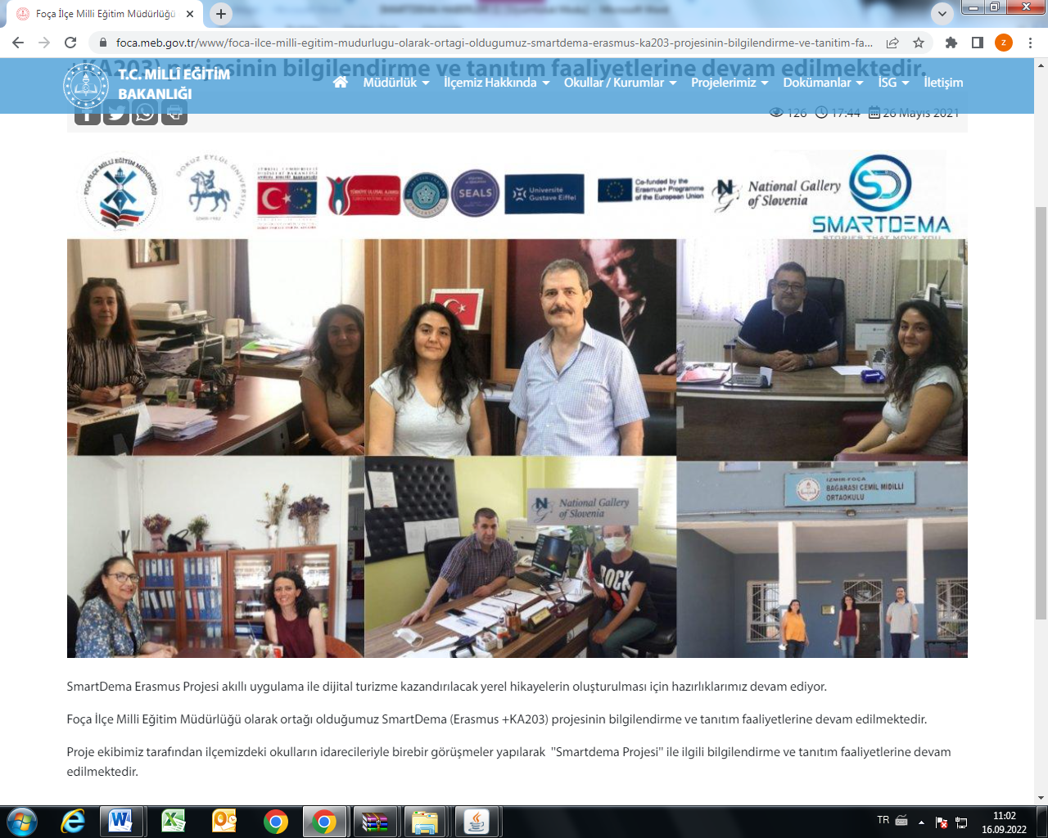

The New Address of Digitalization in Tourism SMARTDEMA
Within the scope of the project on Smart Destination Management (SMARTDEMA) supported by the Directorate of European Union Education and Youth Center within the framework of the Erasmus+ Strategic Partnerships in the Field of Higher Education (Innovation Development) Program for the period 2020-2022, led by Associate Professor Emir Özeren from Dokuz Eylül University Faculty of Tourism. The multiplier event was held at Mövenpick Hotel İzmir with the wide participation of valuable stakeholders of the tourism ecosystem, heads of associations, chambers, industry representatives and academics.

Link: https://www.izmirtime35.com/turizmde-dijitallesmenin-yeni-adresi-smartdema-63177-haberi

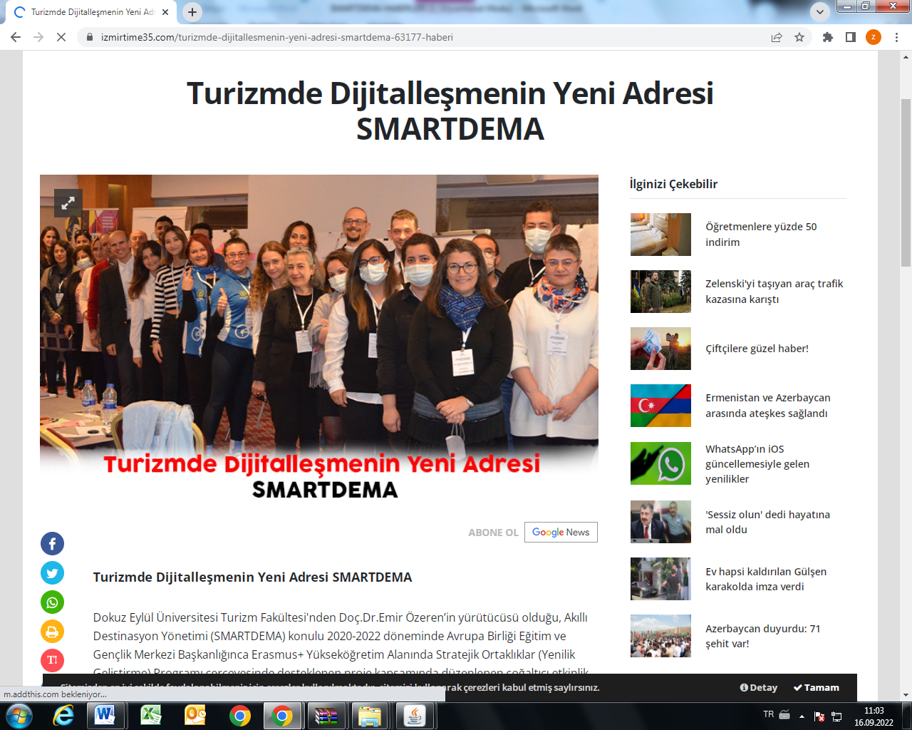

The France Meeting of the 2020-1-TR01-KA203-D92920 SmartDema Project was held.
The LTTA (Learning Teaching Training Activity) hosted by Paris Gustave Eiffel University between January 24 - 28 within the framework of SmartDema Erasmus+ KA2 Project was conducted. In the activity, in which Turkey, the Netherlands, France and Slovenia are partners, a series of training, brainstorming sessions were held in order to develop unique digital "Openbadge" that will be created by DEU, NEU, NGS and Foca MEM.

Link: https://foca.meb.gov.tr/www/2020-1-tr01-ka203-d92920-smartdema-projesinin-fransa-toplantisi-basladi/icerik/1955

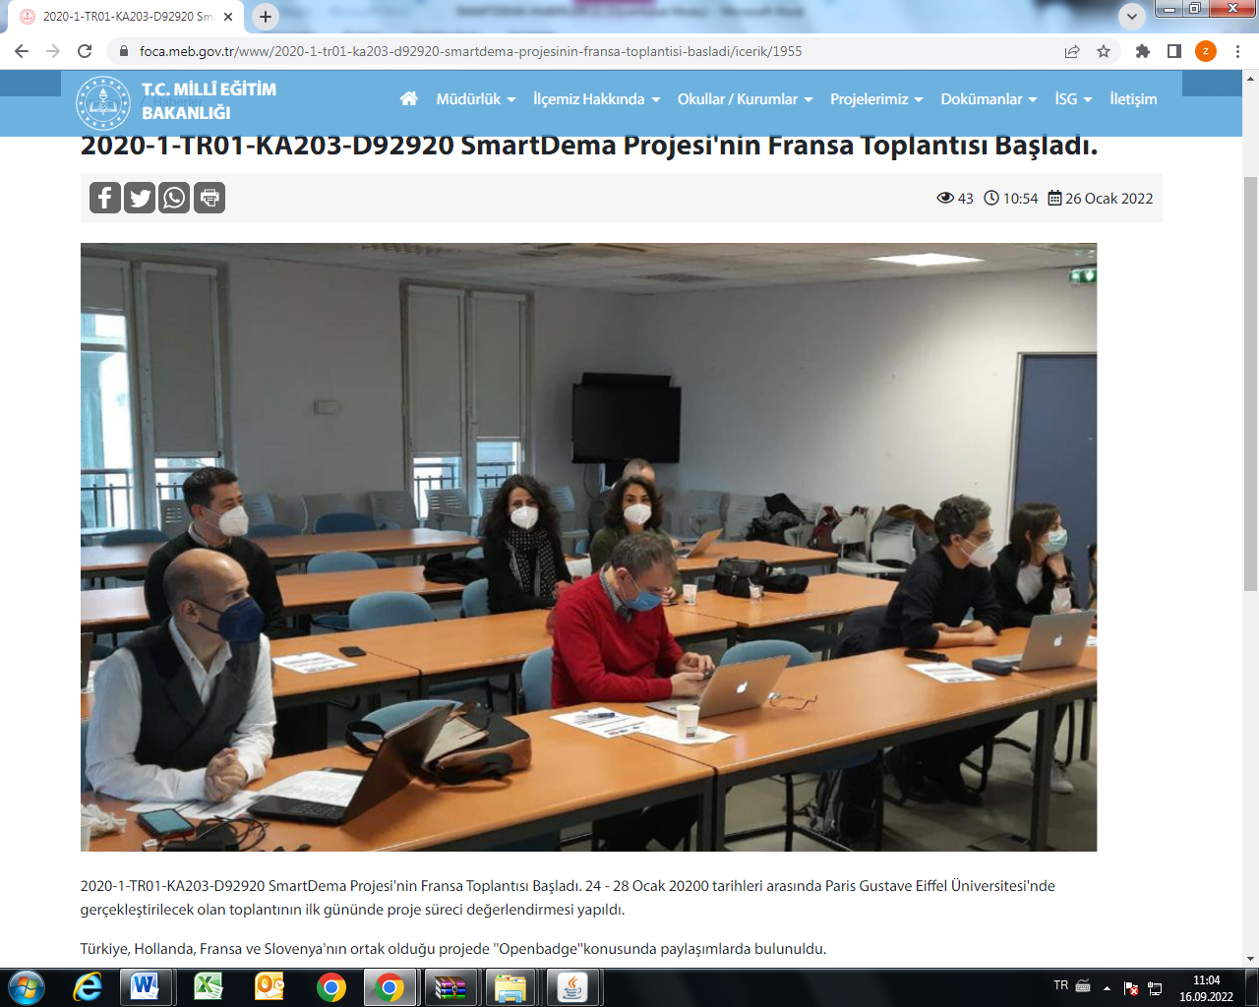

They introduce Turkey with the SMARTDEMA project
Under the guidance of Literature teacher Aybala Selcen Doymuş, one of the coordinators of the Smartdema project, an event was organized to raise awareness for her students, accompanied by a literature teacher from Foça Anatolian High School. Foça Anatolian High School Literature Teacher Birgül Nalbantoğlu stated that they participated in the SMARTDEMA project with 19 students, and said that it was a good experience for them to raise awareness for Foça.

Link: https://www.medyaege.com.tr/smartdema-projesi-ile-turkiyeyi-tanitiyorlar-190638h.htm
https://foca.meb.gov.tr/www/smartdema-projesi-kapsaminda-focanin-kultur-varliklari-ogrencilere-tanitildi/icerik/1965

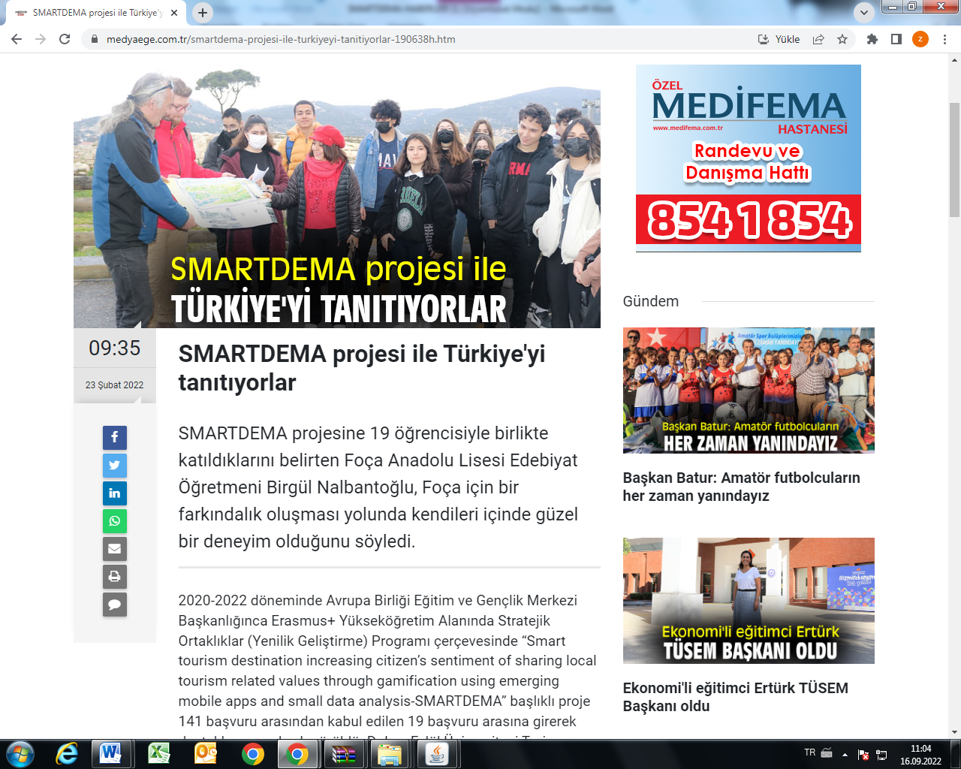

After the event, the news of our project took place in the main news bulletin in the visual media, which was a good step for the dissemination of the project.

https://ne-np.facebook.com/Worldturkhaber/videos/izmir/757080055209643/

A Writing Workshop was held at Reha Midilli Anatolian High School as part of the Smartdema Project

In the writing workshop organized as part of the Smartdema Project at Reha Midilli Anatolian High School on 09.03.2022, our students created their stories and uploaded them to the Smartdema application

Link: https://foca.meb.gov.tr/www/reha-midilli-anadolu-lisesinde-smartdema-projesi-kapsaminda-yazi-atolyesi-duzenlendi/icerik/1976

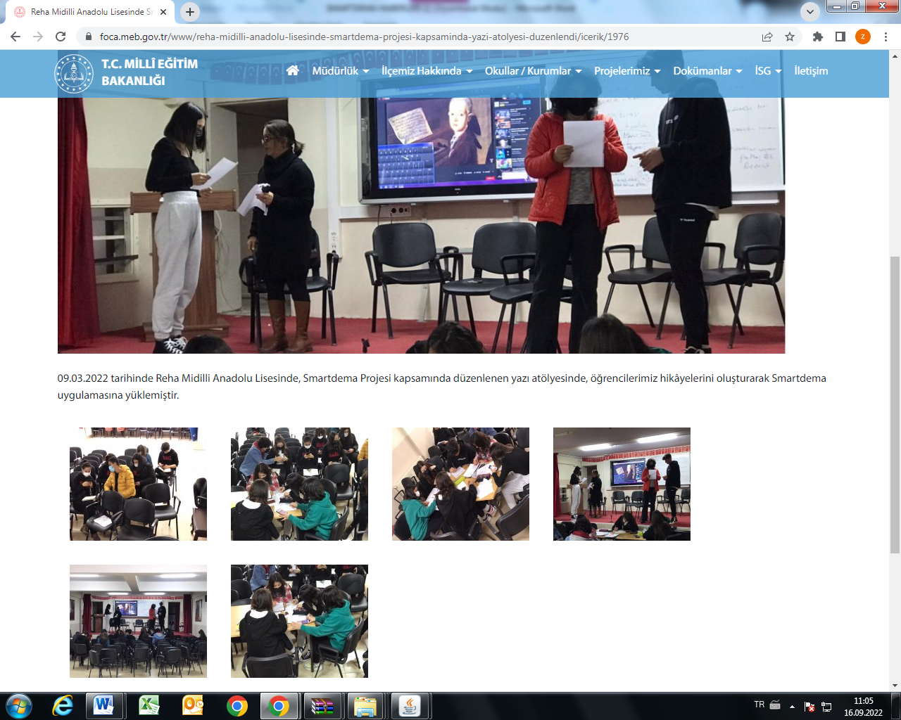

MEETING OF DISTRICT INSTITUTIONAL DIRECTORS
The activities carried out by our Directorate within the scope of the Smartdema Project were transferred to our school principals. It was decided to organize a contest among children in order to disseminate the project.

Link: https://foca.meb.gov.tr/www/ilce-kurum-mudurleri-toplantisi/icerik/1980

HALİM FOÇALI MTAL "Gluten Free and Vegan Cuisine Event" was held within the scope of SmartDEMA Project.
Within the scope of Smartdema Project carried out by Halim Foçalı Vocational and Technical Anatolian High School students under the coordination of DEU Tourism Faculty, in partnership with Foça District Directorate of National Education, Necmettin Erbakan University, Güstava Eiffel University (France), National Gallery of Slovenia and SEALS (Netherlands) on 30.03.2022. Products were prepared as part of the 'Vegan Kitchen' event.

http://foca.meb.gov.tr/www/smartdema-projesi-kapsaminda-halim-focali-mtal-glutensiz-ve-vegan-mutfak-etkinligi-yapildi/icerik/1985
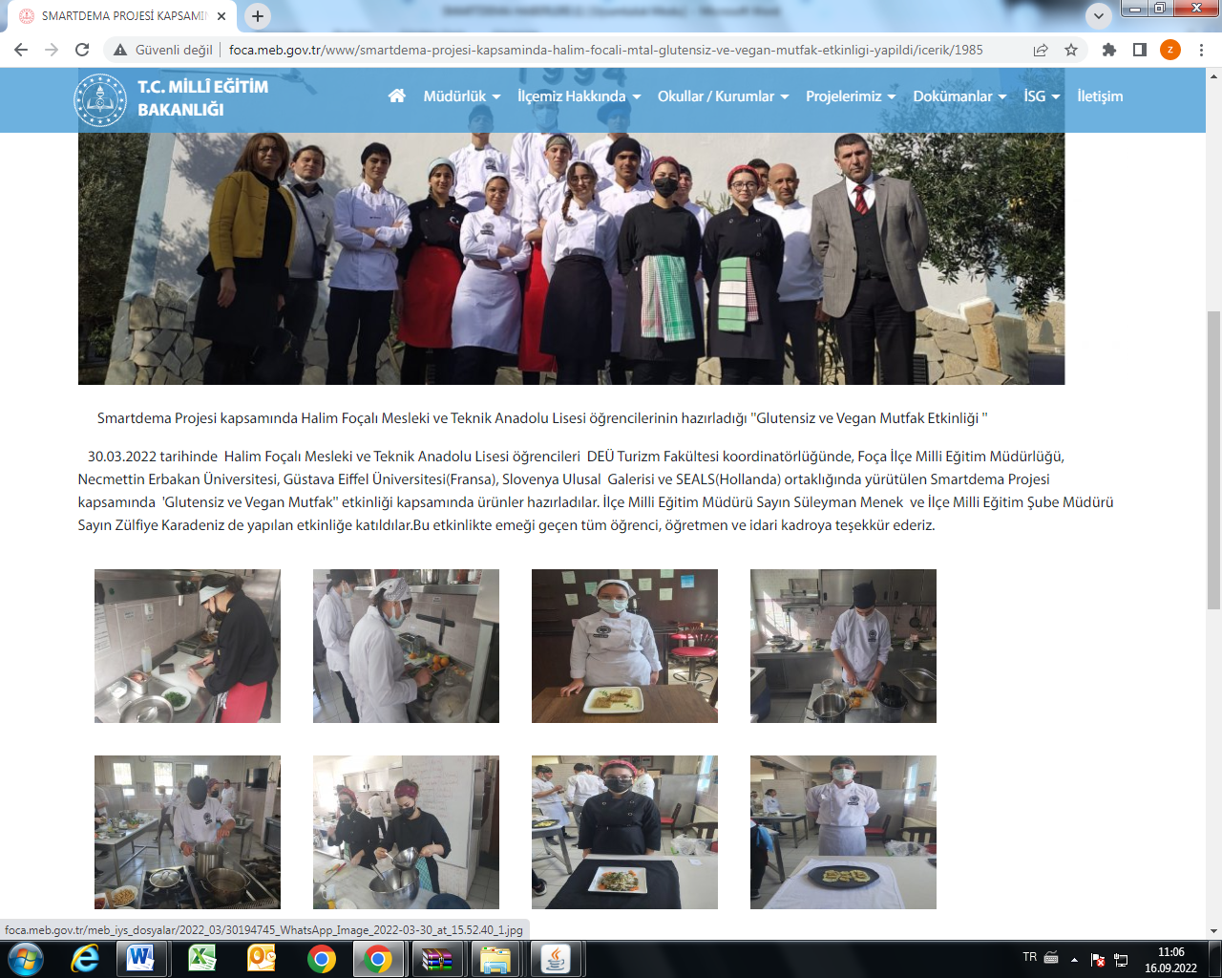

Transnational meetings of our project were held in Slovenia - Amsterdam, respectively.

Slovenia/Ljublijana
https://foca.meb.gov.tr/www/erasmus-smartdema-projesi-slovenya-toplantisi/icerik/1992
Holland/ Amsterdam
https://foca.meb.gov.tr/www/smartdema-projesinin-son-ulusotesi-toplantisi-amsterdamda-gerceklestirildi/icerik/2051
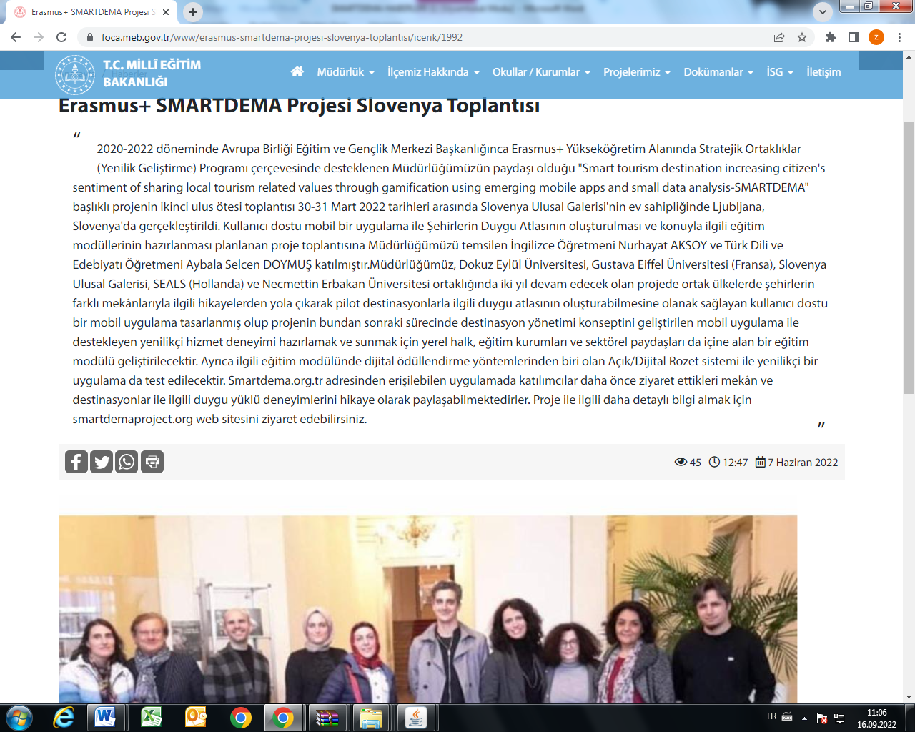

A competition themed "A Day in Foça with Atatürk" was held within the scope of the Smartdema Erasmus+ KA2 Project.
Under the the Strategic Development (Innovation Development) Program in the field of Erasmus + Higher Education by the 2020-2022 European Union Education and Youth Center; our students who participated in the competition titled "A Day in Foça with Atatürk" was prepared by FOCA Directorate within the scope of the "Smart tourism destination - SMARTDEMA" project, which increases the citizens' sense of sharing local tourism-related values ​​through gamification by using a smart tourism destination, developing mobile applications and small data analysis. Their works were exhibited in the Foca Directorate of National Education.

https://foca.meb.gov.tr/www/ataturk-le-foca-da-bir-gun-konulu-sergimiz/icerik/2057
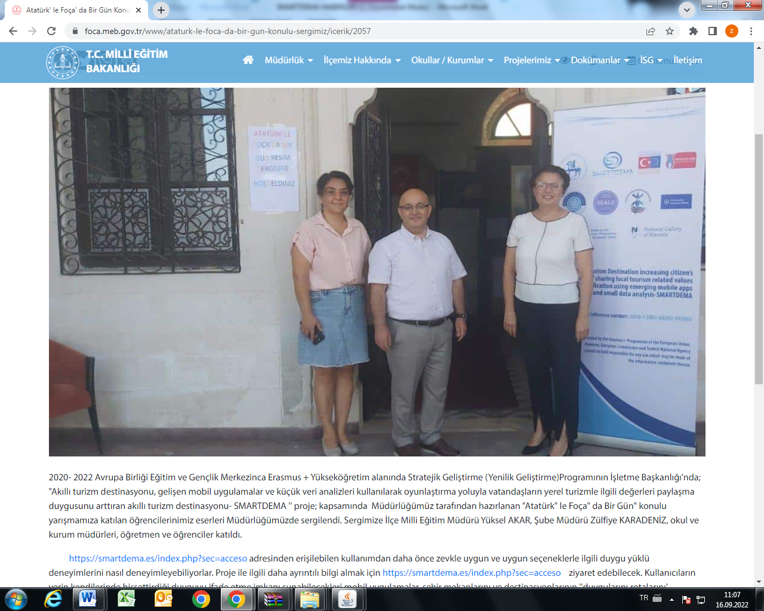

SMARTDEMA PROJECT ACTIVITIES WERE PRESENTED AND PROMOTED AT FOÇA 4006 TUBITAK DISTRICT SCIENCE FAIR

Under the Strategic Development (Innovation Development) Program in the field of Erasmus+ Higher Education by the 2020-2022 European Union Education and Youth Center; "Smart tourism destination - SMARTDEMA" project, the activities carried out by Foça District National Education were introduced, presented and the mobile application (SmartDEMA app.) was promoted to the District Governor Ali ÇETİN as well as teachers, students and local people attending at Tübitak 4006 District Science Fair Festival.

https://foca.meb.gov.tr/www/tubitak-4006-ilce-bilim-fuari-festivalinde-smartdema-projesi-tanitildi/icerik/2048
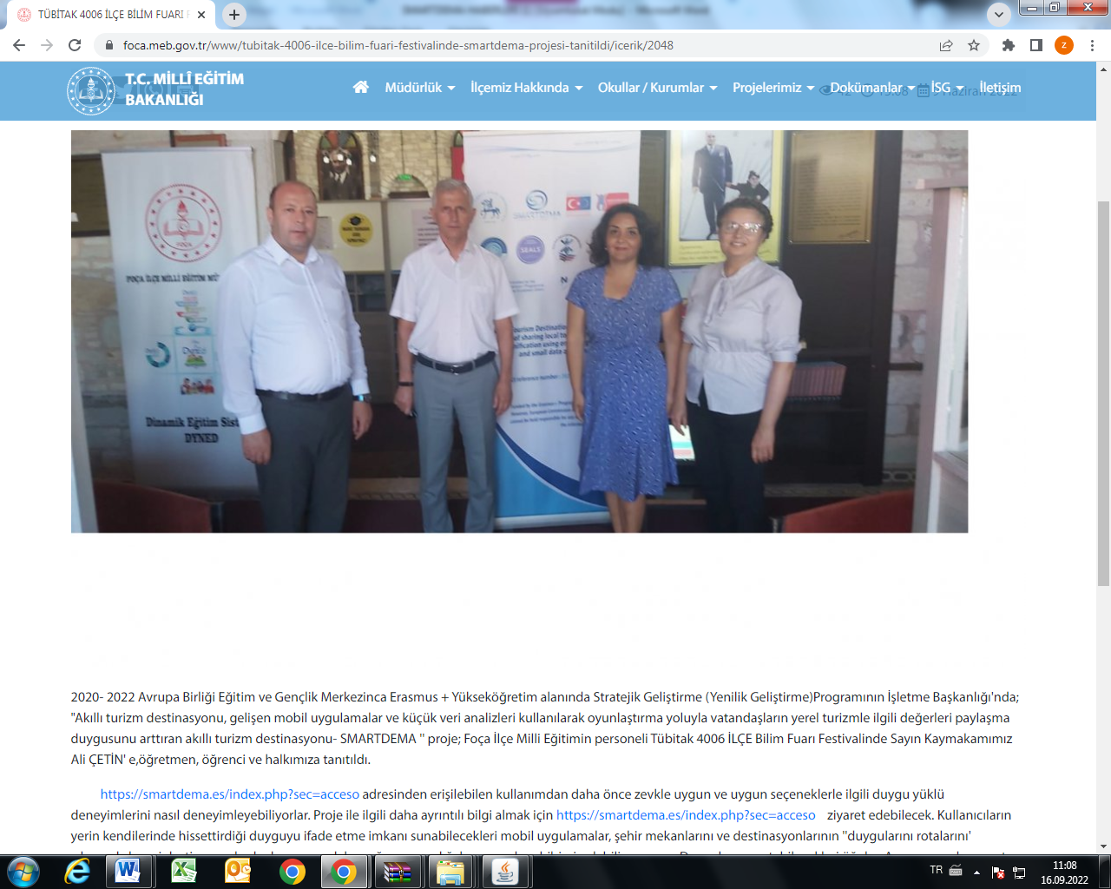
Dokuz Eylul University Multiplier Event Meeting

Under the the Strategic Development (Innovation Development) Program in the field of Erasmus + Higher Education by the 2020-2022 European Union Education and Youth Center; "Smart tourism destination, smart tourism destination that increases citizens' sense of sharing local tourism-related values ​​through gamification using developing mobile applications and small data analysis - SMARTDEMA" project; a multiplier event hosted by the coordinator Dokuz Eylül University on 21-22 July 2022 was held at Mövenpick Hotel. On behalf of Foça District Directorate of National Education, District Director of National Education Yüksel Akar, Branch Manager Zülfiye Karadeniz, and Adil Keskin, Adalet Aslan, Alev Çelik, Bariş KüçükGüner, İlknur Küçükgüner, Aybala Selcen Doymuş and Nurhayat Aksoy participated on behalf of our institution.

