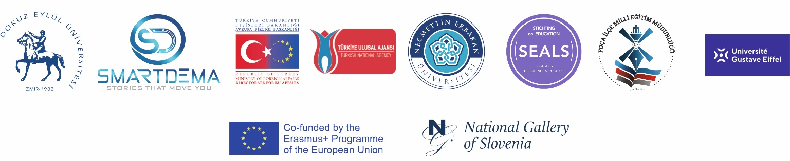

AGENDA OF THE MEETING
SMARTDEMA PROJECT
1 – 2 October 2021
MARK WARNER PHOKAİA BEACH RESORT OTEL https://mwphokaia.com/
01 OCTOBER FRIDAY

10:00 - Opening Speech

10.00 - 11.00 – Description of the SmartDEMA Erasmus+ KA2 Project and Informative Speech
(Dr.Emir Özeren – Dr. Kevser Çınar )

11:00 – 11:30 – Actvities carried out by Foca District National Education Directorate
(Foca MEM Director Süleyman Menek)

11:30 – 12:00 – Process of identification of destinations in Foca

LUNCH

14:00 – 15:00 – Presentation on App. developed by the SmartDEMA Project (Daniel Weiss)

15:00 – 16:00 – Future activities and next processes of the Project ( Dr. Kevser Çınar )

16:10 – 16:30 - Introducing the destinations determined in Foça

16:30 – 17:30 – Cultural traces of Foça history and cultural heritage –
“Foça is the most beautiful place a pair of eyes can see”
(Sebahattin Karaca)

18:00 – 20:00 - Introducing the destinations determined in Foça and Sea from the Sea with the Boat Tour
(Cevat Yıldırım)

DINNER

02 OCTOBER SATURDAY

10:00 – 12:00 – Introducing the Foça surroundings and the destinations that will create content in the SmartDEMA
application with guidance

LUNCH

13:30 – 14:30 - Opinions about the project, new cooperation opportunities, final remarks and evaluation
(Project team and participants)

CLOSURE SESSION

