SMART Tourism Destination increasing citizen’s sentiment of sharing local tourism related values through gamification using emerging mobile Apps and SMALL Data analysis-SMARTDEMA
SMARTDEMA Grant Agreement No.
2020-1-TR01-KA203- 092920
Erasmus+ Key Action 2
ERASMUS+ HIGHER EDUCATION
EU PROGRAMME FOR STRATEGIC PARTNERSHIP IN THE FIELD OF EDUCATION, TRAINING, AND YOUTH
TRANSNATIONAL PROJECT MEETING (TPM)
MINUTES OF MEETING
Amsterdam
Date: 14 June 2022

- The Context
The TPM meeting brings on board a selected group of professionals from partnering organisations to discuss the progress of the SmartDema project, exchange ideas for the next steps of the ongoing project activities, elaborate on open badges, evaluate training, improvements in the digital SmartDema Application. The core of the meeting includes:
Themes: thematic map analysis, open digital badges, good practices, description of stories training programs, partners’ coordination
The meeting is organised with the full participation of all partners;
Leading Organisation:
Stichting for Education on Agility Liberating Structures (E10057522, NL)

Participating Organisations:
Dokuz Eylul Unıversıtesı (E10208896, TR)
Université Gustave Eiffel (E10233280, FR)
Foca Ilce Milli Egitim Mudurlugu (E10200825, TR)
Necmettin Erbakan Üniversitesi (E10073224, TR)
Narodna galerija (E10247818, SI)

- Meeting Minutes
The first session of the transnational project meeting (TPM) started at 09:30 with the participation of all project partners under the moderation of Daniel Weiss, representing SEALS as the partner and the host institution of TPM. He made a welcome and introduction speech and presented the TPM agenda. The meeting started with an introduction of the hosting organisation, SEALS and a brief presentation of the Netherlands and the city of Amsterdam. Daniel Weiss presented the rebranding transformation of Amsterdam (Dutch partner-related), moving from a city of “cannabis and Red District Light” to a sustainable and circular economy ecosystem connected to the SmartDema project.

Following his opening speech, the first topic of the meeting’s agenda, which consisted of ‘Thematic Maps’ presentations, started. Each project partner was given 20 minutes for presentation.

Nurhayat Aksoy representing Foca District National Education Directorate (Foca MEM), delivered a presentation on the way how thematic stories were developed. More than three hundred stories have already been uploaded to the SmartDema app. The stories mainly demonstrate the various impacts, feelings and emotions of cultural and historical heritage and natural beauties on people. Accordingly, the experiences and memories had a substantial effect on the way how stories were shaped. In the creation of thematic routes in Foca, it was observed that the themes were generally shaped by positive emotions. In the stories, while themes such as "peace, happiness, relaxation, enjoyment" came to the forefront in general, themes such as "sadness, longing" were also reflected in the stories by those who used them on certain routes, depending on their experiences.

There were generally positive feelings and notifications about the flavour stops and routes in Foça. The abundance of food alternatives was reflected in the stories as satisfaction. Nurhayat Aksoy evaluated themes through routes and stories; For instance, natural events on sea routes, sunrises and sunsets, the different states of the sea, the colours it takes, and the plays of light often reinforced the themes of "peace, happiness, relaxation and admiration". These beautiful images of the sea also led people to the tunes of inspiration and romance. According to the presentation by Nurhayat Aksoy, historical windmills, one of the symbols of Foça, were among the routes most often covered in stories. Another topic determined as a route in the stories is the historical Foça stone houses. Stone houses, frequently the subject of stories, create a sense of belonging in the narrators. Marseille Square’s story dates back to BC and is among the most marked routes. The mythological story of the Siren Cliffs evoked emotions such as surprise, fright, inspiration and curiosity in people's minds. Users describing this route feel inspired and enchanted. The Mediterranean Seals, which gave Foça its name, also found a place on the route and were covered in the stories with the themes of curiosity and surprise. Küçükdeniz, called the heart of Foça, is the place where the themes of happiness, joy, relaxation, enjoyment and peace are handled the most on the route of SmartDema.

Following the description of stories and thematic maps, Nurhayat Aksoy continued her presentation on the open digital badge (IO2 of SmartDema) developed by the Foca District of National Education Directorate (Foca MEM). In her presentation, she mentioned earning criteria to earn the badge on Teacher Training and shared the following link:
https://eu.badgr.com/issuers/623f06c25beac903ffbcde8a/badges/623f0d4545ba4321489bb49d/overview
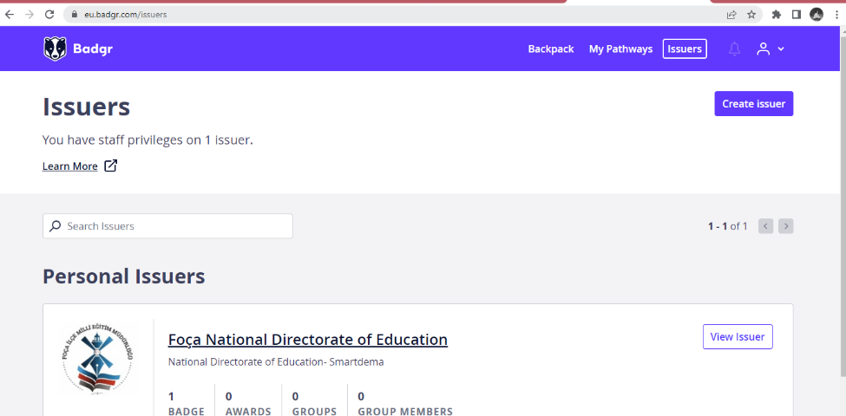

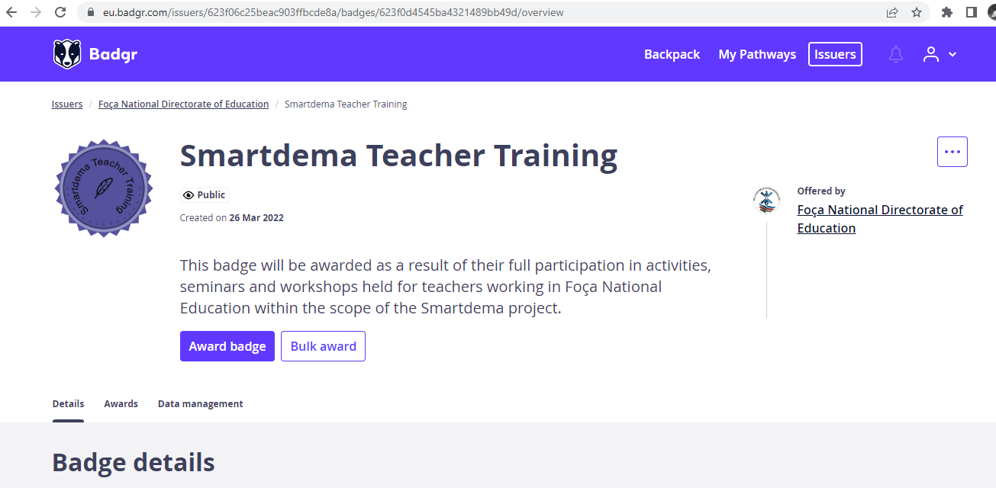

After the presentation by Nurhayat Aksoy, the project partners exchanged ideas and gave some useful feedback on the activities that Foca MEM will carry out. The second presentation was delivered by Dr.Kevser Çınar (NEU) on the draft version of the digital destination management training. She explained in greater detail about the target group, training description, training modules, why the target group will get the training, what skills the learner will acquire and which criteria are used to assess the acquired skills. In each module, specific assignment questions were designed for the participants. There were three levels of learning outcomes of the training program: basic, specific and transversal.

There was a fruitful discussion among the partners to adjust and revise the final version of seven integrated training modules that are as follows: Module 1: Destination Management Players, Module 2: The transformation of the tourism landscape: trends and challenges, Module 3: Strengthen your brand through Geo-Semantic Emotion, Module 4: Aggregate Services, Module 5: Digital Tools as a Personal Travel Influencer, Module 6: Planning methodology in DDM, Module 7: Digital marketing: social media management.

Following the partners’ feedback session on training modules designed by NEU, Dr.Kevser Çınar presented the open digital badge on ‘Tourism Destination Management’, which certifies this training series on seven modules provided by Necmettin Erbakan University to certify their training. Accordingly, the participants can engage in a digitally personalised way to discover their emotions triggered by different aspects caused by places in the destination through the App. The participants will be able to access the details of the open badge created and developed by NEU through the following link: https://eu.badgr.com/public/badges/lAzptWzJSuKyGhSfarD-cw

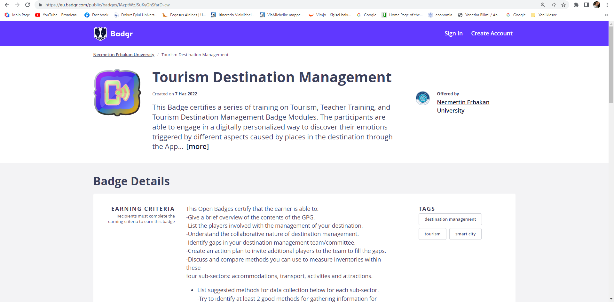

The morning session ended at 12:30 for a lunch break. The afternoon session started at 13:30. The first speaker, Daniel Weiss from SEALS, delivered his thematic map training analysis presentation through GEO-DEMA App. He underlined in his presentation that a thematic map is a type of map that portrays the geographic pattern of a particular subject matter in a geographic area. These maps are very useful for SmartDema Project in terms of analysing the spatial distribution of information or looking for any geographic patterns and trends within the data sets. In SMARTDEMA, thematic maps enable to locate of citizen stories. A series of predefined filters to create thematic maps are embedded in the web app: Happy, Joyful, Romantic, Excited, Proud, Inspired, Hopeful, Peaceful, Surprised, Relaxed, Nostalgic, Sad, unhappy, Fear, Anger, Ashamed, Worried, Boredom, Disgust, Guilty, Disappointment, Uncomfortable. The list of emotions has been updated based on the feedback and suggestions from each partner.
The next speaker was Michel Mohor from the National Gallery of Slovenia (Narodna Galerija), and he presented the thematic map report of the Gallery. Accordingly, they have thus far created nine unique thematic routes that align very well with the main purpose and objectives of the SmartDema project. These routes were available in the SmartDema app. The routes were designed with Ljubljana’s visitors in mind - Ljubljana mostly hosts people who visit the city for one to two days and spend most of their time exploring the town on foot. The Gallery team checked basic statistics on tourism both at the Gallery and for the city. It programmed walkable trails that showcase different aspects of Ljubljana’s heritage: the UNESCO-protected Ljubljana embankment, the old and new fountains work by Jože Plečnik, select baroque churches, monuments to people of note, both museums in the city and contemporary galleries where one can purchase a work of art, trails of Slovenian Impressionism with locations where some of their works were painted and, lastly, places connected to a Ljubljana native and Slovenian cultural icon, Ivana Kobilca. The routs elicited different emotions. However, most of them were positive - the research by the Gallery demonstrated that visitors expected positive stories and would also post ones with such a tone.

Following Michel Mohor, Dr.Joumana Boustany (Gustave Eiffel University) delivered a presentation on analysing the SmartDema data using qualitative software. She mentioned the characteristics of the small data and how partners could use this data to arrive at conclusions. She showed several examples from N-Vivo software to analyse SmartDema data. Accordingly, the software allows us to organise, code and manage our data and facilitate its analysis with visualisation, memorisation and reporting functions. It helps us analyse text, audio, video, email, images, spreadsheets, online surveys, web content and social media from various sources. A browser extension, "Ncapture", allows data collection directly from the web. However, Dr.Joumana Boustany mentioned that the difficult work of sorting the data still rests on the shoulders of the researcher who is actually doing this kind of analysis. All partners learned that before they could process the data, it was important to clean it first, and they needed to ensure that the columns and rows had been exported correctly. Some characters may cause problems, so the participants are kindly suggested to delete irrelevant data since sometimes people write irrelevant content unrelated to the context. Finally, she presented the corpus analysis process with N-Vivo with the following figure:
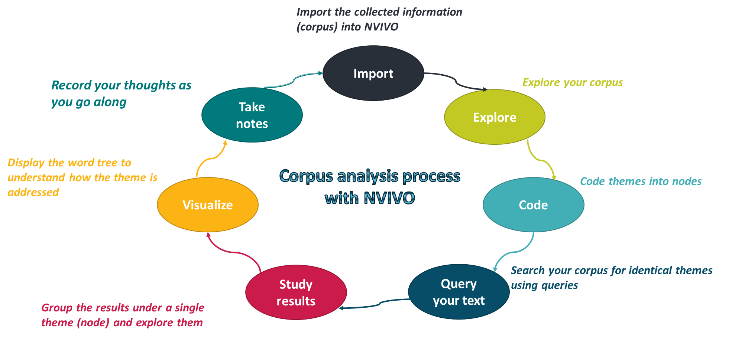

The last partner presentation was delivered by Dr.Emir Ozeren (DEU) as the project coordinator. In his presentation, he first introduced the description of thematic stories and then the process of creating unique stories under twelve different categories. More than four hundred authentic, thematic stories were developed and uploaded to the App thanks to the first multiplier event, the nutritional healthy chef, the university and the dissemination activities carried out by the SmartDema project team of Dokuz Eylül University.
These posts were classified into the following main categories;
- Historical places route
- Museums Route
- Nutritional chef route
- Religion & Faith route
- Cycling route
- Sightseeing route
- Walking route
- Culture Route
- Local Cuisine Route
- Nature route
- Art Route
- Leisure route
Based on the presentation, when the content analysis of the thematic stories is examined, it is seen that ‘very positive’ and ‘positive feelings’ are shared at a high rate. People are more likely to share positive feelings about themselves and the positive aspects of the places they have visited. There are also 73 neutral comments.

Following the description of stories and thematic maps presentation, Dr.Emir Ozeren continued his presentation on the open digital badge (IO2 of SmartDema) developed by DEU. In his presentation, he mentioned the criteria to earn the badge on Nutritional Health Chef Literacy. This open badge certifies that the earner can
- acquire digital literacy by reflecting on the Mediterranean, local, healthy food menu alternatives, including gluten-free and vegan, through SmartDema App,
- acquire nutrition literacy which can be defined as “the degree to which individuals can obtain, process, and understand nutrition information and skills needed to make appropriate nutrition decisions,
- create an interactive visualisation of your urban healthy diet exploration.

The Open Badge created by DEU certifies that the earner can:
- Work in a restaurant that offers vegan, vegetarian or gluten-free alternatives,
- Share or record descriptive information about the nutritional values of the dishes in the
App to promote them and encourage other restaurants (use Smartdema app. actively)
- Create thematic maps,
- Certify as a dietitian & nutritionist (as a chef), Certify as a food engineer,
The major advantage of taking the DEU open badge is that the university, the Faculty of Tourism, particularly the Gastronomy & Culinary Arts Department, is issuing this badge. Dokuz Eylul University ranked first in Turkey and is amongst the top 100-150 universities in the world for “hospitality and tourism management” based on the academic ranking of world universities listed by Shanghai Ranking 2022. The target group is chefs, food specialists, dieticians, nutritionists, gastronomy & culinary arts students, and those who are really interested in local, healthy food and diets. The badge is accessible via the following link:
https://eu.badgr.com/public/badges/UJHfbxZLQNOk_zFiQHfqmg
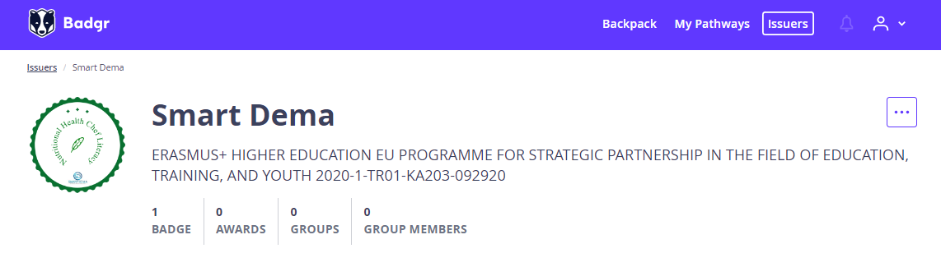

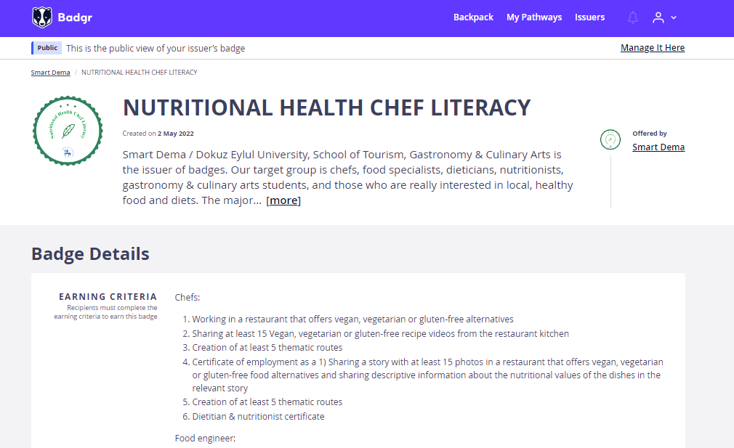

In the last session of the TPM, the partners discussed the issue of evaluation and quality assurance strategy and risk management plan of the SmartDema project. Partners agreed upon the scope and objectives of the quality management within the project, the fields of evaluation, the methods and the quality indicators and monitoring, and evaluation tools. Additionally, the timing of the evaluation was set, and the quality assurance process was reviewed carefully by each partner. All partners came to the conclusion that the main goal of the evaluation and quality assurance strategy is to establish a support mechanism for the project management to ensure smooth cooperation and high quality of the project outputs.

In this regard, in the last session of TPM, partners collaborated on a series of internal (self-assessment) and external (external evaluation, beneficiary input) evaluation and quality assurance actions striving for a level of excellence in delivery that meets identified needs among stakeholder groups and target audiences, and which achieves (or surpasses) all contractual delivery promises. Finally, the partners reviewed the methodology, risk identification and hypothesis of risk response strategies, risk monitoring and review strategy. They made several adjustments and modifications to the plan in preparing its final version in light of insightful suggestions raised in the Amsterdam TPM.

In the last session of the meeting, partners also discussed and presented information about their dissemination efforts and how to make SmartDema Project more visible to target groups. Partners also discussed the future activities, goals and timelines, together with deciding the date of the Second Multiplier Event and final TPM that will be held both in Izmir. Accordingly, the second multiplier event will be organised on 21 July 2022, and the final TPM will be carried out on 22-23 July 2022 in the city of Izmir, hosted by DEU. Amsterdam TPM was fruitful and useful as the partners laid down the final deadlines and delegated the remaining tasks to appropriate partners. Partners went through all the activities on the Miro Board that have to be completed by the end of the project. Partners could also express and share the challenges encountered and the solutions they found while working on the intellectual outputs.

