MINUTES OF MEETING
SECOND MULTIPLIER EVENT

21 July 2022, İzmir, Turkey
Erasmus+ Higher Education
EU Programme for Strategic Partnership in the Field of Education, Training and Youth
2020-1-TR01-KA203-092920

The second multiplier event of the Erasmus + Higher Education Strategic Partnership Program titled “SMART Tourism Destination increasing citizen’s sentiment of sharing local tourism-related values through gamification using emerging mobile Apps and SMALL Data analysis-SMARTDEMA” was organised on 21 July 2022 under the leadership of Dokuz Eylül University. The event was hosted at the Mövenpick Hotel İzmir, Turkey.

The event was planned and organised in two live sessions. The morning session was led by Dr. Emir Özeren, the project coordinator, Dr. Kevser Çınar, the project partner; Mr. Daniel Weiss, the project partner and Mr. Michel Mohor, the project partner. Whereas the afternoon session was moderated by Aybala Selcen Doymuş, the project partner and Dr. Emir Özeren the Project coordinator.

The purpose of this multiplier event is to present the SMARTDEMA project’s results and disseminate these results and the GeoDEMA application to tourism stakeholders in Izmir and neighbouring cities such as Aydın, Denizli and Manisa. In this direction, the participants were determined by considering the potential contributions and insightful suggestions they could make to the SMARTDEMA application. An invitation letter was sent three weeks before the event. The event was held with the participation of 56 tourism stakeholders, including academics, teachers, industry representatives, NGOs, PhD students and tourism communities.

Four SMARTDEMA project roll-ups were placed in the conference hall to promote the project and its visibility. The conference hall was prepared in the form of classroom seating. A brochure with information about the daily agenda and the guests' badges were distributed at the reception desk at the conference hall entrance. SmartDema project summary booklet, cardboard folder, letterhead and pen with the SmartDema logo were distributed to the tables for the participants.

The participants had two coffee breaks together with a lunch served in the middle. Once the event had been completed, certificates were presented to each participant to recognise their presence and contribution to the event.

The first session started at 10:00 am. The inaugural speech was delivered by Dr. Emir Özeren, the project coordinator from Dokuz Eylül University, Turkey. Dr Emir Özeren presented the Smart Dema project and the agenda of the second multiplier event. Then, he mentioned that the project aims to bring geo-referenced stories to light by focusing on tangible and intangible cultural heritage elements related to tourism in partner countries (especially Izmir and Ljubljana) and to increase the recognition of destinations by integrating them with digital and innovative applications (Open Badge, Geographical Mapping, etc.) and services. Although it has been the subject of the smart city discussions to collect data about the needs of the people living in the city with ICT applications and use this data to ensure their quality of life and subjective well-being, the specific role of shared emotions in creating social collectivities in a city has received scant attention in the scholarly literature. SmartDema project made an attempt to fill this void. Dr.Emir Ozeren underlined that shared emotions play an essential role in bringing people travelling to and living in that city together and connecting them with each other, building bridges between emotions and spaces of the city, and making them feel belonging to the city and places.

Following the speech by Dr.Emir Ozeren, Dr Kevser Çınar, project partner from Necmettin Erbakan University, Konya; delivered a presentation on the innovative features of the App. and ensured that the App. was installed on their phones by all participants of the multiplier event. The participants made a quick registration for the App. Afterwards, Dr.Kevser Çınar gave detailed information on how to post and share stories, pictures, videos, emojis and create routes by showing examples directly from the App. Publishing stories in the App is straightforward. She described through 3 episodes in SMORE format and showed how to do it through a series of short videos and images with explanations. The App, with the mobile phone, automatically geolocates the users in their position. The App uses Google Map layers of information that we have customised to give users a better experience. The selected stories and videos were shown to the participants as examples. At the same time, video shoots for healthy chefs were watched, and the digital open badges were introduced. A digital badge is a digital representation of a skill, learning achievement or experience. Digital badges can be earned in a wide variety of environments. She gave inspiring examples of open badges such as Cities of Learning, Huffington Post, IBM – Desing Thinking and GeoDEMA Open Badge created as an intellectual output of the SmartDema project itself.

The third speaker, Mr Daniel Weiss, from Stichting for Education on Agility Liberating Structures (SEALS) in the Netherlands, presented the main idea behind developing such a Smart Dema application based on a design thinking approach. Design Thinking defines four steps: ideate, prototype, test, and iterate. For the first step, the project partners decided to create a MIRO board https://miro.com/app/board/o9J_lZr54OA=/ containing a series of elements that may help them understand what they want to discover with the App, what kind of emotions they should choose and what features the App must have.
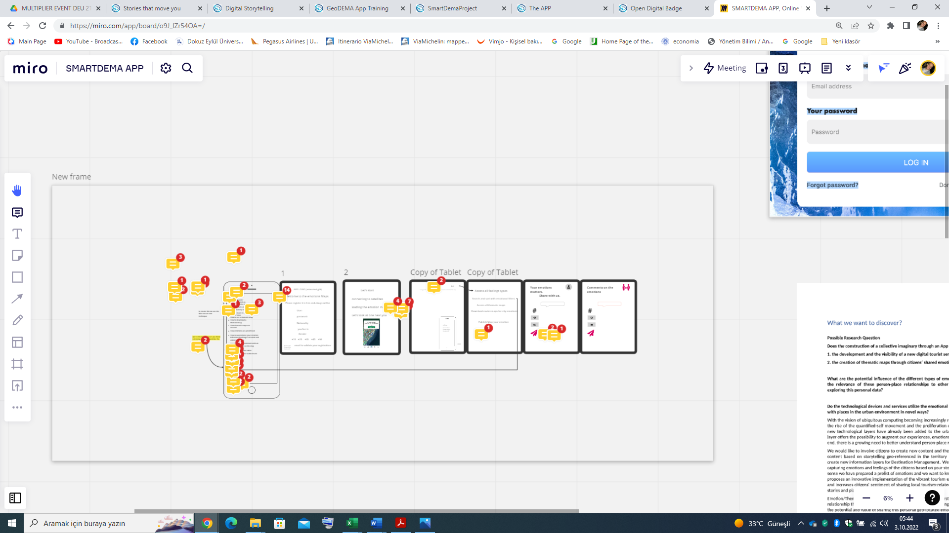

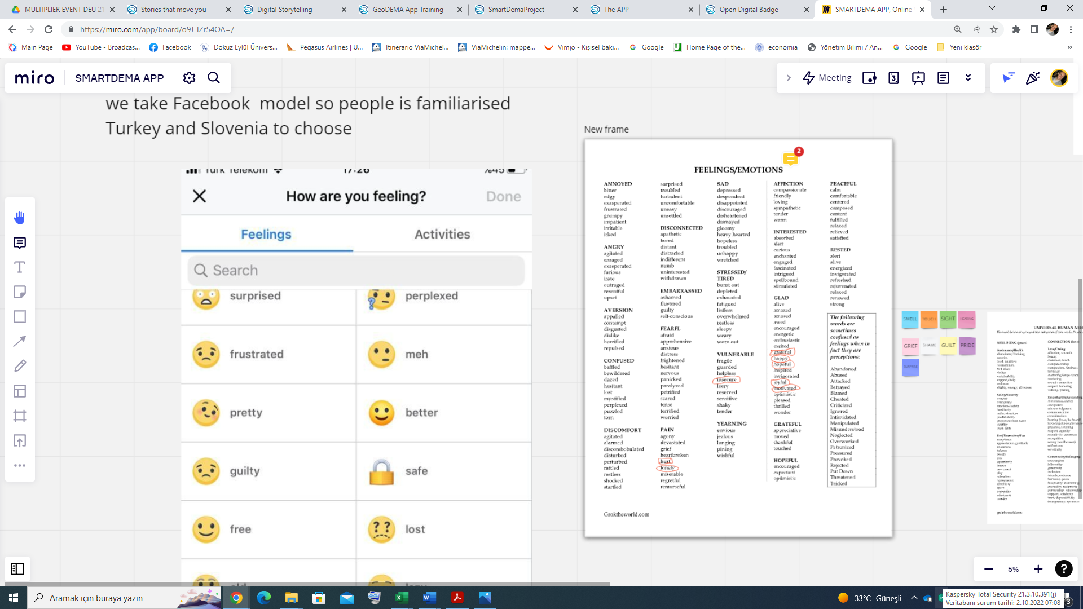
Accordingly, most cities are designed by urban planners and architects who leave their footprint through multiple buildings that become iconic pieces of cultural heritage. The SmartDEMA project question itself “what if citizens can leave their footprint in the form of emotions?” Then he discussed the creation of thematic maps, sense the city from a different angle and bringing into light muted voices.

This was followed by the last speaker Mr, Michel Mohor, creator of the National Gallery of Slovenia (Narodna Galerija), who introduced and presented their work for the project to the participants. The Gallery prepared nine thematic routes for the app. The routes were designed with Ljubljana’s visitors in mind - Ljubljana mostly hosts people who visit the city for one to two days and spend most of their time exploring the town on foot. In this way, thematic maps with instructions on how to get from one point to another are tourist added value. The team checked basic statistics on tourism both at the Gallery and for the city and programmed walkable trails that showcase different aspects of Ljubljana’s heritage: the UNESCO-protected Ljubljana embankment, the old and new fountains, works by Jože Plečnik, select baroque churches, monuments to people of note, both museums in the city and contemporary galleries where one can purchase a work of art, trails of Slovenian Impressionism with locations where some of their works were painted and, lastly, places connected to a Ljubljana native and Slovenian cultural icon, Ivana Kobilca. The routes elicit different emotions, mostly positive ones – Michel Mohor said that his research showed that people expected positive stories and would also post ones with such a tone.

As the last stage of the morning sessions of the event, the digital city marathon event called the 'city tour game' was introduced. Participants who wanted to experience the city tour were informed about museums, ruins, restaurants and event venues within walking distance of Izmir Mövenpick Hotel. They had 1 hour to visit the locations and share their stories on Smart Dema App. Fifteen participants visited the advised locations and shared their stories with SmartDema App. After the volunteer participants returned from the city tour game, the morning session ended at 1:00 pm for a lunch break.

The afternoon session started at 14:00. The first speaker, Aybala Selcen Doymuş from Foça District Directorate of National Education, presented their works to the participants. Firstly, the trip event at Foça with the students of Foça Reha Midilli Anatolian High School under the guidance of Ertan Aksoy was explained. Then, a video demonstration of Gluten Free and Vegan Kitchen Event for Virtual Nutritional Healthy Chef Events was held.

After Aybala Selcan Doymuş’s presentation, the moderation continued by Dr. Emir Özeren.
In this part of the event, ideas and feedback were exchanged on the experience of using the Geo Dema App. during the ‘City Tour Game’ made by the participants. The second multiplier event was completed at 16:30 with the completion of this session.

The event was carried out successfully to achieve multi-purposes: widespread dissemination of the project to the audience of the tourism community, information about the implementation of the Geo-Dema App, story sharing and route creation training, digital open badge concept, city tour game and user experience sharing activities. All sessions were recorded and photographed as evidence and source of information.

Annexes
Annex-1 Invitation letter
Annex-2 List of participants
Annex-3 Roll-up
Annex-4 Guests' badges
Annex-5 Brochure
Annex-6 Certificate of attendance
Annex-7 Project summary booklet

