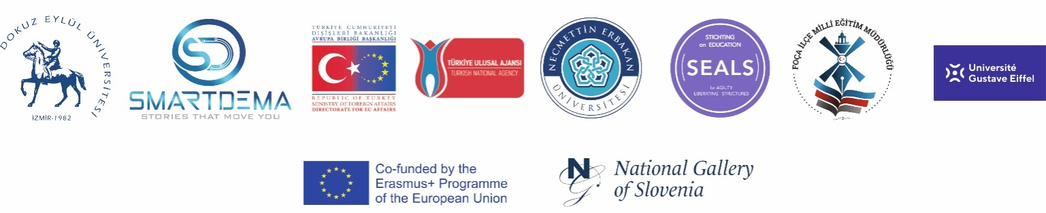

SMARTDEMA PROJECT MEETING
1 – 2 October 2021 / FOÇA
Minutes of Meeting and Photos

- The introduction and description of SmartDema Project
- The presentation of survey results analyzed by Foca National Directorate of Education
- Evaluation of the prominent and hidden elements on the survey study
- The Lecture of Foça History and cultural richness delivered by the guest speaker Sebahattin Karaçam
- Discussing the language of the stories to be created in the project
- Writing stories with a maximum of 600 characters and comments with 350 characters
- Determining the methods to be applied to evaluate the compatibility of the emojis used with the shared content
- Presentation by Daniel Weiss (Partner of SmartDEMA project) on the updated parts of the app and the process
- The importance of sharing emotions in the SmartDema application for the project and informing the target audience for content entry accordingly
- Contacting the İzmir Provincial Directorate of National Education so that the users are not only local but also from different environments.
- Organizing informative and promotional webinars and similar events for different groups and groups in the district in order to make a minimum of 250 posts from Foça until December 1, 2021.
- Communicating with stakeholders in order to increase the number of users and shares of the application
- Enriching the stories to be added to the application with images and videos
- Discussion of the reward system in the application
- Getting the application ready by October 15, 2021
- Meeting on social media accounts on October 4, 2021
- Gaining insights about the historical and cultural elements of Foça, whose content is planned to be created in the SmartDema application, by visiting the sea and land with the Author and Educator Cevat Yıldırım
- Discussing the activities to be carried out for the dissemination of the SmartDema application
- The next meeting (LTTA) will be held in France in January 2022
- Determination of the number of participants in the planned meeting in France
- Following updates on Miroboard
- Preparing vegan cuisine by January 2022

PHOTOS OF THE MEETING
