STORYBOOK COLLECTION
By Foça İlçe Milli Eğitim Müdürlüğü , Izmir, Türkiye
Project Number : 2020-1-TR01-KA203-09920
Duration : 01 September2020 – 31 August 2022(24 months)
Title of the Project : SMART Tourism Destination increasing citizen’s sentiment of sharing local tourism related values through gamification using emerging mobile Apps and SMALL Data analysis

1.

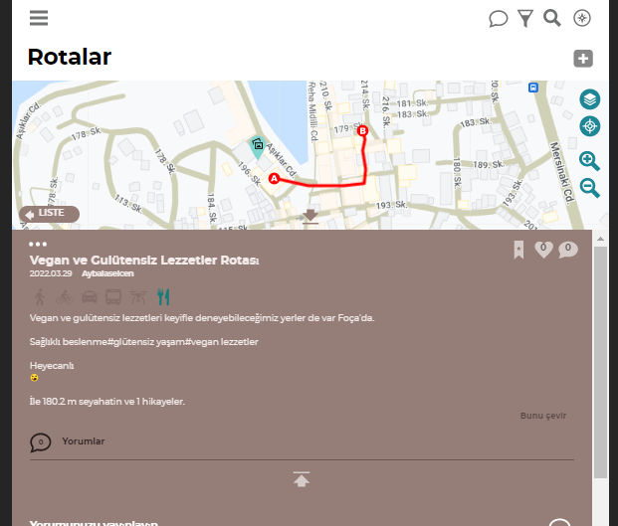
You can watch the beauties of Foça from the deep blue sea with short and long excursions by boats departing from the harbor. Who knows, maybe you will come across a Mediterranean Seal.

2.
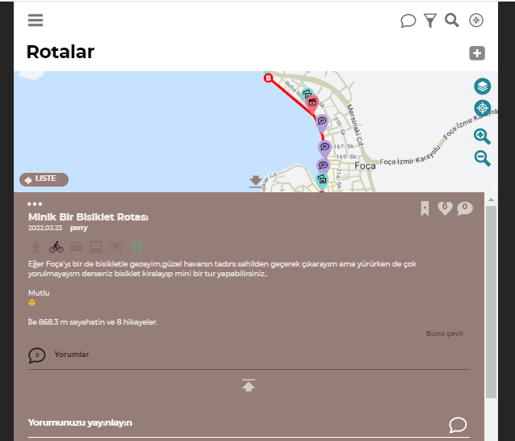
If you want to visit Foça with a bike and enjoy the beautiful weather by walking along the beach, but don't get tired while walking, you can rent a bike and take a mini tour.
3.

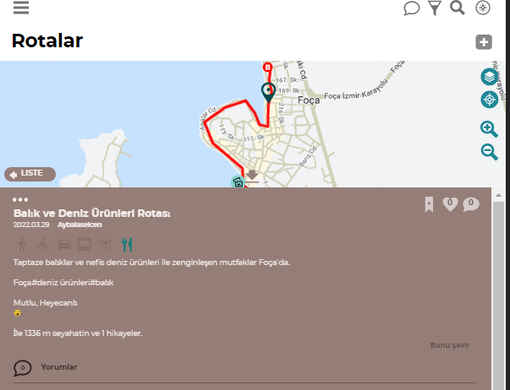

Cuisine enriched with fresh fish and delicious seafood is in Foça...
4.
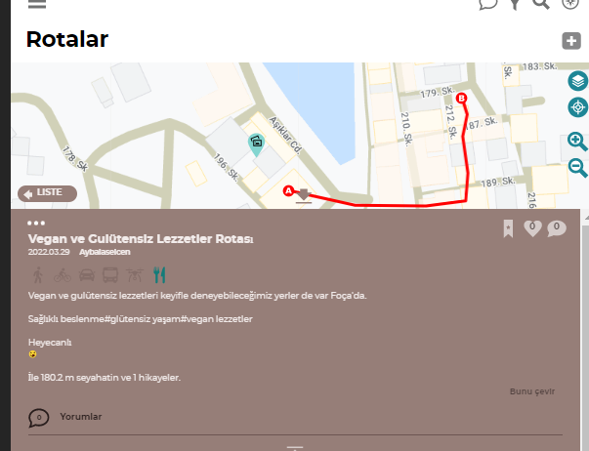
There are also places in Foça where you can enjoy vegan and gluten-free delicacies.

5.
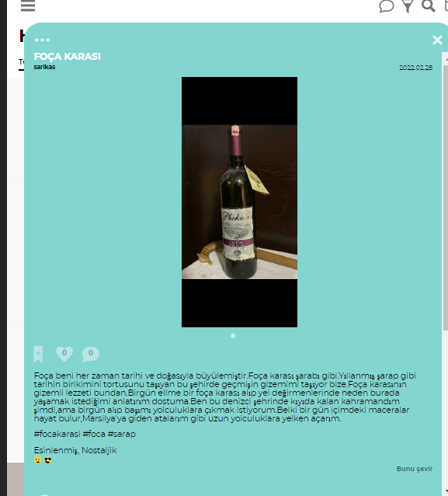
Foça has always fascinated me with its history and nature. Like Foça black wine. In this city, which carries the accumulation of history like aged wine, it carries the mystery of the past to us. The mysterious flavor of Foça land is due to this. Now I was the hero who stayed on the shore in this seafaring city, but one day I want to take my head and go on a journey. Maybe one day my adventures will come to life, I will sail on long journeys like my ancestors to Marseille.

6.
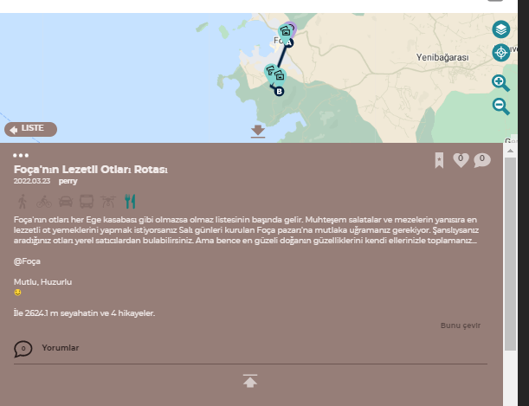
Foça's herbs are at the top of the must-have list like every Aegean town. If you want to cook the most delicious herb dishes besides the magnificent salads and appetizers, you should definitely stop by the Foça market, which is set up on Tuesdays. If you're lucky, you can find the herbs you're looking for from local vendors. But I think the most beautiful thing is to collect the beauties of nature with your own hands.

7.
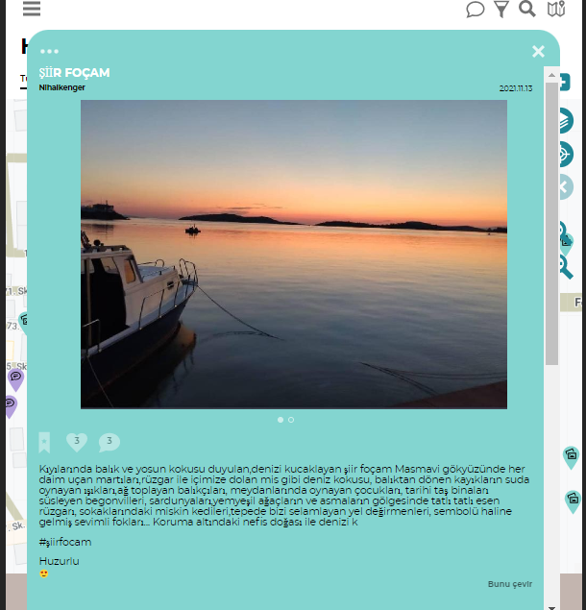
A poem that smells of fish and algae on its shores, embraces the sea... Seagulls flying all the time in the deep blue sky, the smell of the sea that fills us with the wind, the lights of the boats returning from the fish playing in the water, the fishermen collecting nets, the children playing in the squares, the bougainvillea and geraniums decorating the historical stone buildings, The gentle wind blowing in the shade of lush trees and vines, the sluggish cats in the streets, the windmills greeting us on the hill, the cute seals that have become its symbols... My Foça is a poem with its fabulous nature under protection.

8.
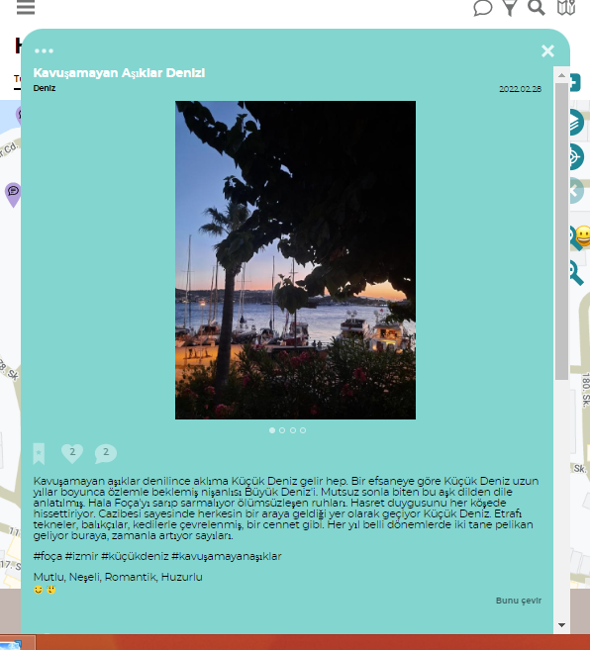
When it comes to lovers who cannot be reunited, I always think of the Little Sea. According to a legend, Küçük Deniz had longed for his fiancee Büyük Deniz for many years. This love with an unhappy ending has been told from mouth to mouth. Their immortal souls still surround Foça. It makes the feeling of longing feel in every corner. Thanks to its charm, the Little Sea is known as the place where everyone comes together. It is like a paradise surrounded by boats, fishermen and cats. Two pelicans come here every year at certain times, their numbers increase over time. There are lots of people in holidays. Many tourists come from far to feel the endless power of love. However I walk, live here everyday, and inhale its inspiring air. People coming here again and again are right, it is worthy to come here again.

9.
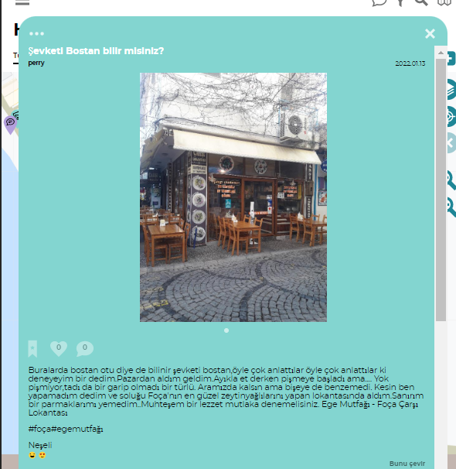
It is also known as bostan grass around here, they told so much about it, they told me so much that I thought I should try it. I bought it from the market and came here. When I said extract the meat, it started to cook. Just between us, but it didn't look like anything. I said that I couldn't do it for sure, and I took my breath in the restaurant that makes the best olive oil dishes in Foça. I think I didn't eat my fingers. Aegean Cuisine - Foça Carsi Restaurant.

10.
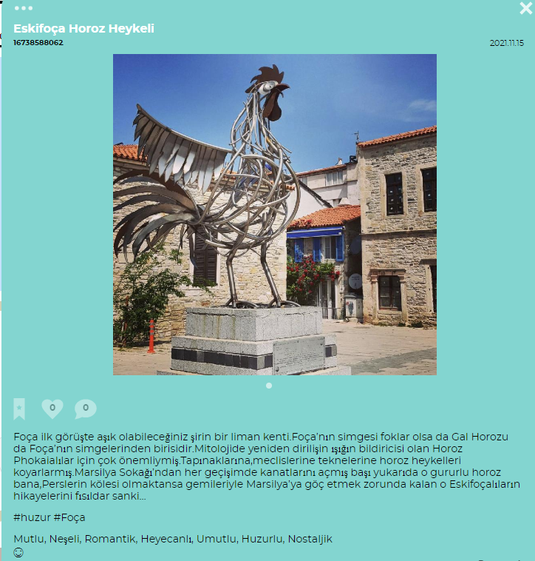

Foça is a cute port city where you can fall in love at first sight. Although the seals are the symbol of Foça, the Welsh Rooster is also one of the symbols of Foça. The Rooster, who is the notifier of the light of the resurrection in mythology, was very important for the Phokaians. They put rooster statues in their temples, assemblies, on their boats. From Marseille Street Every time I pass, that proud rooster that spreads its wings with its head up is whispering to me the stories of those Eskifoça people who had to migrate to Marseille with their ships rather than being slaves of the Persians…

11.
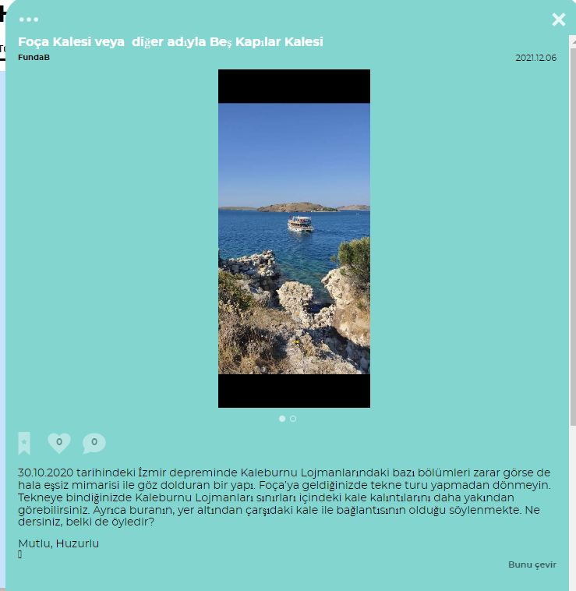
Although some parts of Kaleburnu Lodgings were damaged in the Izmir earthquake on 30.10.2020, it is still a stunning building with its unique architecture. When you come to Foça, do not leave without a boat tour. When you get on the boat, you can see the castle ruins within the borders of Kaleburnu Lodgings more closely. It is also said that this place has a connection with the castle in the underground market. What do you think, maybe it is?
12.
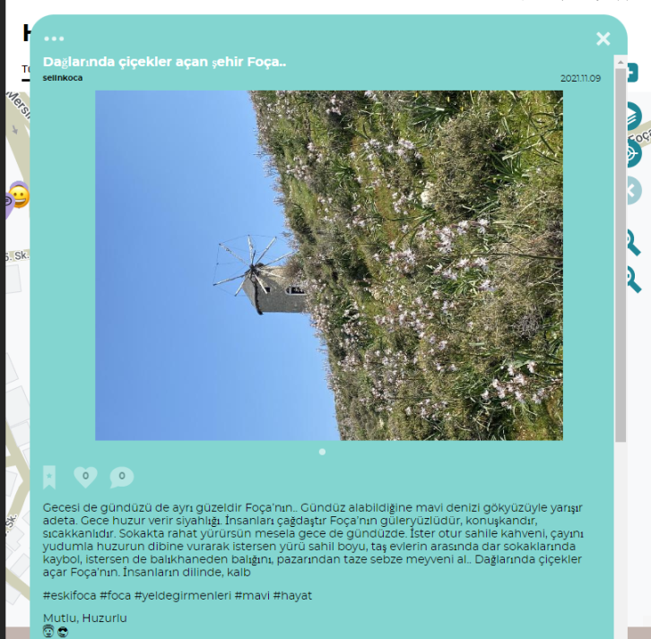
Foça is beautiful both at night and during the day. During the day, its blue sea almost competes with the sky. It gives peace at night. The people of Foça are modern, smiling, talkative and warm-blooded. You can walk comfortably on the street, for example, day or night. Whether you sit on the beach, sip your coffee, sip your tea and hit the bottom of the peace, you can walk along the coast, get lost in the narrow streets among the stone houses, or buy your fish from the fish shop, fresh vegetables and fruits from the market.. Flowers bloom in the mountains of Foça.
13.
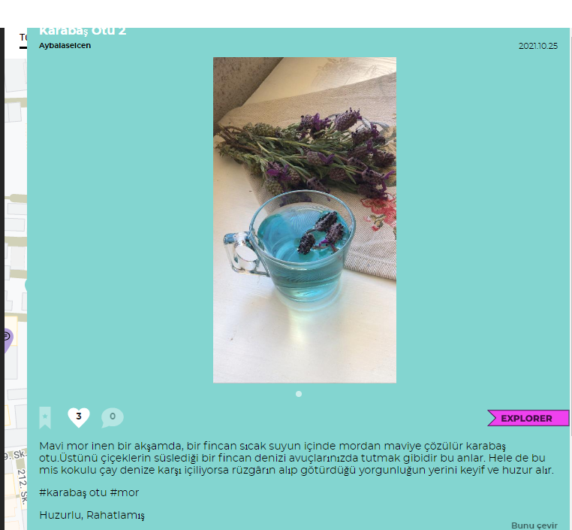
Black herb dissolves from purple to blue in a cup of hot water on a blue-violet evening. These moments are like holding a cup of sea decorated with flowers in your palms.
Especially if this fragrant tea is drunk against the sea, pleasure and peace take the place of the tiredness that the wind takes away.

14.
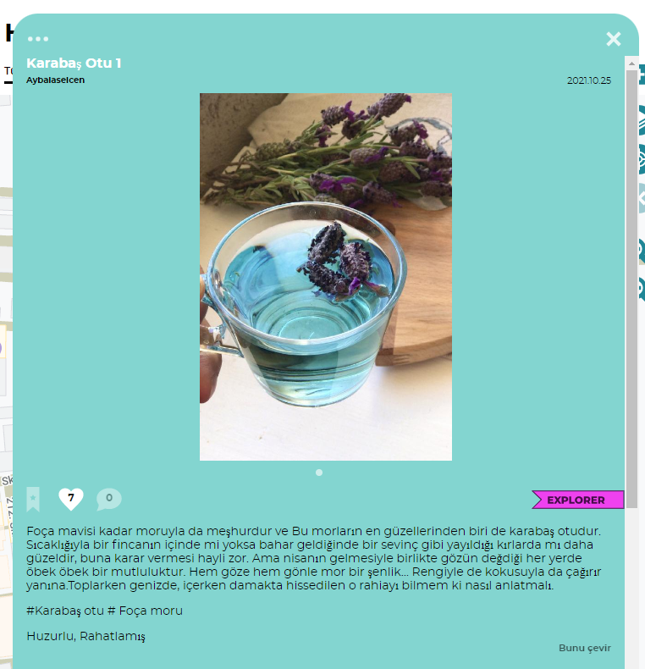
Foça is famous for its purple as well as its blue, and one of the most beautiful of these purples is black herb. It is very difficult to decide whether it is more beautiful in a cup with its warmth or in the countryside where it spreads like a joy when spring comes. But with the arrival of April, happiness is in abundance wherever the eye touches. A purple festivity for both the eyes and the heart... It calls to you with its color and smell. On a blue-violet evening, black herb dissolves from purple to blue in a cup of hot water. These moments are like holding a cup of sea decorated with flowers in your palms. Especially if this fragrant tea is drunk against the sea, pleasure and peace replace the tiredness that the wind carries away.
15.
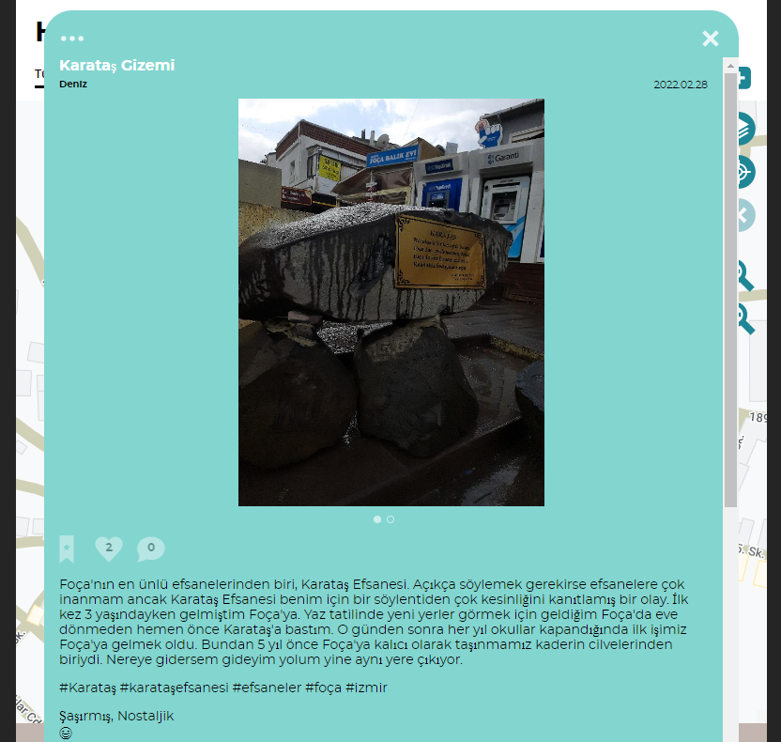
One of the most famous legends of Foça is the Legend of Karataş. To be frank, I don't believe in legends much, but the Legend of Karataş is more of a proven event than a rumor for me. I came to Foça for the first time when I was 3 years old. In Foça, where I came to see new places during the summer vacation, I stepped on Karataş just before returning home. After that day, when the schools closed every year, the first thing we did was to come to Foça. It was one of the twists of fate that we moved to Foça permanently 5 years ago. Wherever I go, my path still leads to the same place.

16.
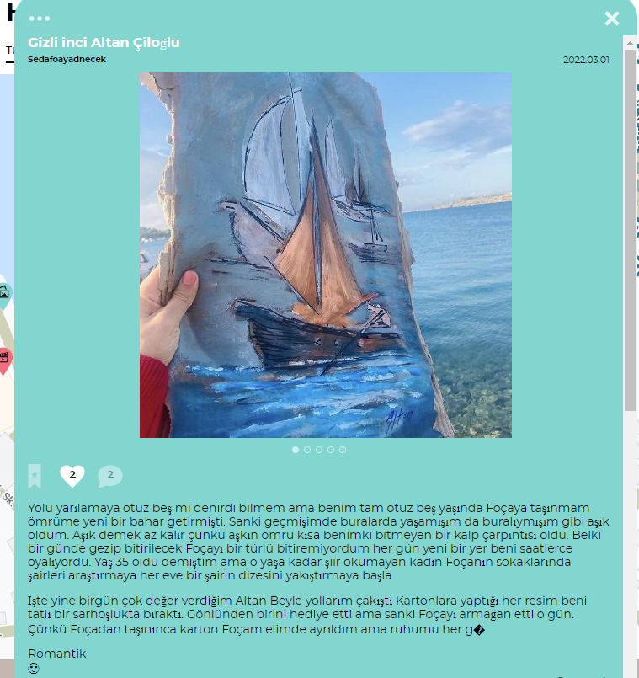

I don't know if halfway through was called thirty-five, but my moving to Foça at the age of thirty-five brought a new spring to my life. I fell in love as if I lived here in my past and I was from here. It would be an understatement to say that you are in love because the life of love is short, mine has been an unending heart palpitation. Maybe I could not finish to learn Foça, which could be visited in one day. Every day a new place kept me busy for hours. I said that she was 35 years old, but the woman who did not read poetry until that age, start to search for poets in the streets of Foça, and to attribute a poet's verse to every house. Here again, one day, my paths crossed with Altan, whom I value very much. Every painting he made on cardboard left me in a sweet drunkenness. He gave a gift from his heart, but it was as if he gifted Foça that day.

17.
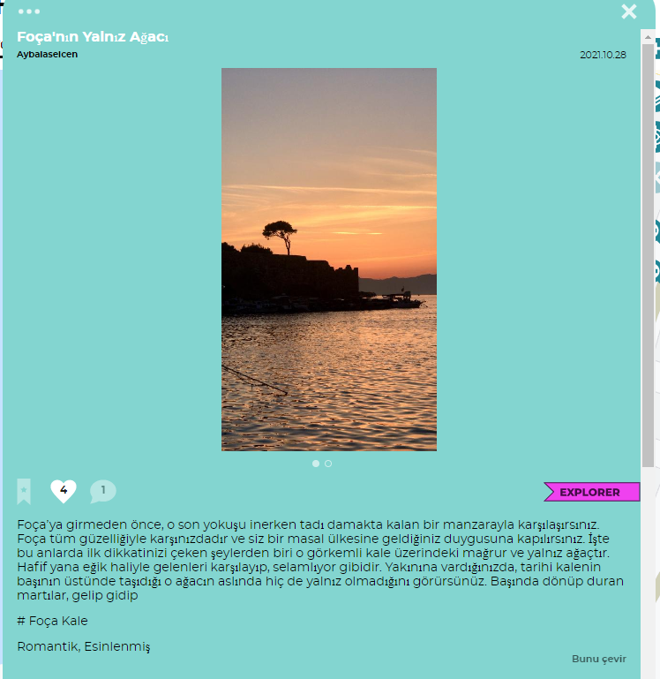

Before you enter Foça, you will come across a view that tastes good as you descend that last slope.
Foça is in front of you with all its beauty and you get the feeling that you have come to a fairyland. At these moments, one of the first things you notice is the proud and lonely tree on that magnificent castle. It is as if she greets those who come with a slight bow. When you get close to it, you will see that the tree that the historical castle carries on its head is not alone at all.
18.
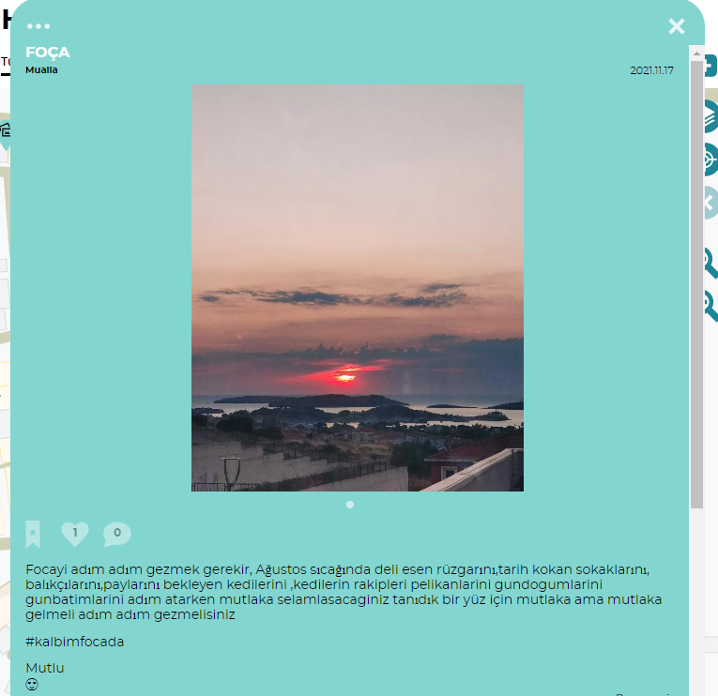
It is necessary to wander Foca step by step.You should definitely come and visit step by step for a familiar face that you will definitely greet as you step through the heat of August, its crazy wind, its streets smelling of history, its fishermen, its cats waiting for their share, the rivals of cats, their pelicans, their sunrises and sunsets. You should come and wander to say hello to familiar ones.
19.
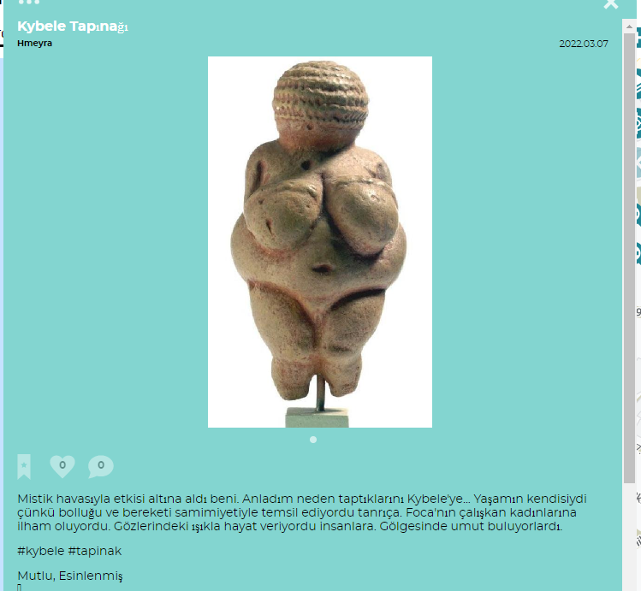
It enchanted me with its mystical aura. I understood why they worshiped Cybele... Because she was life. The goddess represented abundance and fertility with her sincerity. She was an inspiration to the hardworking women of Foca. She gave people life with the light in her eyes. They found hope in her shadow.
20.
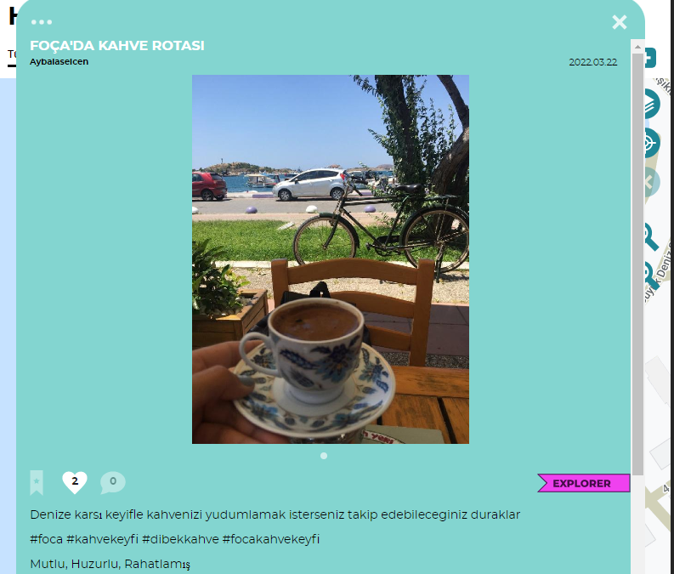
If you want to sip your coffee with pleasure against the sea, you can find lots of stops you can follow...

21.
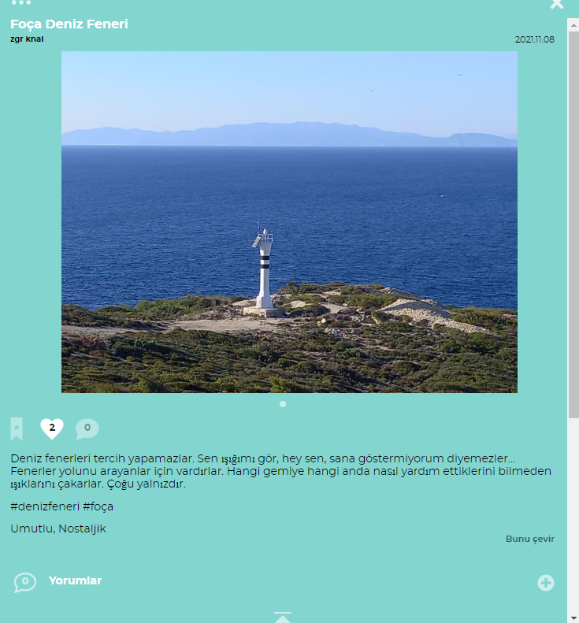
Lighthouses cannot choose. They can't say you see my light, hey you, I'm not showing youmy light... Lanterns exist for those who seek their way. They flash their lights without knowing how they are helping which ship at what time. Most are alone.

22.

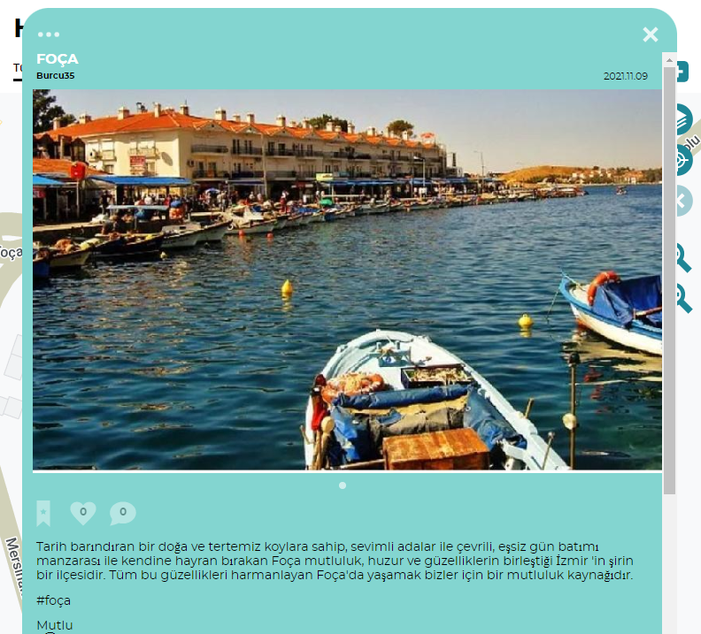

A small coastal city that stands out with its calmness by the sea. While walking around its narrow streets, you suddenly find yourself in the place where fishermen and fish restaurants are located. As if you have lost your way, you turn around and come to the same place. But every time you see it, you will be amazed by this view again and feel that it gives you peace. Even though this view is the same at nightfall, you become a prisoner of different emotions that it makes people feel. Life in Foça is the name of peace, happiness and calmness.
23.
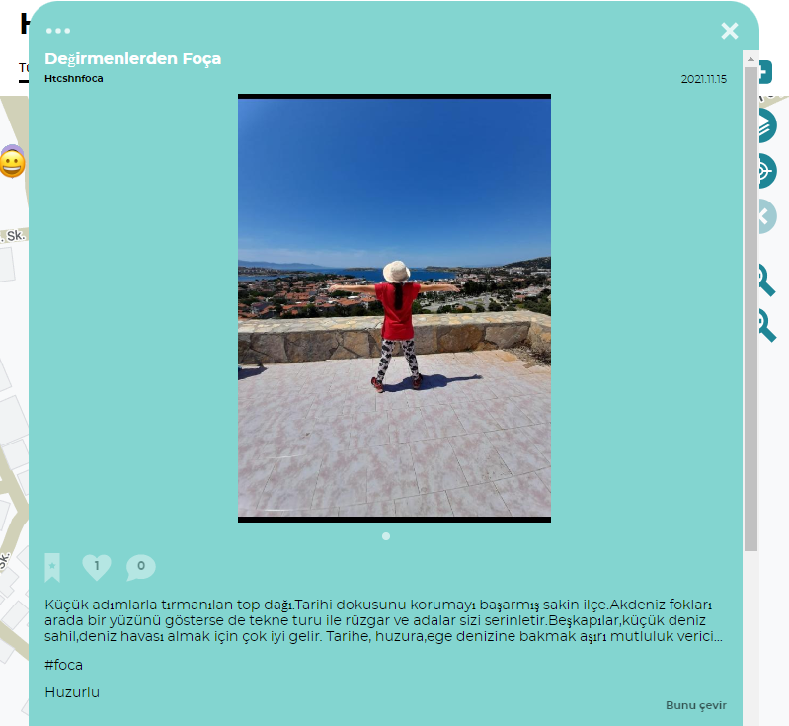
Top mountain climbed with small steps. A quiet town that has managed to preserve its historical texture. Even though Mediterranean seals show their face once in a while, the wind and the islands cool you off with a boat tour. Beşkapılar, the small sea coast, is very good for getting the sea air. It is extremely pleasing to look at history, peace, and the Aegean Sea...
24.

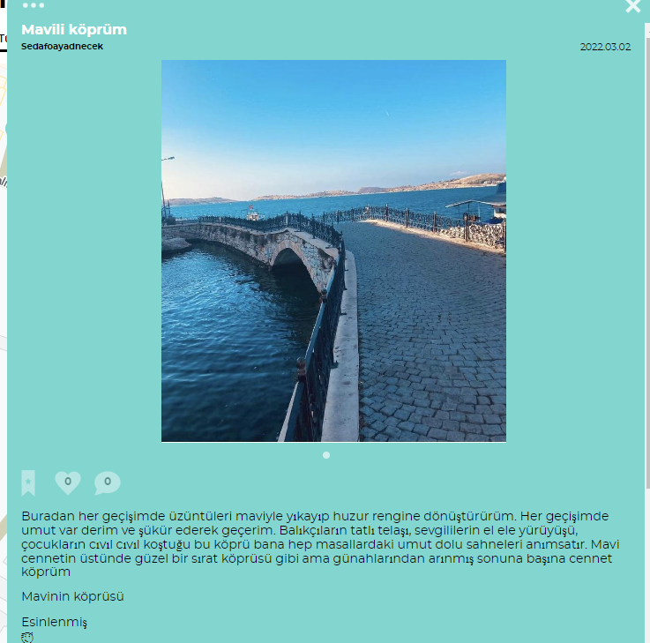
Every time I pass from here, I wash the sadness with blue and turn it into the color of peace. Every time I pass, I say there is hope and I pass with gratitude. The sweet bustle of fishermen, lovers walking hand in hand, and this bridge, where children run chirping, always reminds me of hopeful scenes in fairy tales. It's like a beautiful sirat bridge over the blue heaven, but it's my heavenly bridge to the from sins.

25.
. 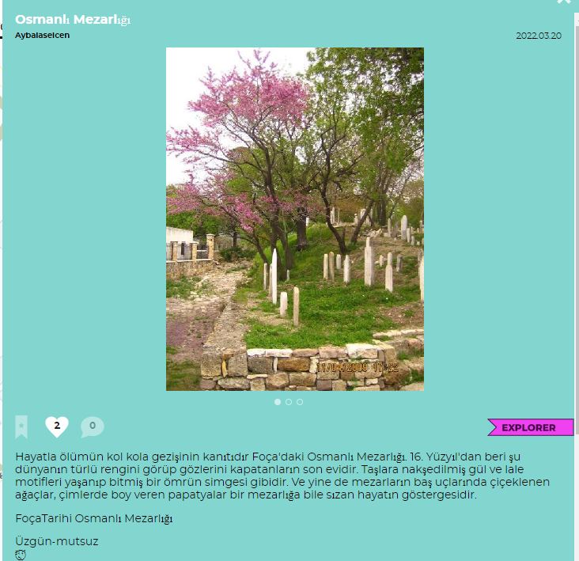
The Ottoman Cemetery in Foça is the proof of life and death walking hand in hand. Since the 16th century, it has been the last home of those who have seen the colors of this world and closed their eyes. The rose and tulip motifs engraved on the stones are like the symbol of a lived life. And yet, the trees blooming at the head of the graves and the daisies blooming in the grass are the indicators of the life infiltrating even a cemetery.
26.
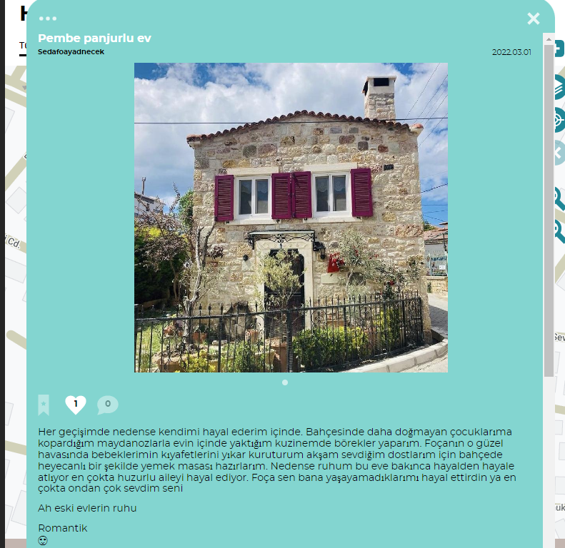
For some reason, I imagine myself in it every time I pass. I make pastries in my kitchen, which I burn in the house with the parsley I pluck for my children who are not yet born in the garden. In the beautiful weather of Foça, I wash my babies' clothes and dry them, and in the evening I prepare a dinner table excitedly in the garden for my dear friends. For some reason, when my soul looks at this house, it jumps from dream to dream, mostly dreaming of a peaceful family. Foça, you made me dream of what I couldn't live, most of all I loved you more than him
Oh the spirit of old houses
27.
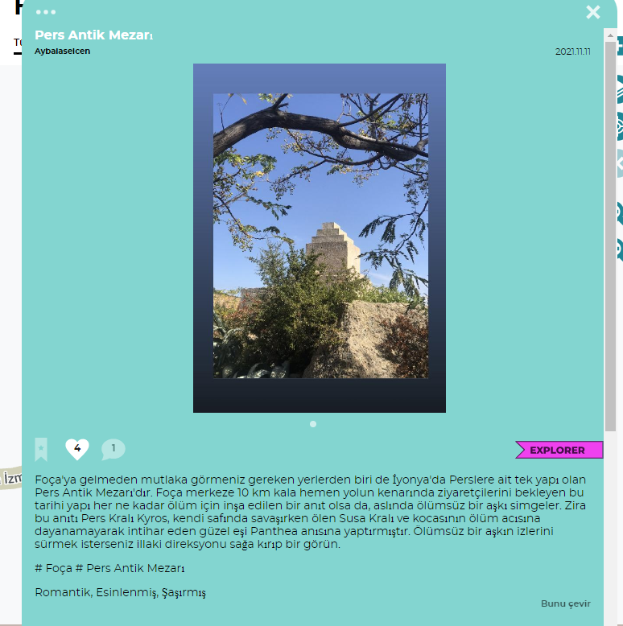
One of the places you should definitely see before coming to Foça is the Persian Ancient Tomb, which is the only Persian building in Ionia. 10 km from Foça center, this historical building waiting for its visitors by the side of the road, although it is a monument built for death, actually symbolizes an immortal love. This is because the Persian King Kyros had this monument built in memory of the King of Susa, who died while fighting on his side, and his beautiful wife, Panthea, who could not stand the death of her husband and committed suicide. If you want to follow the traces of an immortal love, you must turn the steering wheel to the right and have a look.

28.
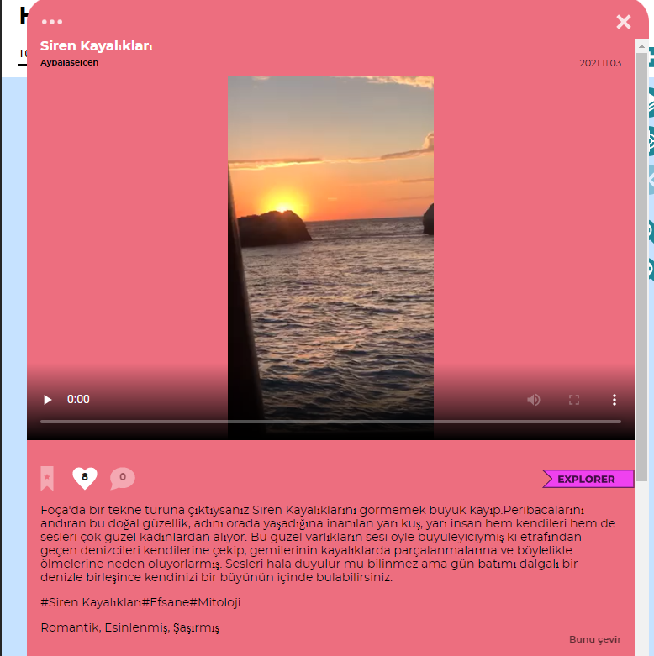
The evenings when the clouds and the sea bid farewell to the sun..It is the most beautiful time in Foça..Don't forget to take your coffee with you..The sips you drink while greeting the fishing boats, which are the scattered toys of the sea, will wipe everything out of your mind. They say that Izmir will make you forget thanks to evenings like this.
29.
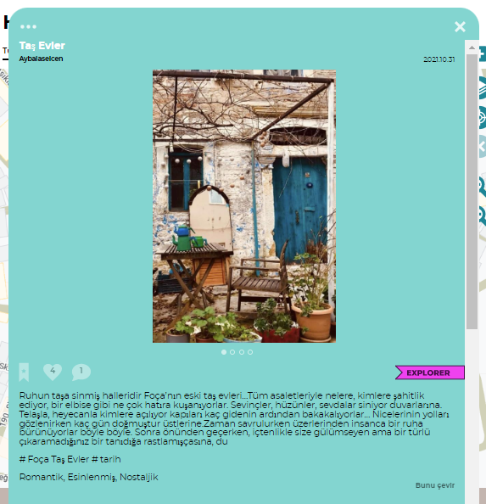

Foça's old stone houses are the state of the soul permeated in stone… With all their nobility, they witness what and who they are, and how many memories they wear like a dress. Joys, sorrows, loves permeate their walls. They open their doors with excitement and excitement. Then, as you pass by, you smile as if you run into an acquaintance who is smiling at you sincerely but you can't get it out. Something gets more beutiful as they get older.

