SUSTAINABILITY PLAN
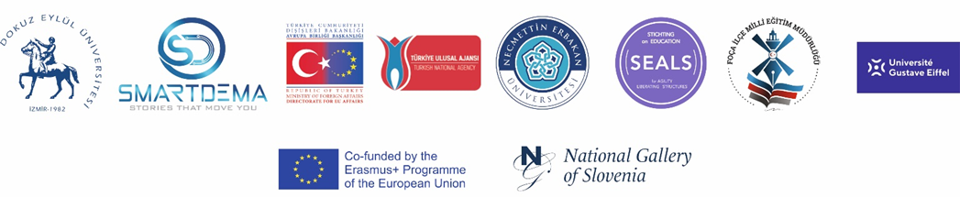

SMARTDEMA is a project funded by the European Commission under the Erasmus+ programme (KA2-Cooperation for Innovation and Exchange of Good Practices, Strategic Partnership for Adult Education). The project is a transnational initiative involving six organisations from four countries: Turkey, France, the Netherlands, and Slovenia. The project has an overall and sustainable impact on all partner organisations, schools, students, teachers, various educational institutions and local communities, as well as a new list of potential stakeholders in the tourism industry at the multi-level, including tour operators, academics, tour-guides and hotels willing to use and adopt the digital mobile application (called SMARTDEMA App.) developed as one of the most concrete outcomes of the project. Ljubljana as city Capital and its integration into other touristic city networks brings a broader perspective that helps the project on sustainability and impact in the implementation clues on other Turkish cities based on the project experience. In this regard, the aim of this plan is to put forward certain specific activities and results that will be maintained after the end of the EU funding. The plan highlights important steps and initiatives project partners have taken thus far for future impact and transferability of the project results and how they ensure the resources to sustain them.
The project supports the transformation of the city and the actual teaching of the tourism model at Destination Management. It implements new learning skills and digital assessment through Open Badges (Intellectual Output 2), which continue to be available to access for all relevant parties who want to get rewarded. It introduces concepts of innovation, technology, sustainability and accessibility to guarantee the present and future of tourism. All Open Badges created in the project are valid in the Universities, Schools and National Galleries. DEU and Foca District Directory of National Education become a referent in the Open Badge giving support to other educational institutions. The tourism ecosystem is involved in the creation of some specific Badge (Digital Destination Management), generating a win-win situation. Open Badge SMARTDEMA is a versatile, sustainable system for organizations wanting to learn how to create Open Badges. The experience collected in the project innovation is transformed in the Badge.
The National Gallery of Slovenia (Narodna Galerija) prepared a digital badge that focuses on the museum’s permanent collection in order to align the SMARTDEMA project goals with the strategic aims of the Gallery to ensure the sustainability of the Erasmus+ project’s results. The aim of the digital badge is to be available to all who visit the SMARTDEMA website or the website of the National Gallery of Slovenia, with no need for registration - the user merely has to put in her/his e-mail address to receive the certificates and the badge. The National Gallery of Slovenia systematically automated the entire learning and quiz process; staff only needed to issue the badge to each individual user. In this way, the Gallery made the digital badge sustainable for the future, with no fear that a change in gallery staff or programmes would render the badge obsolete. The National Gallery of Slovenia (Narodna Galerija) used its previous experiences with digital games to design the open badge (IO2): the Gallery operates an interactive app. that features several gamified aspects (finding a work of art, answering questions about it, connecting general knowledge with art history through multiple choice answers, left/right swipes, puzzles). The Gallery also saw great feedback for its weekly Instagram quiz that attracts hundreds of responders. The SMARTDEMA project thus allowed the museum’s digital cultural heritage operators to learn about a new way to gamify the museum experience and make the knowledge one gains in it certifiable and available on multiple platforms.

The project proposes an innovative and sustainable implementation of the vibrant tourism experience of the partners’ countries and increases citizens’ sentiment of sharing local tourism-related values and co-creation of geo-referenced stories very connected to smart tourism city and concept. Most cities are designed by urban planners and architects who leave their footprint through multiple buildings that become iconic pieces of cultural heritage. The SMARTDEMA project question itself “what if citizens can leave their footprint in the form of emotions?” Based on the abovementioned point that has not been sufficiently taken into account in smart city discussions, the project creates various thematic maps, senses the city from a different angle and brings into light their muted voices and hidden stories. In terms of sustainability, emotion/thematic maps can help us understand the personal, emotional relationship that people currently have with personally meaningful places in the city and explores the potential and value of sharing this personal geo-located emotion data with other people in novel ways shortly.

The project designed and created a custom-made free download mobile App named GEO-DEMA and implemented training and “Small Data software analysis” to perform new smart tourism-related services called SMARTDEMA (Smart Destination Management). Instead of big data that is driven by machine interpretation, the project addresses small data to understand the real needs and behaviours of the visitors. A series of thematic maps are created based on the stories (data) created by the citizens (own sentiment of shared and valued) and the insights of the visitors (data) collected in the App. while unravelling the digital stories.
The point reached in the tourism industry is not only to provide a service but also to create new, authentic, unique and unmemorable experiences that can stir emotions. To achieve this purpose, a digital application was developed to understand the emotion-based experiences of the destination, which offers the opportunity to express the emotion of the destination through the stories that users share about the places. In terms of sustainability, this project is indeed important to shed some light on investigating people’s emotions by drawing on their stories linked to different places in cities. Remarkably, emotions lie at the very heart of the tourist experience in destinations. Moreover, people are increasingly co-creating the destination with the digital age by constructing a digital dialogue using a specific App. about the city. Such a smart destination application makes it possible to link users’ emotions about important life experiences held by the inhabitants, locals and visitors with places in the city through geolocation. Thanks to the free mobile application called SMARTDEMA, even after the project, people will still be able to access the app. and enjoy the "emotional routes" of the city and discover which emotion is experienced more intensely in which destination. Thus, people will be able to travel to places and destinations that they think best reflect the emotion they want to feel. The users of the SMARTDEMA App. who could be locals, tourists or visitors can have the great potential to discover places they never knew existed right in their neighbourhood. Local impact and sustainability are granted.
Destination management faces the challenge in an ever-changing environment dominated by the new digital economy, with a tourist profile that is much more demanding and informed, hyperconnected and multi-channelled. Therefore, a new training program on Digital Destination Management (SMARTDEMA) was created to manage new demanded digital experiences. The new training program created by DEU enables us to add/co-create/reinvent the city with layers of information and services that do not exist today.

SMART tourism responds to new challenges and demands in a fast-changing sector, including the expectation of digital information, products and services; equal opportunities and access for all visitors; sustainable development of the local area; and support to creative industries and local talent. The project enhances the actual Destination Management program at Dokuz Eylul University. It creates a new training framework (Digital Destination Management) focused on digital city tourism connecting several actors ranking from citizens, education systems and stakeholders to co-create and deliver a unique training and service experience supported by mobile technologies.
DEU provides the right scenario and knowledge (undergraduate programs and students) for designing, prototyping, and implementing the project results in a broad ecosystem. The fact that DEU ranked 1st in Turkey and is amongst the top 100-150 universities in the world for “Hospitality and Tourism Management” in the Academic Ranking of World Universities List (Shanghai Ranking) in 2022 brings added value for the transferability, impact and sustainability of the project since DEU implements the results of the project at multilevel. Having two prototypes at the end of the project, one in Izmir and one in Ljubljana will enable us to compare experiences having a broader and sustainable impact on the project both in Turkey and in Europe that can be transferred to other cities afterwards.
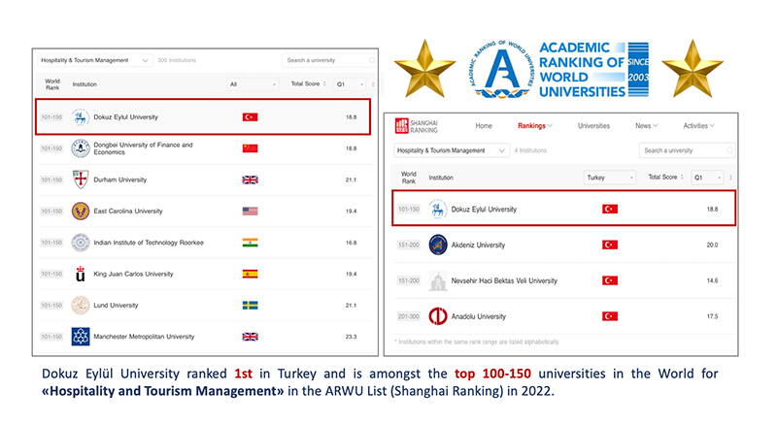
In terms of sustainability, the outcomes of the project will be used as a basis to improve the curriculum of the Tourism Management undergraduate program in the Faculty of Tourism at DEU. The digital destination management training program, mobile application and project output documents developed within the scope of SMARTDEMA were adopted in the course titled TUR 4028 Destination Management at the undergraduate level.
Lecture and case analyses, story and route creation, gamification experience and exercises through the SMARTDEMA mobile app. are planned learning activities and teaching methods in the aforementioned course. In this way, students will be able to learn more effectively how visitors can explore and experience any tourism destination through an emotion-based digital application. The detailed course description (TUR 4028 Destination Management) and course catalogue can be found via the following links:
https://debis.deu.edu.tr/ders-katalog/2022-2023/eng/en_9824_9824_229.html (English Version)
https://debis.deu.edu.tr/ders-katalog/2022-2023/tr/tr_9824_9824_229.html (Turkish Version)
Besides, the case studies, which will be the product of the SMARTDEMA project, will be incorporated as teaching material into the main curriculum of the undergraduate program at DEU. These case studies will also be used for the bachelor course titled “TUR 4039 Case Studies in Tourism” in the same university where the project coordinator is a permanent faculty member.
All the results and outcomes, including the training program, are uploaded on the project website, which will remain open for full access (Please check the link of the project website for Intellectual Outputs, including results and outcomes: https://smartdemaproject.org/ ) It will be supported even after the end of the project. Apart from that, information and links to the above-mentioned results will be published on relevant sites for educators as well as in eTwinning and Erasmus+ dissemination platforms. That will ensure the long-term sustainability and availability of the project. The outputs of the project will be presented at renowned international conferences to share the results with the academic community and to have their invaluable feedback aiming to better reflect their sound criticisms of the project. Apart from the presentation at conferences, the project outputs will be extended and circulated through practitioners, NGOs, and trade associations by organizing thematic workshops in partner countries.
Associated Partners in SMARTDEMA are the organizations (e.g. TURSAB, ETİK, Directorate of Izmir Culture and Tourism, Bled Municipality, Bohinj Municipality, Radovljica Municipality) which are relevant to the project in terms of area of expertise and, at the same time, are interested in providing professional support to the project and are able to offer valuable input for the development of project outputs. Thus, Associated Partners may bring a significant contribution to the sustainability of the project outputs. Their involvement is crucial for developing, implementing and sustaining the outputs of the projects.
They were actually invited to project dissemination events and multiplier events in order to ensure ownership after the project end, thus guaranteeing the durability and ensuring the leverage effect of the project outputs and result. DEU and all partners will be in close contact with them in the planning and implementation of the project activities. The project outcomes will be disseminated through target local communities in the region by actively organizing workshops. In this regard, the industry, policymakers and local communities in the region will facilitate outreach to the expected outcomes of the project. The outputs of the project will be more likely to turn into strong publications in prominent scholarly journals.
The sustainability plan was prepared in two main categories: organizational and community sustainability. Community sustainability is how the community carries out the project activities even after the project is completed. Namely, more than 60 stories have already been created by Izmir (DEU) and Ljubljana (Narodna Galerija) cities based on storytelling training. After the project, the trained staff will continue to share their knowledge with other academics, teachers and students in their communities being embedded in Google maps and located virtual and physically in the territory, delivering a new mobile destination experience. In this way, the project will continue to reach an additional 100 stories with the indirect beneficiaries one year after official project activities are completed.
Organizational sustainability is how the partners by themselves continue to function after the project. They will go on using SMARTDEMA social media platforms to publicize the new stories and the updated App, and also help attract new users and stakeholders. The hosting fee for the created website (online platform) has been paid in advance, and it is guaranteed that it will remain active even after the project is completed and that its technical infrastructure will continue to be supported by partners. It is foreseen to keep the relevant content up-to-date and to continue using this infrastructure with the use of similar project outputs. Partners will continue to share the project outputs and activities through social media, Facebook, Instagram and Twitter. The created website and digital application (SMARTDEMA mobile app.) will be open to use by the public freely and remain active, and partners will be able to upload new information and share materials and announcements with their target groups and key stakeholders even after the project is closed officially.

SMARTDEMA ERASMUS+ Project (2020-1-TR01-KA203-092920)
The Official Web Site: | https://smartdemaproject.org/
Motto of the Project: | “Stories that move you”
Social Media Accounts: | : smart_dema  : smart_dema  : smartdemaproject
SMARTDEMA Mobile App. | https://smartdema.org/

The involvement of local stakeholders is foreseen in the city of Izmir, connected to the Department of Tourism Management and the Department of Gastronomy & Culinary Arts at Dokuz Eylul University. The involvement of local stakeholders to gain impact and sustainability is going to be included by asking them to publish the digital marathon poster in their networks. The involvement of the citizens is foreseen in Izmir (DEU & FOÇA MEM) and Ljubljana (Narodna Galerija) for the creation of digital stories. The involvement of visitors is foreseen in two digital events through multiplier events. Once the training tools are available in the community of professionals they can be used, replicated or adapted to new forms in unpredictably ways, reaching an indefinite number of people. Apart from that, a core contribution is defined by the French Partner (Université Gustave Eiffel) since their expertise on the impact of Disney in the city and how the digital stories were put in place for the transformation of the tourism ecosystem attracting new visitors. Through Digital storytelling and Virtual Smart Destination Management training have an impact on the educational level since the model can be replicated for educational purposes for any content. Furthermore, the transferability impact is high because trained teachers can train other teachers and then replicate on cascade the learning experience. Through teachers, a broader community can be engaged to enhance the digital stories, create new ones or give insights into the existing ones.
The network of this project will also become a space where the organizations will be able to share the difficulties they have met during implementation and its obtained results. Actually, this does not need additional resources. It would be good if it is possible to organize an annual meeting between the organizations involved in the project to maintain a strong network strictly connected. To reach this aim the project partners need additional resources to pay the cost of the mobility. Therefore, the partners are planning to apply for some other related projects as a complimentary to SMARTDEMA results in the near future to develop their existing transnational cooperation into the future step.
DEU, as the beneficiary of the project (Applicant and Coordinator Institution), aims to apply for TUBITAK 1512 Entrepreneurship Support Program in order for entrepreneurs to transform their technology and innovation-oriented business ideas into enterprises with high-added value and qualified employment creation potential, activities from the idea stage to the market are supported, thus encouraging qualified entrepreneurship and producing innovative products with high technology level with international competitiveness. It is aimed to create start-up companies that can develop innovative services.
In this regard, entrepreneurship training (DETTOBİGG Program) was provided to the project team, and key staff of DEU within the scope of the program, and technical, commercial and administrative support was provided with industry-experienced guides. The poster of the event specifically designed for this purpose and SMARTDEMA news and announcements published on the official website by the DEU Faculty of Tourism can be seen below. Thus, university students and tourism industry professionals who are interested in smart tourism and digitalisation can easily review the project results, outputs and achievements through the pages of the DEU Faculty of Tourism online portals.

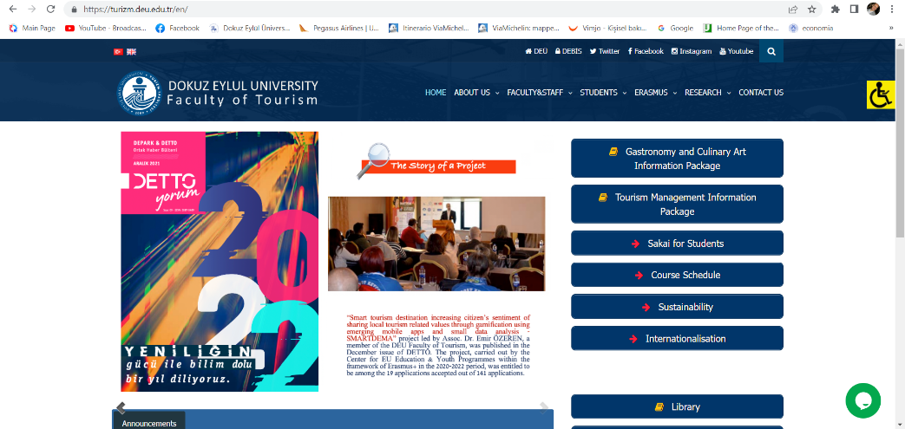

https://turizm.deu.edu.tr/en/internationalisation/
https://turizm.deu.edu.tr/wp-content/uploads/2022/03/SMARTDEMA-WEB-Sitesi-Tanitim-Yazisi-EN.pdf
https://turizm.deu.edu.tr/wp-content/uploads/2022/03/SMARTDEMA-WEB-Sitesi-Tanitim-Yazisi-TR.pdf

