“SMART Tourism Destination increasing citizen’s sentiment of sharing local tourism related values through gamification using emerging mobile Apps and SMALL Data analysis- SMARTDEMA”

AGREEMENT n° 2020-1-TR01-KA203-092920

SURVEY REPORT
for the identification of Foça destinations

In order to plan the historical, cultural and local elements that will be the subject of the stories to be created for Foça in the SmartDema Project, a questionnaire was developed for the teachers working in the schools affiliated with the Foça District Directorate of National Education, Izmir, Turkey.

In the survey study, a list of 30 items about Foça was prepared for the participants and they were asked to choose 12 topics that they thought represented Foça.

164 people have participated in the survey.
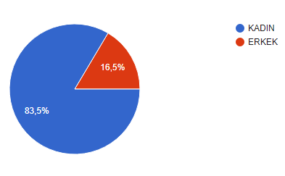

Gender
%83,5 Woman
%16,5 Man

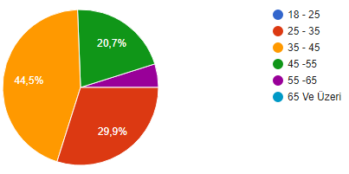
Age
%44,5 between 35 – 45
%29,9 between 25 – 35
%20,7 between 45 – 55
%4,9 between 55 – 65

Inhabitancy
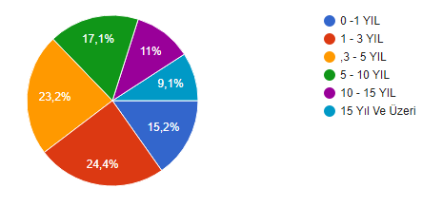
%24,4 between 1 -3 Years
%23,2 between 3 -5 Years
%17,1 between 5 -10 Years
%15,2 between 0 -1 Years
%11 between 10 -15 Years
%9,1 15 Years and more

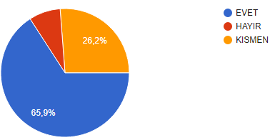
Rates of having positive emotions about Foça
%65,9 Positive emotions
%26,2 Partially positive emotions
%7,9 Negative emotions

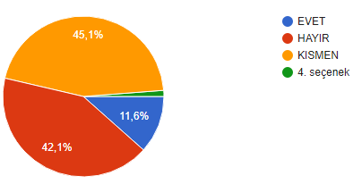
Rates of respondents feel that there is sufficient Foça promotion

%45,1 Partially enough
%42,1 Not enough
% 11’6 Enough

Rates of respondents' preferences for Foça to be a global value
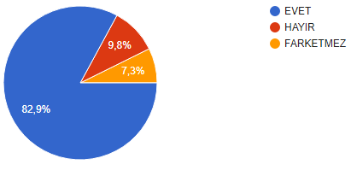
%82,9 Yes
%9,8 No
%7,3 Not matter

In order to represent Foça, the participants were asked to choose the 12 most preferred items out of 30 options.
According to the findings, the most preferred ones, the percentage order and the additional items specified by the participants are as follows:

1. %84.1 YELDEĞİRMENLERİ
2. %82,9 TAŞ EVLER
3. %70,7 – FOÇA KOYLARI
4. %68,9 BEŞ KAPILAR KALESİ
5. %68,3 – AKDENİZ FOKU
6. %64 – SİREN KAYALIKLARI
7. %55,5 PERS MEZAR ANITI
8. %53 – KARATAŞ
9. %48,8 KOZBEYLİ KÖYÜ
10. %43,3 FOÇA ANTİK TİYATRO
11. %41,5 PHOKAIA ANTİK KENTİ
12. %34,1 – KİBELE TAPINAĞI
13. %32,9 – MARSİLYA MEYDANI
14. %30,5 – ORAK ADASI
15. %29,9 EGE OTLARI
16. %25,6 – SU KEMERLERİ
17. %20,7 – ATHENA TAPINAĞI
18. %20,1 – OSMANLI MEZARLIĞI
19. %15,9 – FOÇA FRİGYA TEPESİ
20. %15,2 – GAL HOZORU
21. %14,6 – SARI KANTORON
22. %14,6 – FATİH CAMİİ
23. %14 – DIŞ KALE
24. %13,4 – KARABAŞ OUT
25. %13,4 – GOPEZ BALIĞI
26. %12,8 – YERYÜZÜPAZARI
27. %9,1 – ŞEYTAN HAMAMI
28. %8,5 – KAYALAR CAMİİ
29. %4,9 – AĞALAR KONAĞI
30. %4,9 – PRUVAT ÇİÇEĞİ
Additional items:
- KARADUT SUYU
- BALIK
- GEDİZ DELTASI
- DAĞ ÇİLEĞİ
- KOCAMEHMETLER KÖYÜ

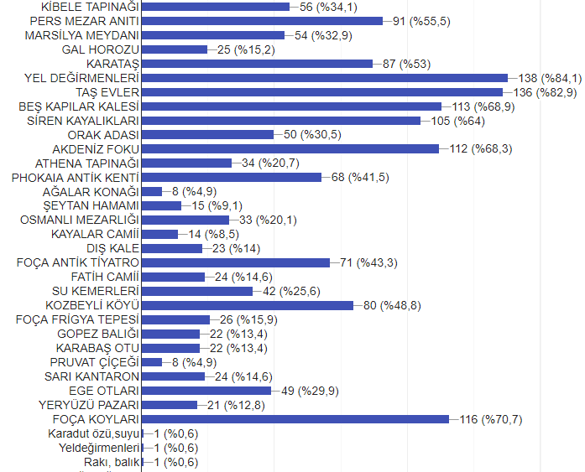

According to the results of the questionnaire, the touristic and historical elements that are thought to represent Foça consist of frequently known elements, and some elements that the participants do not have intensive knowledge due to the period of residence do not receive high percentage points.
It would be appropriate to determine the 12 elements first, by evaluating them in cooperation with experts who have knowledge of Foça's history and who have conducted research and publications on Foça, Izmir, Turkey.
In addition, it would be beneficial to evaluate other options in the process of creating the stories and in the promotion of Foça, İzmir, Turkey.

