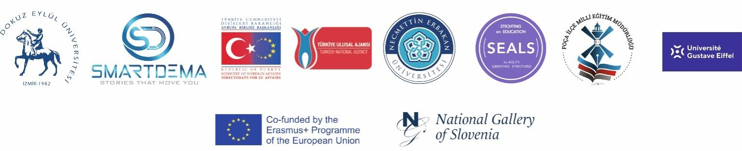

“SMART Tourism Destination increasing citizen’s sentiment of sharing local tourism related values through gamification using emerging mobile Apps and SMALL Data analysis- SMARTDEMA”
AGREEMENT n° 2020-1-TR01-KA203-092920

Foça National Directorate of Education
Thematic Map Report

Contents
Collecting Data
Project introduction meetings
Foça Meeting
Dissemination activities

Collecting Data

At the beginning of the project as the Foça National Directorate of Education we applied a questionaire to teachers. The purpose of this questionaire is to have data from teachers. 164 people participated this survey.
%83.5 of the respondents were female and 16.5% were male.
%44.5 of them are between 35 and 45 years old
%29.9 of them are between 25 and 35
%20.7 of them are between 45 and 55
%4.9 of them are between 55 and 65

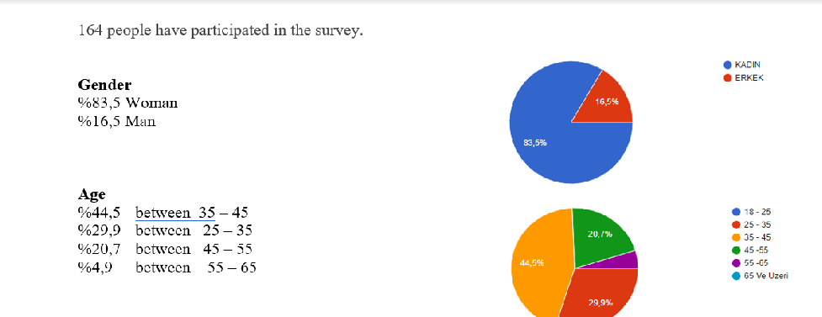

We learnt their inhabitancy duration
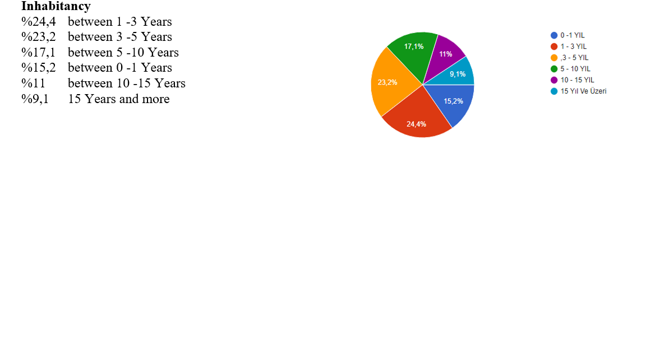Thanks to this survey we understood that the most dominant emotions about Foça are positive. %69.5 of them have positive emotions ,%26.2 of them have partly positive emotions. %7.9 of them have negative emotions. Moreover % 42.1 of them thinks that people know less about Foça.
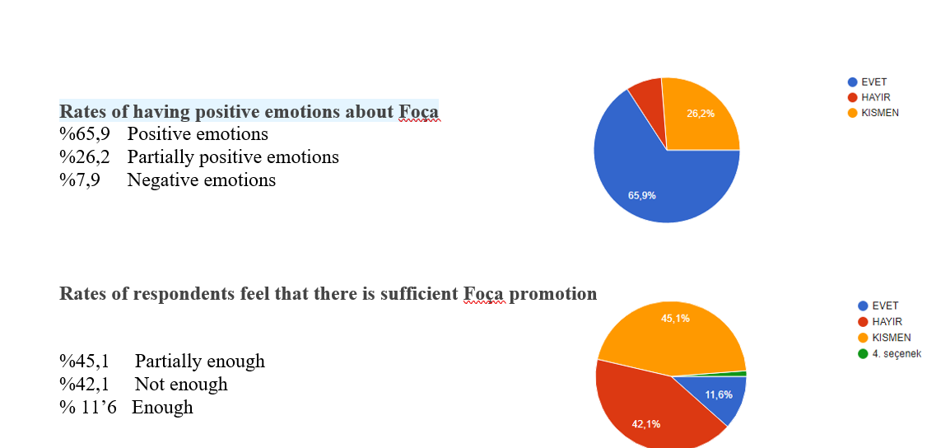

We also asked them what came to their minds first when they think of Foça.

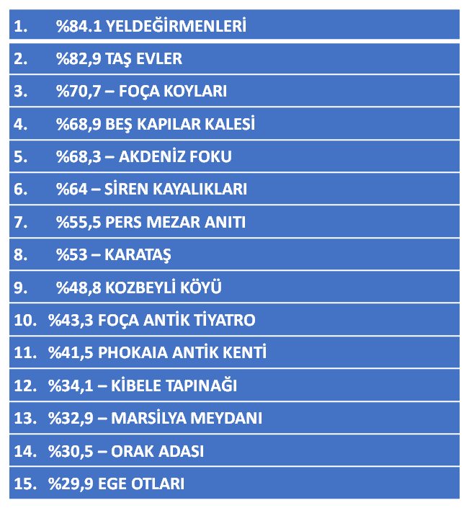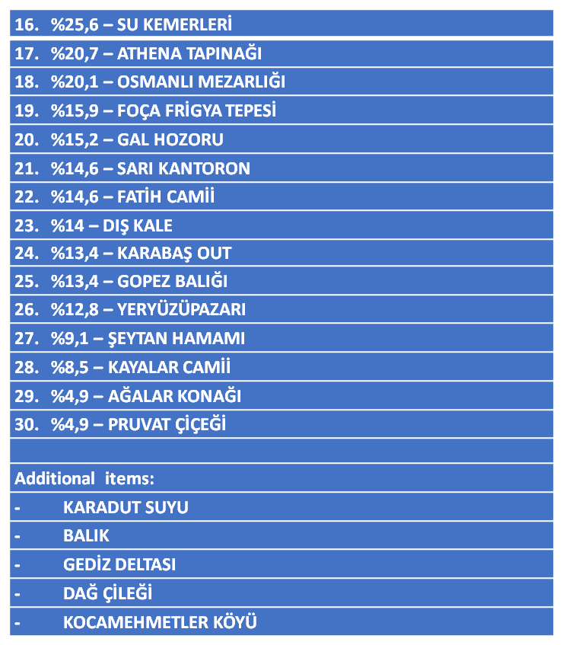
According to the results of the survey, the awareness of historical and cultural elements was evaluated.

For collecting more data meetings were held with Cevat Yıldırım and Sebahattin Karaca that they have many studies and publications on Foça stories and history.

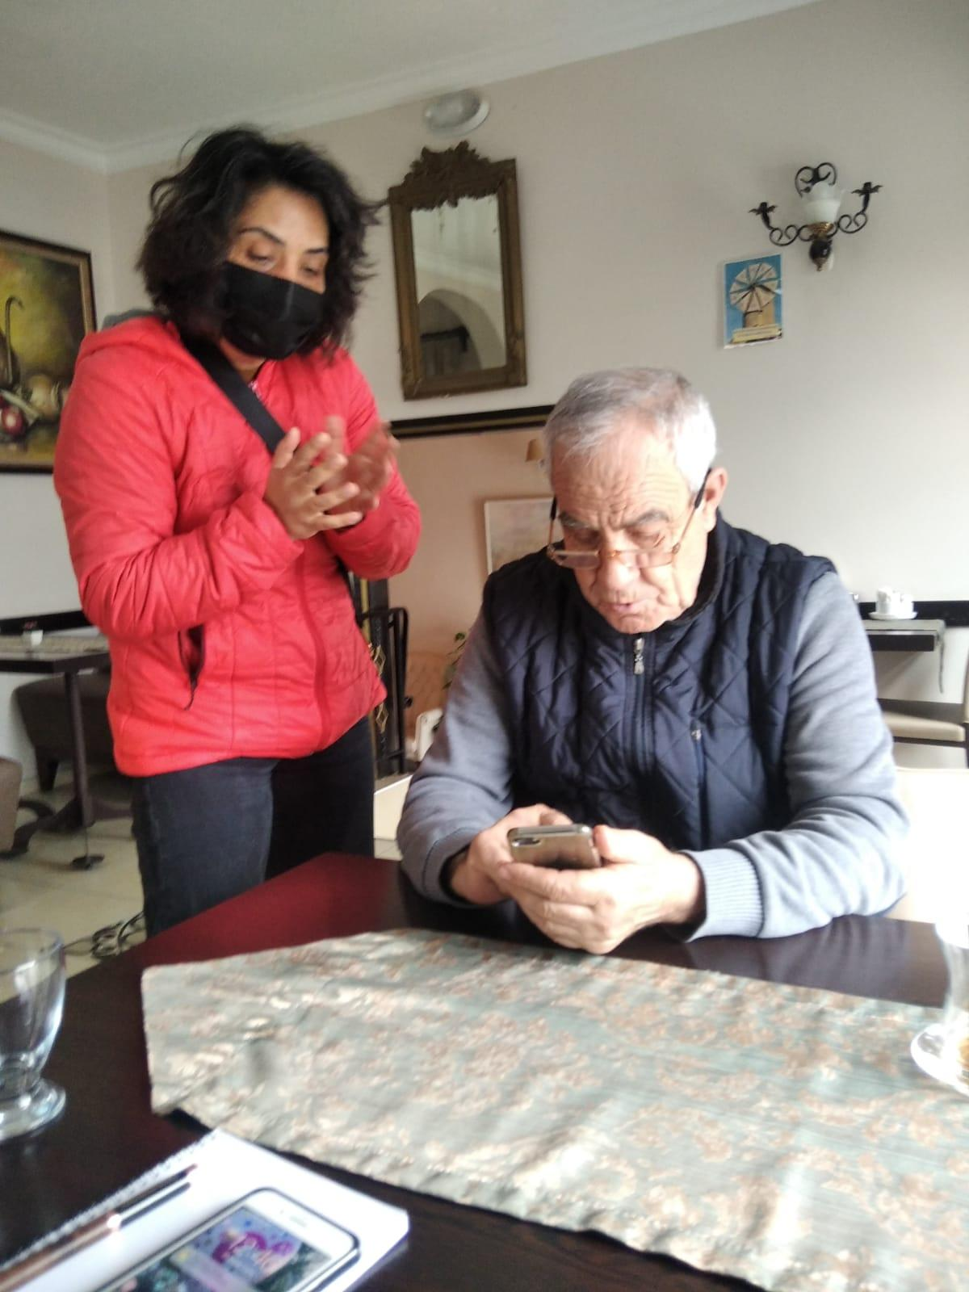

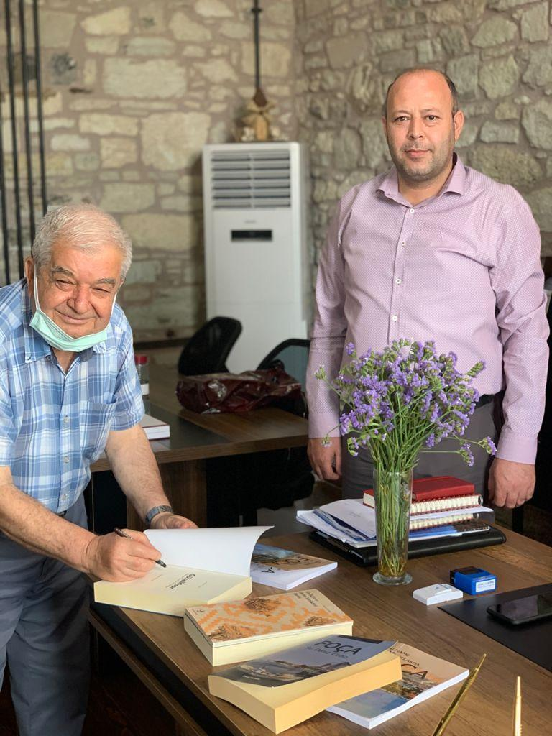

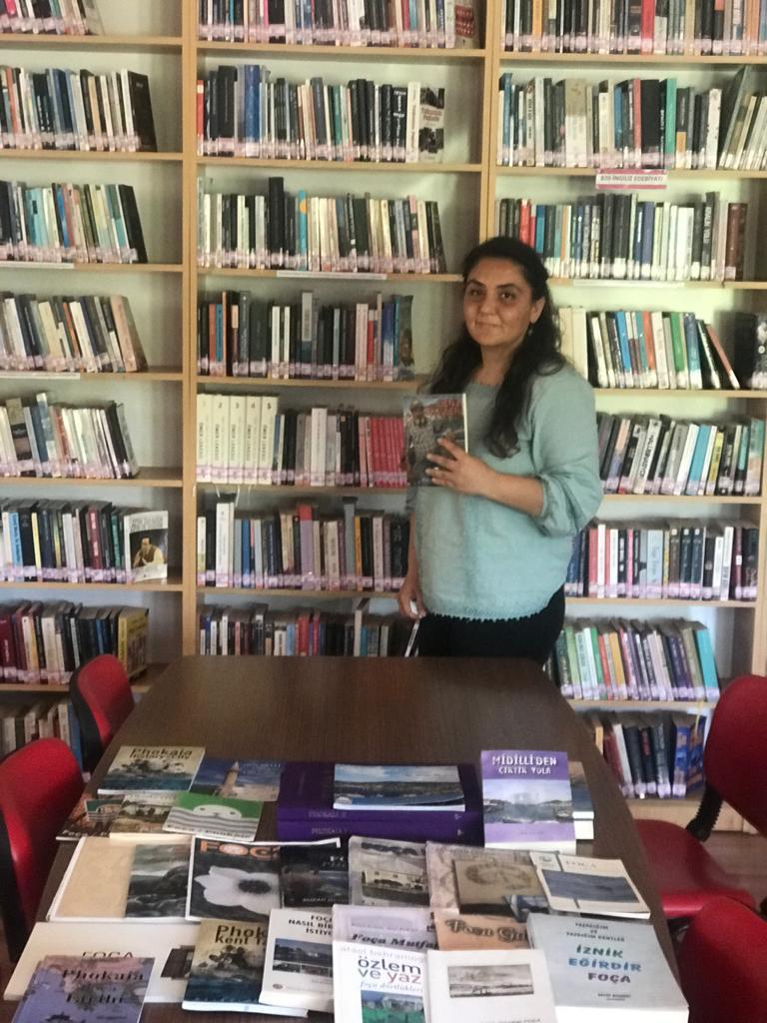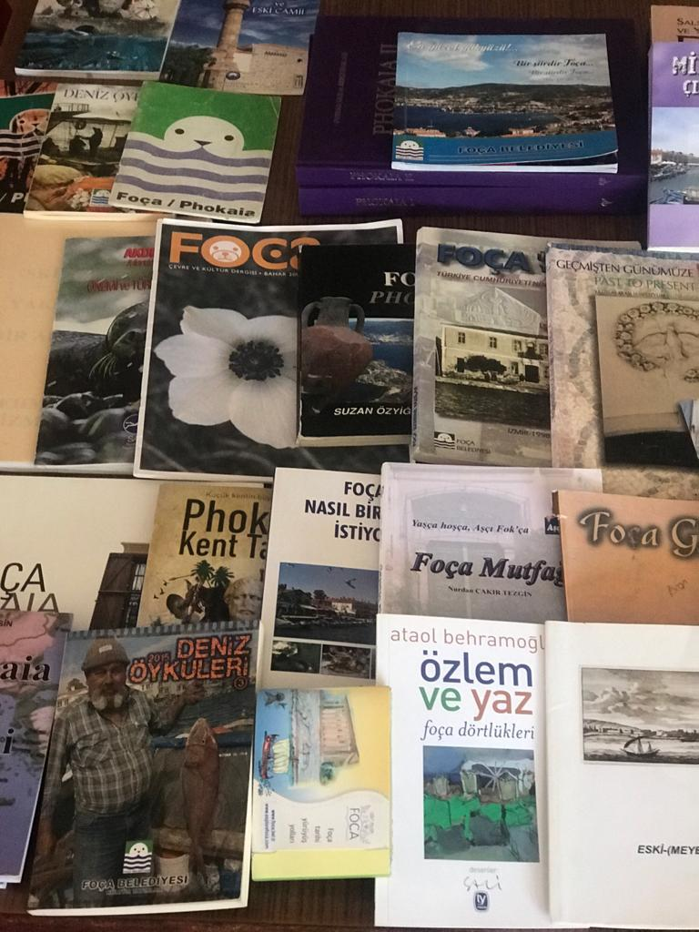
A meeting was held with the Foça Public Library officials and the books published in the history of Foça were examined.

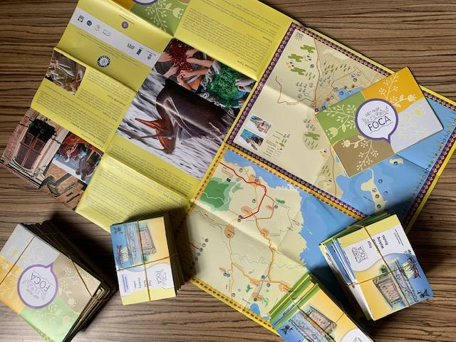

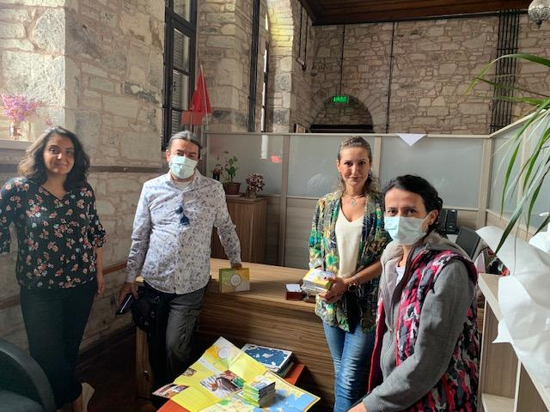
A meeting was held with the Foça Tourism Association. The maps of the association, which indicate the historical and cultural places of Foça, were given to the Directorate of National Education for the project. The Association enhanced our knowledge.
We started our work in the light of these data.

Project Tanıtım Toplantıları

A meeting was held with the school principals to introduce the project and explain the SmartDema application.

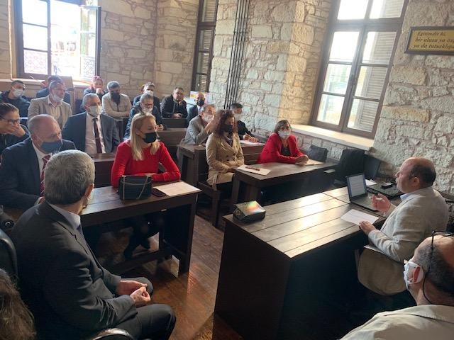
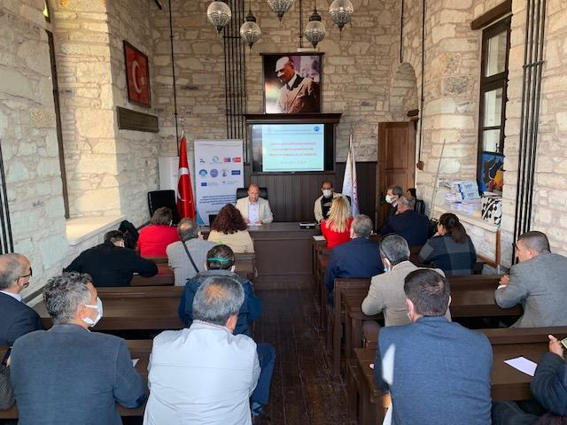
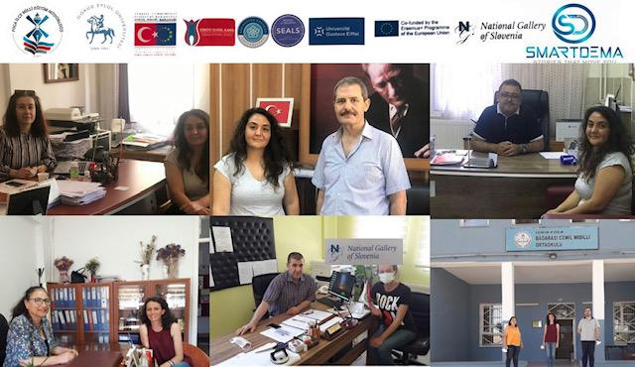

We visited all the schools and formal education cources in order to introduce Smartdema project.

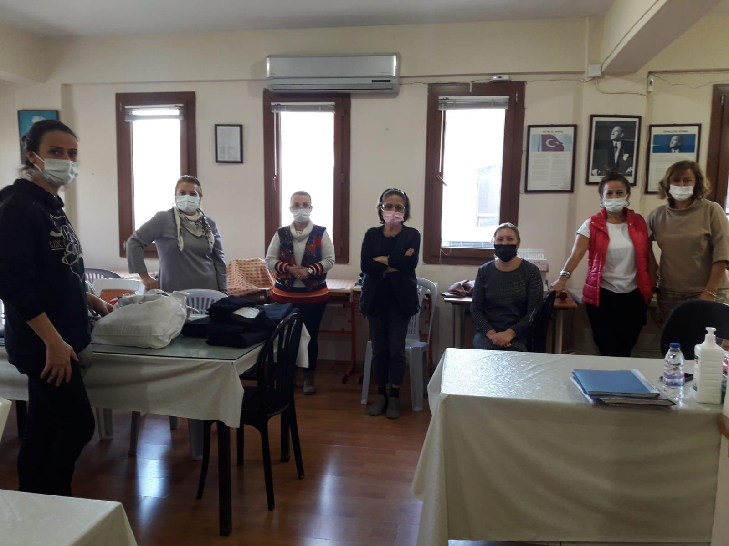

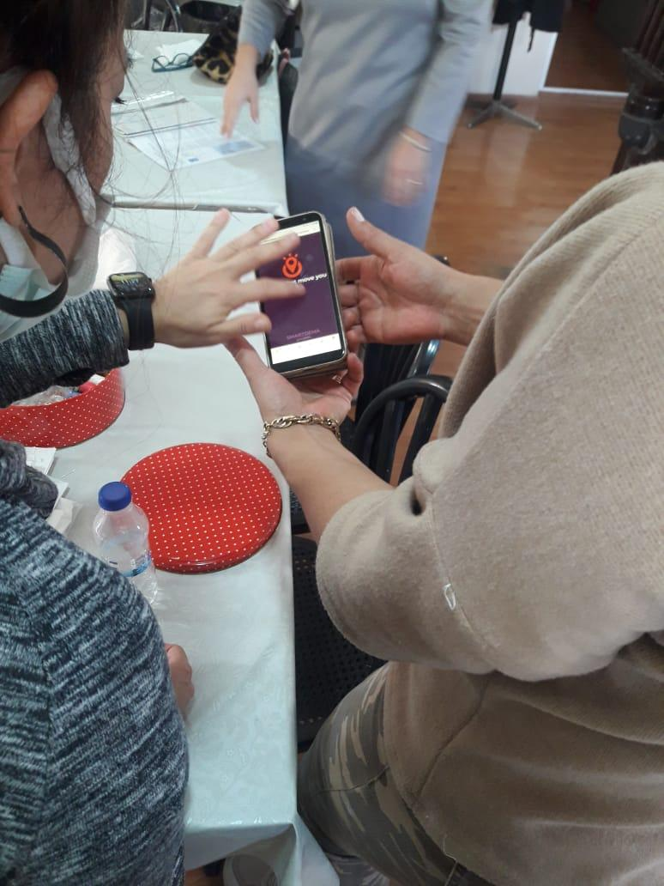

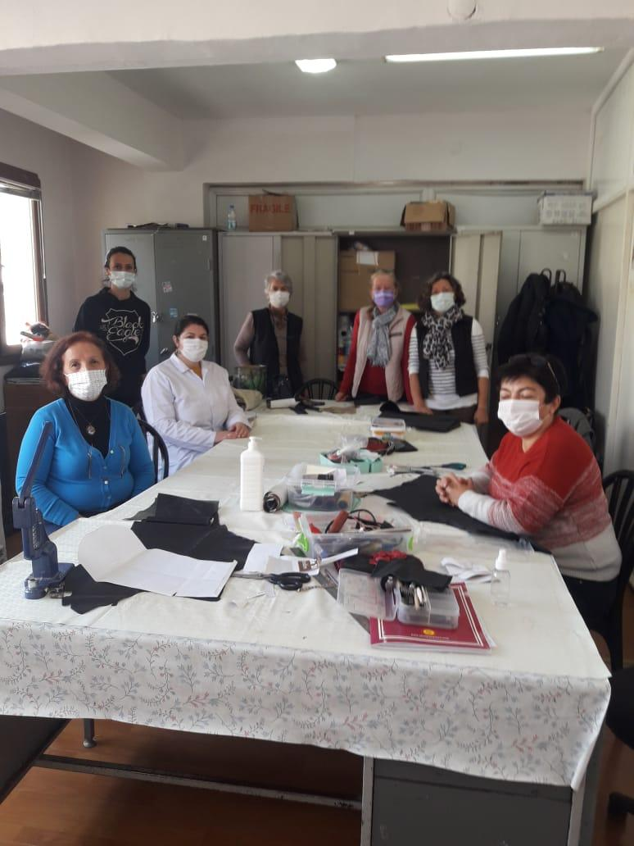

Within the scope of the project, meetings were held with Foça Municipality Municipality was informed about the project and the details of activities. For further activities and projects, Municipality expressed that they are ready to help National Education
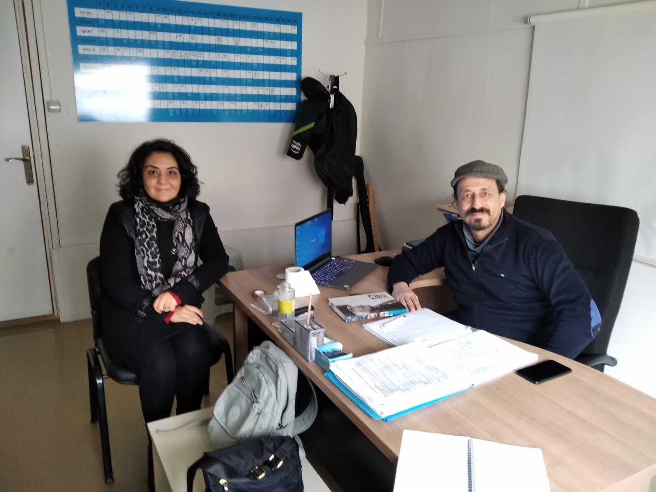
A meeting was held with the Bedia Midilli Primary School Manager. The topic of the meeting was about the book that will be published at the end of the project. As Foça National Directorate of Education wants to publish a story book about Foça that will be written by our students.
Thanks to this project, our students' awareness of the history and culture of Foça increased.

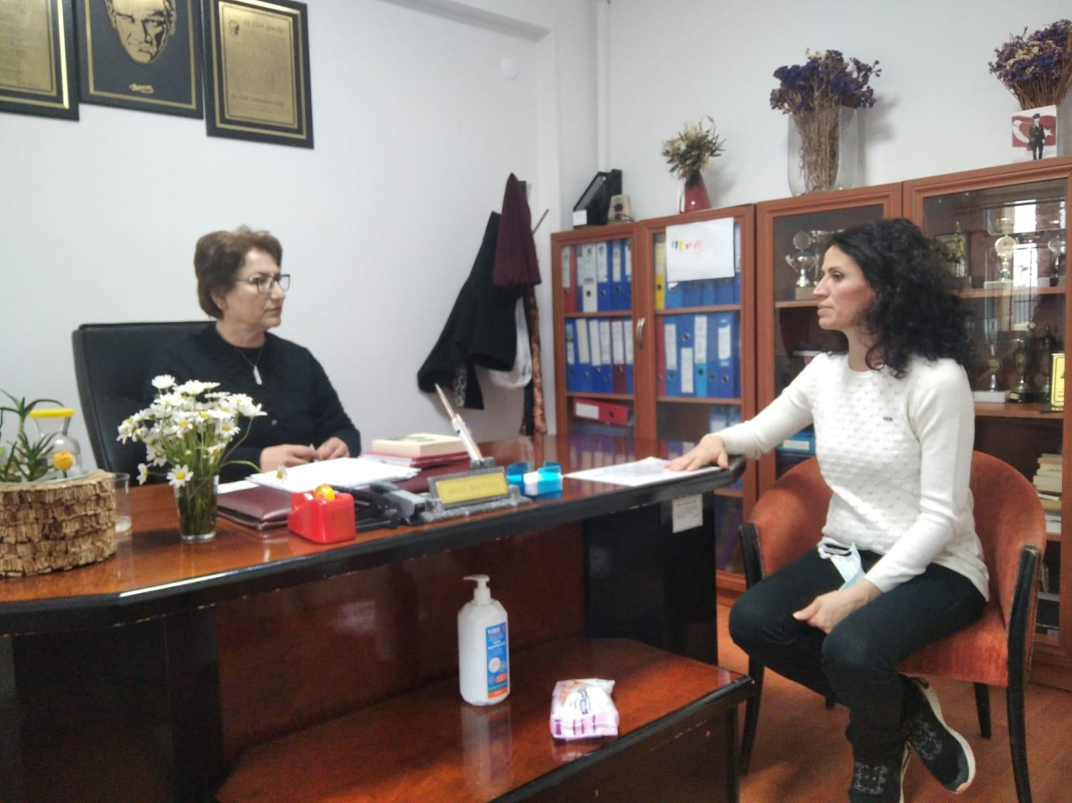
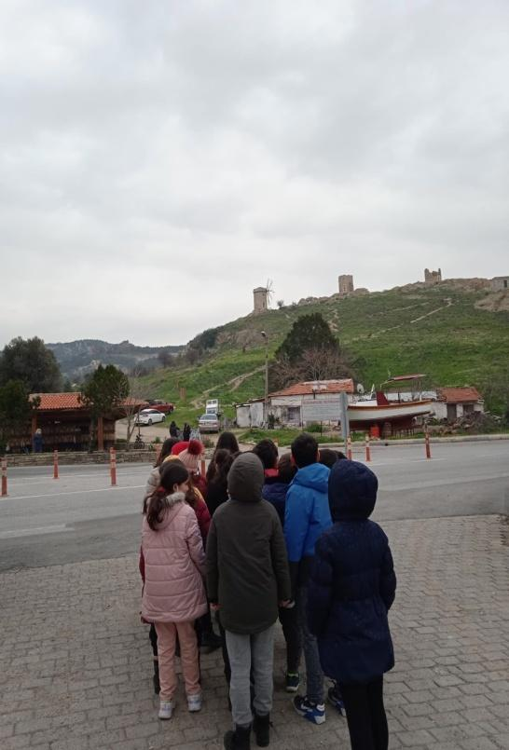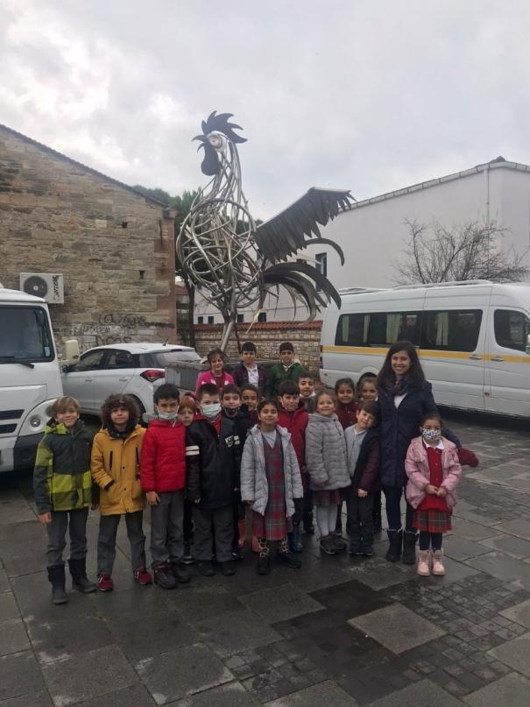

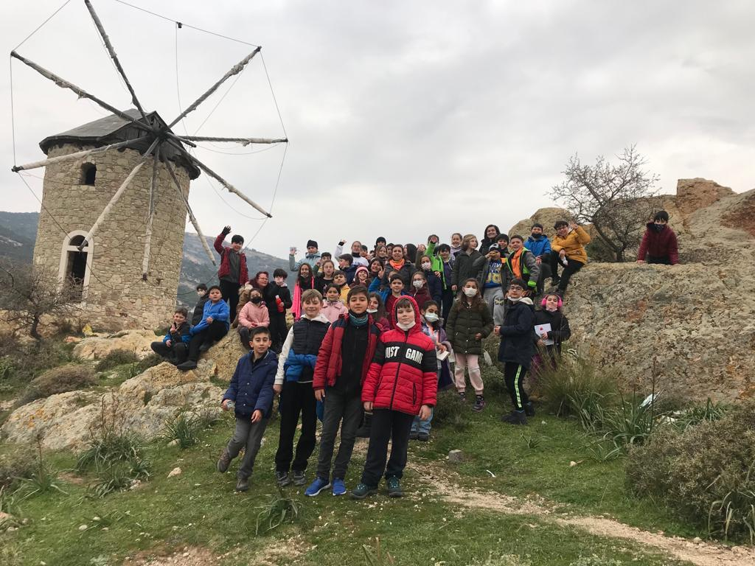

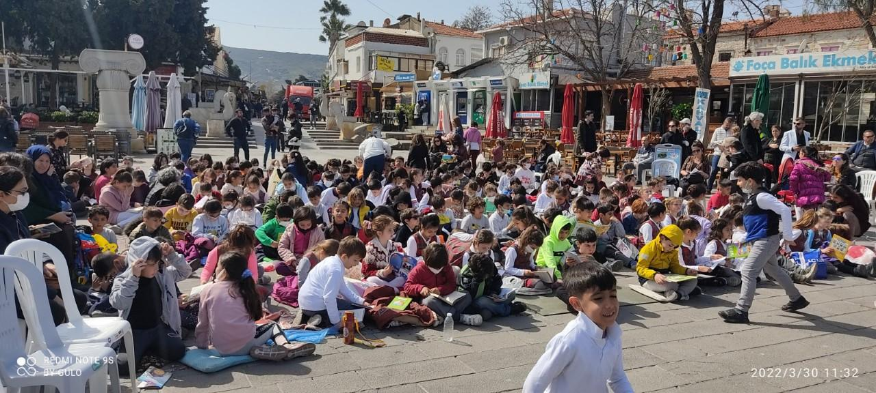
FOÇA MEETING

The transnational meeting organized within the scope of the Smart Destination Management (SMARTDEMA) project conducted by Dokuz Eylül University Tourism Faculty was successfully held in Foça with the participation of project partners from 4 countries and DEPARK/DETTO.

In the meeting organized within the scope of the project on Smart Destination Management (SMARTDEMA), which was supported by the Directorate of European Union Education and Youth Center within the framework of the Erasmus+ Strategic Partnerships in the Field of Higher Education (Innovation Development) Program in the 2020-2022 period, and conducted by Dokuz Eylul University Tourism Faculty, a concrete and concrete meeting was held in Foça. The Foça meeting of the digital application developed to reveal the undiscovered cultural heritage through stories was completed.

The project is carried out under the coordination of Dokuz Eylül University Tourism Faculty, in partnership with Foça District Directorate of National Education, Necmettin Erbakan University, Gustava Eiffel University (France), National Gallery of Slovenia and SEALS (Netherlands).

The meeting was organized on 1-2 October 2021 under the leadership of Dokuz Eylül University. -The meeting was hosted at the Mark Warner Phokai Beach Resort Foça, Turkey.
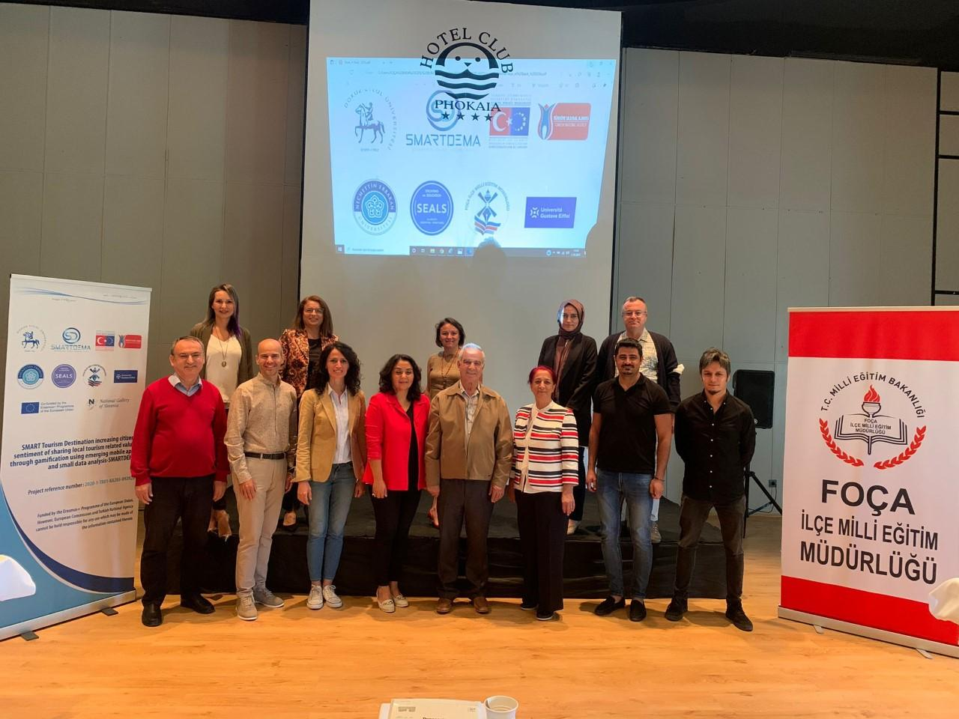

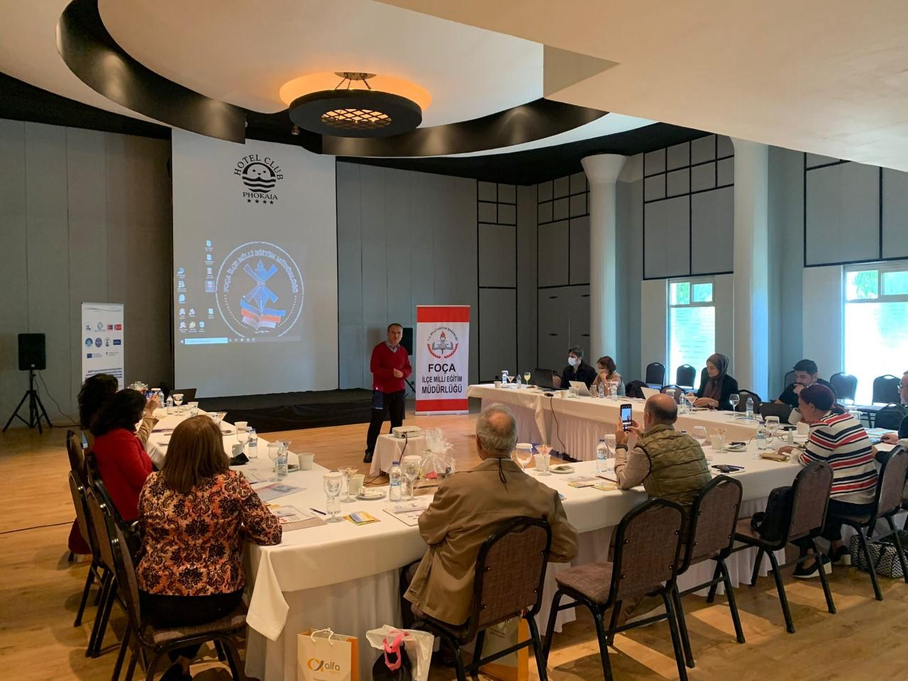

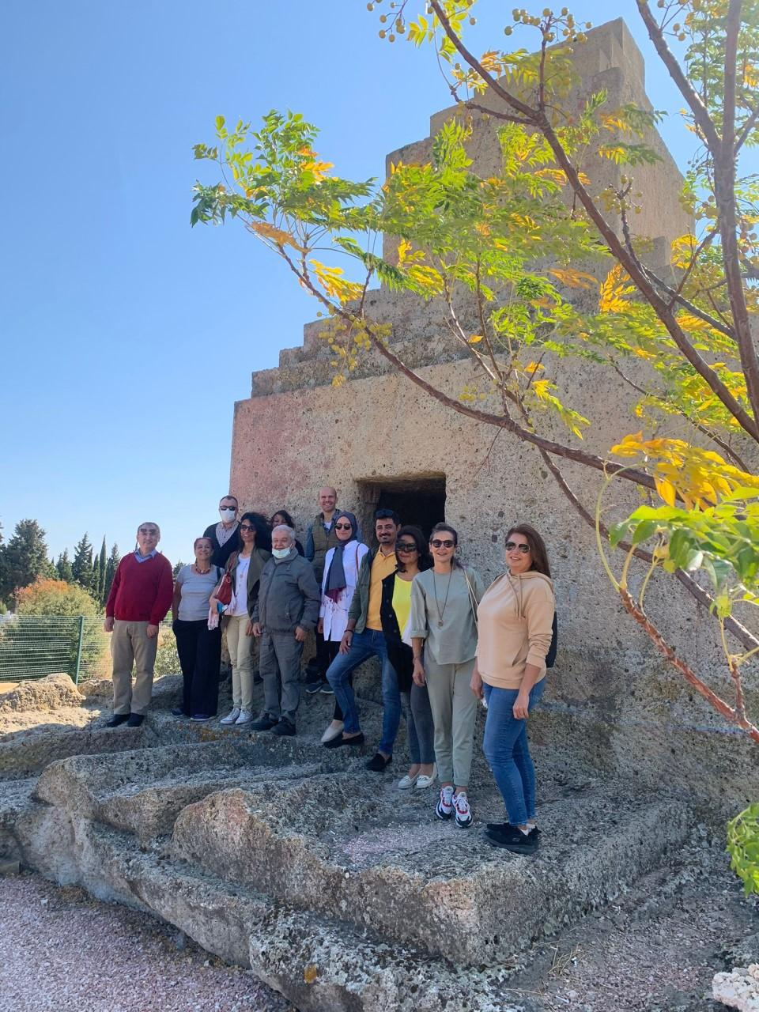

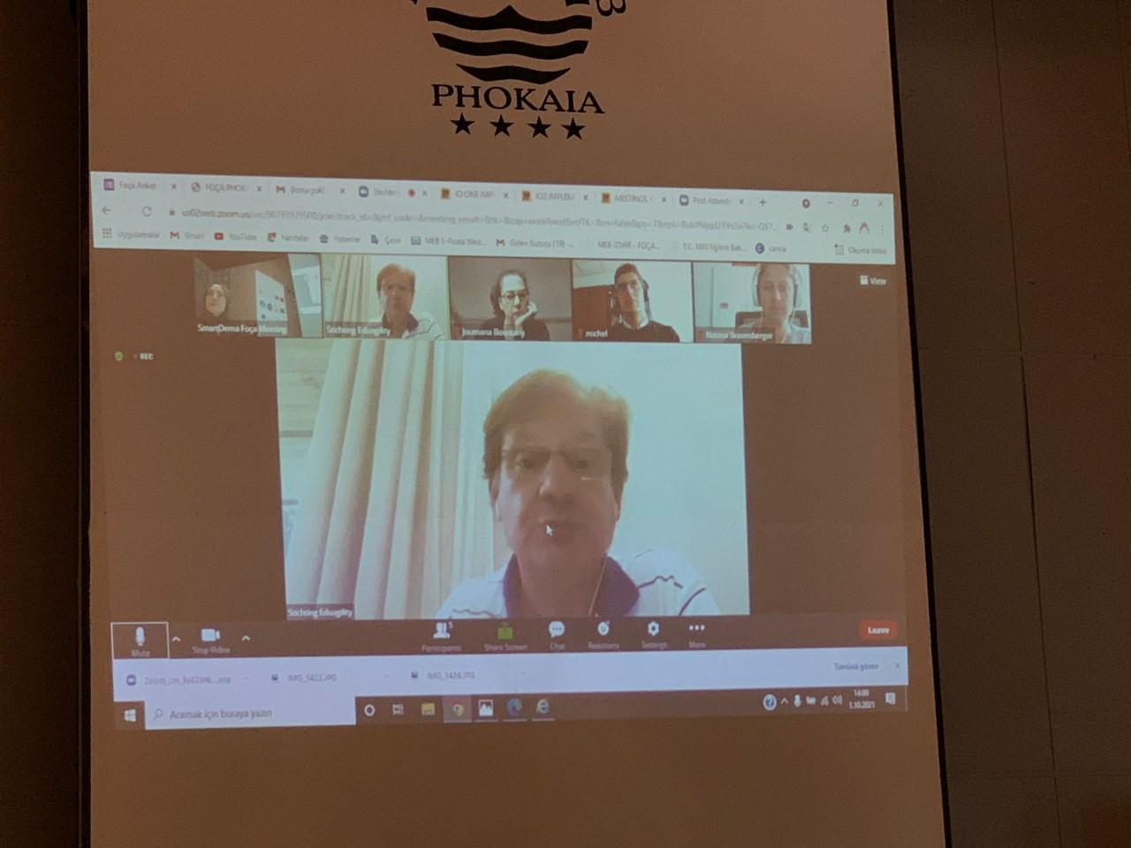

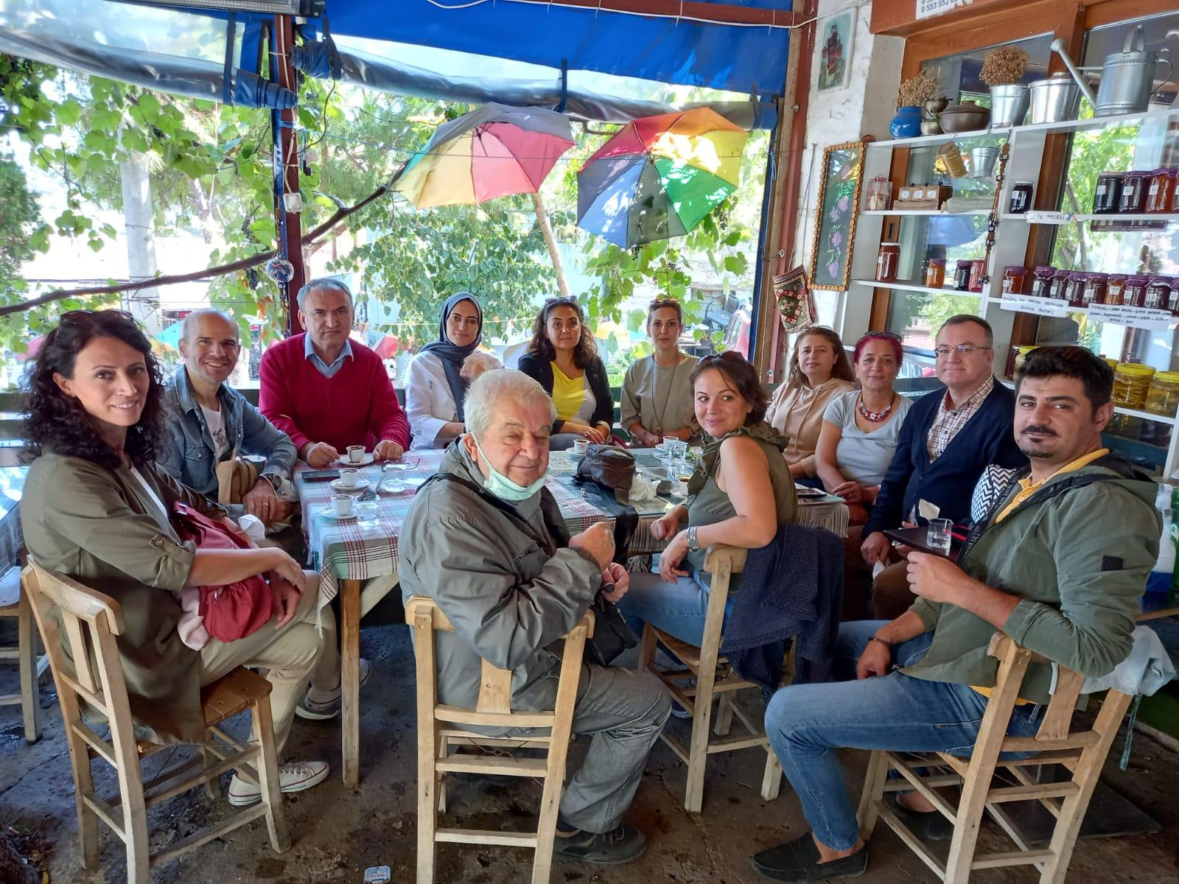

DISSEMINATION ACTIVITIES
Halim Foçalı Vocational and Technical Anatolian High School "Gluten-free and Vegan cuisine" event was held.
Halim Foçalı Vocational and Technical Anatolian High School students prepared meals within the scope of this event. Foça National Directorate of Education manager Süleyman Menek and branch manager Zülfiye Karadeniz attended the event.

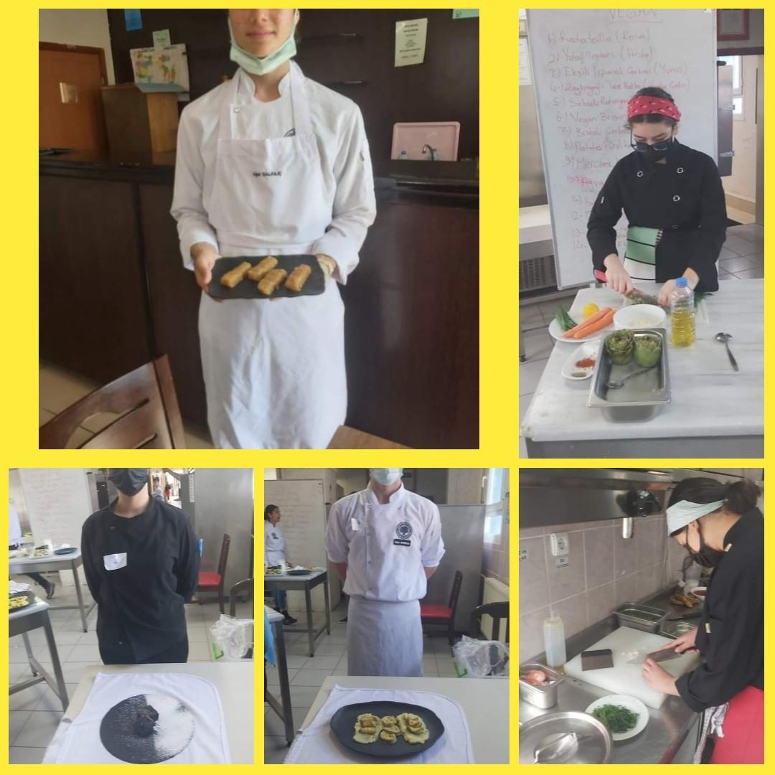
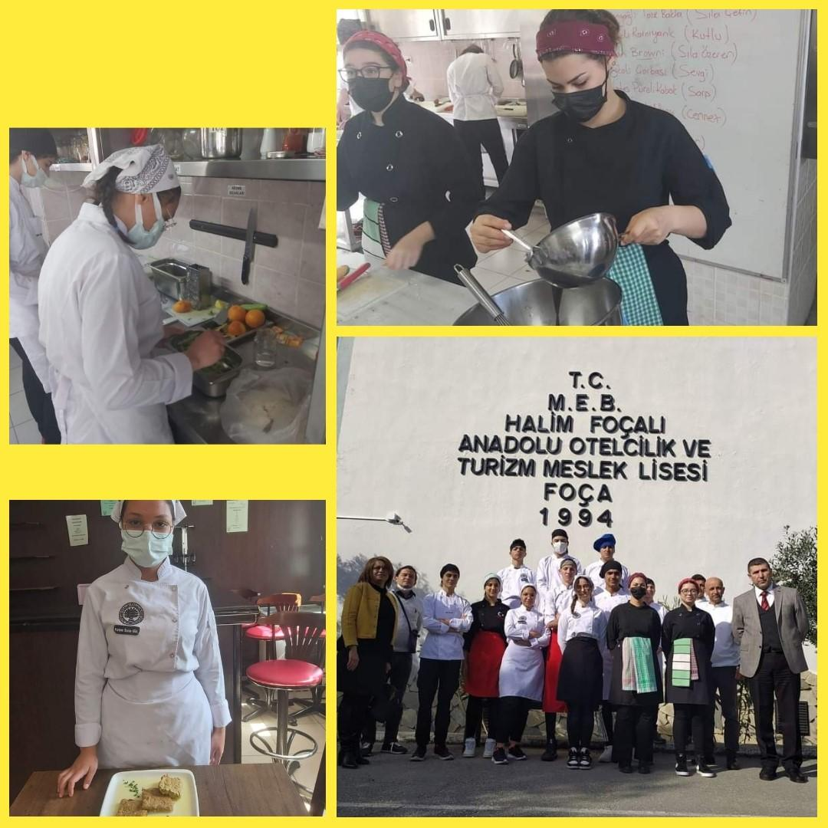

A trip to high school students was organized within the scope of Smartdema project activitie.
The cultural assets of Foça were introduced by Ertan Aksoy.
Reha Midilli Anatolian High School students who participated in the event, and Literature teachers Birgül Nalbantoğlu were informed about the SmartDema project and the stories to be created within the scope of the project.

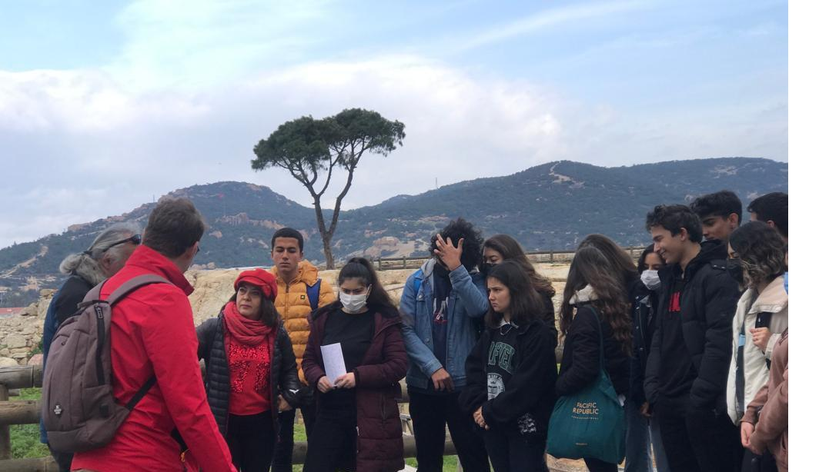

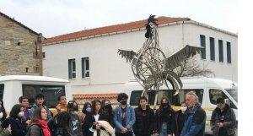

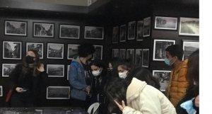

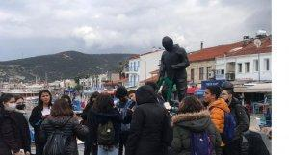

After this trip a writing workshop was held in Reha Midilli Anatolian High School.The students were informed and created their stories and uploaded them.

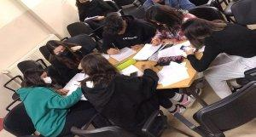

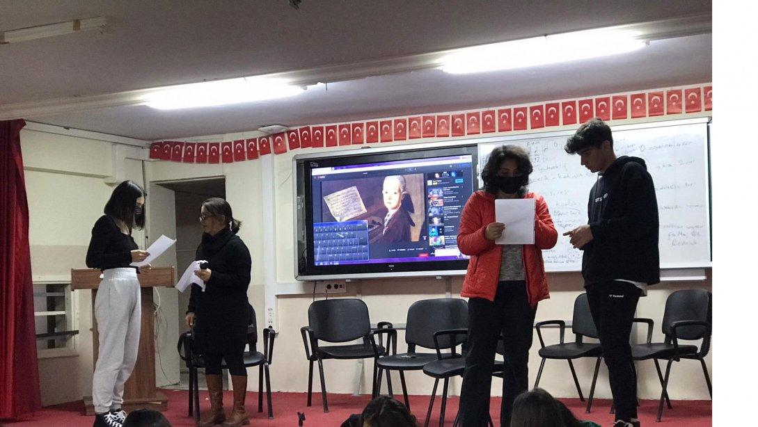

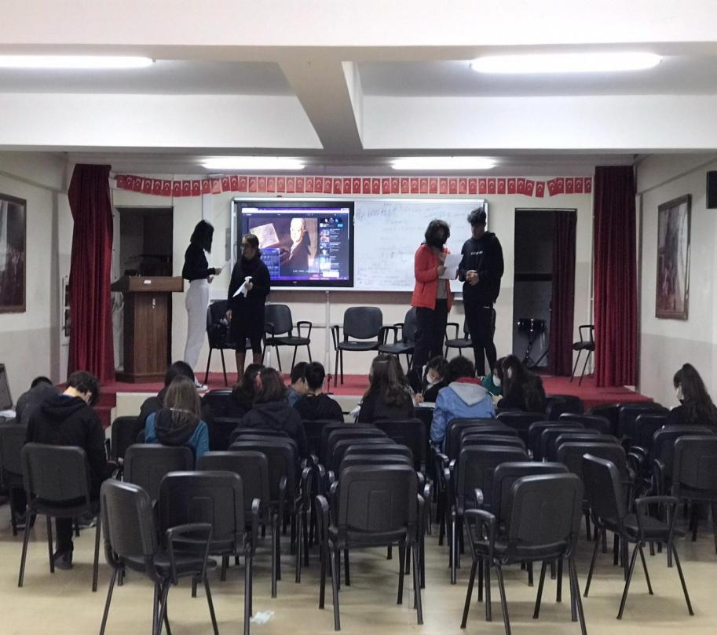

As part of the 23 April National Sovereignty and Children's Day, painting, poetry and composition competitions were held on the theme "A Day in Foca with Atatürk". The students were asked to express their feelings and emotions about the cultural assets of Foça. The awards were given to the students who were ranked as a result of the competition at the 23 April celebration ceremony.

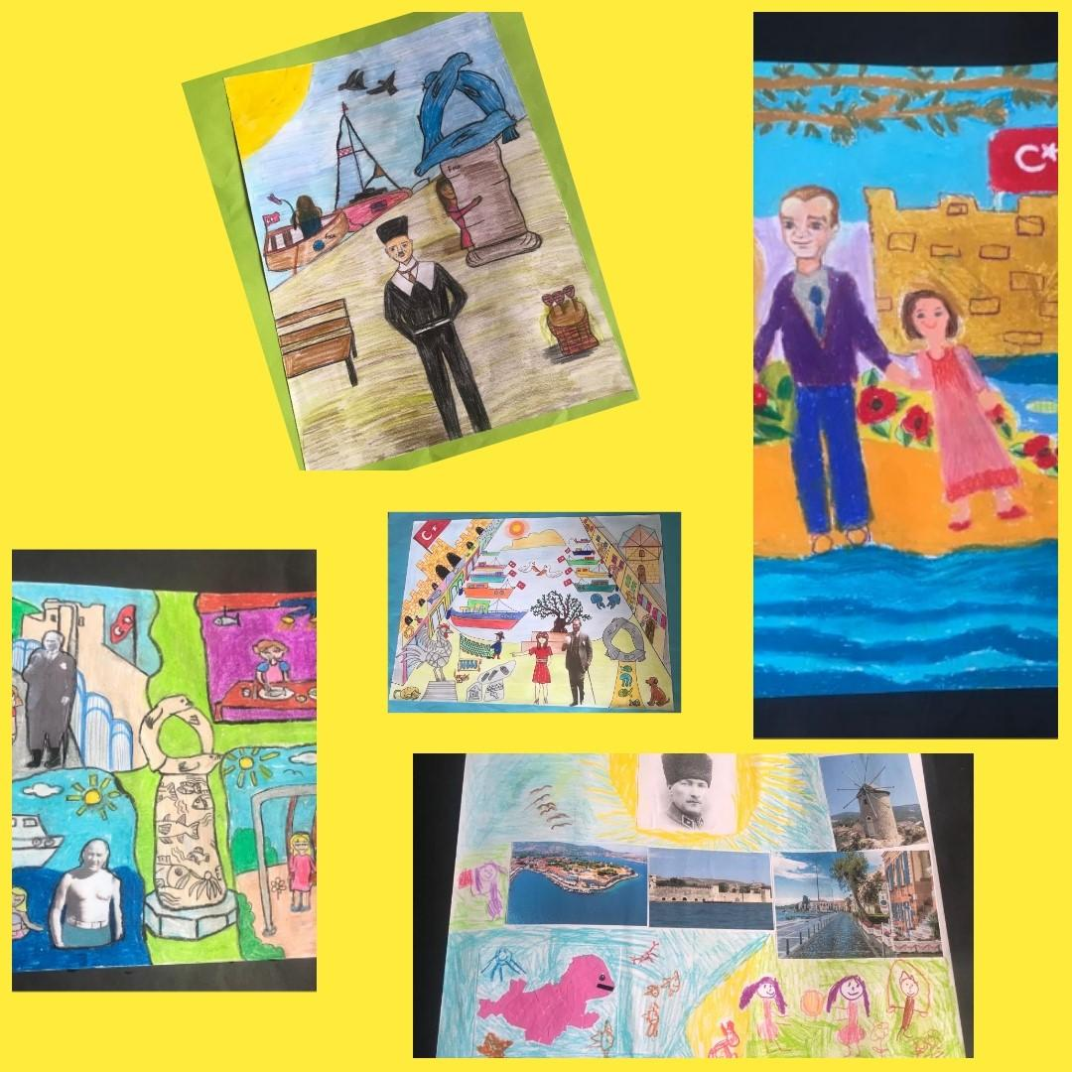

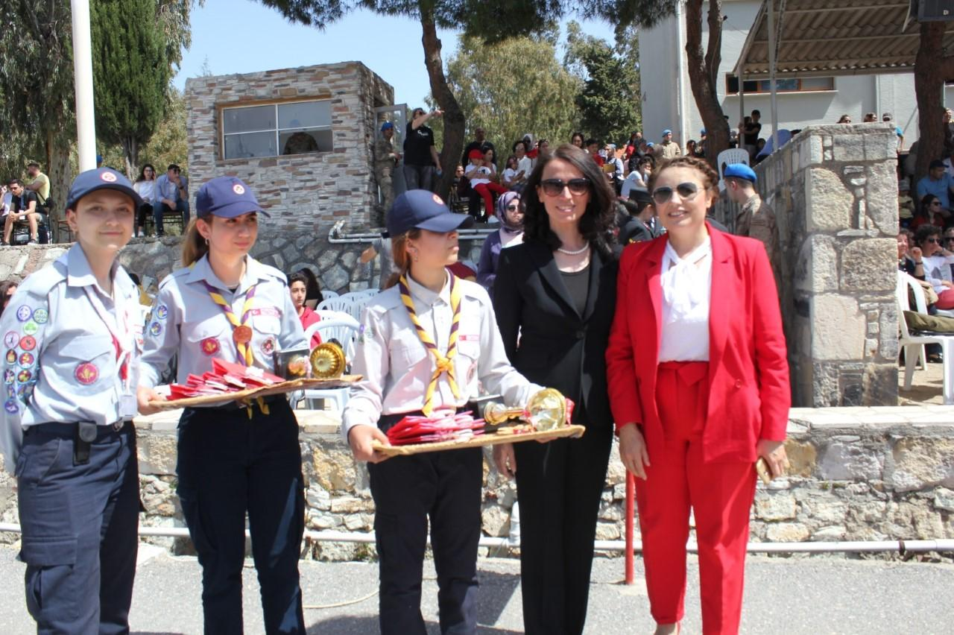

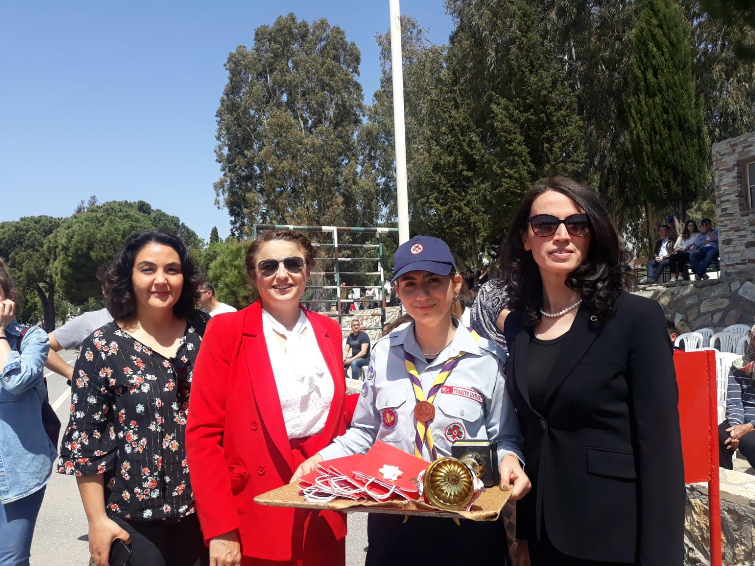

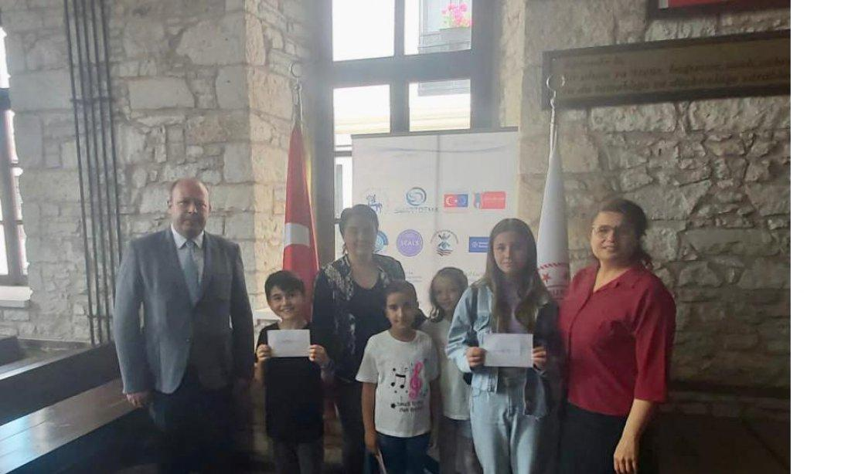

Erasmus + Higher Education Strategic Partnership Program titled as “SMART Tourism Destination increasing citizen’s sentiment of sharing local tourism related values through gamification using emerging mobile Apps and SMALL Data analysis-SMARTDEMA Project's activities are introduced to Foça District Governor,SchoolManagers and students within the scope of Tübitak 4006 District Science Fair Festival.

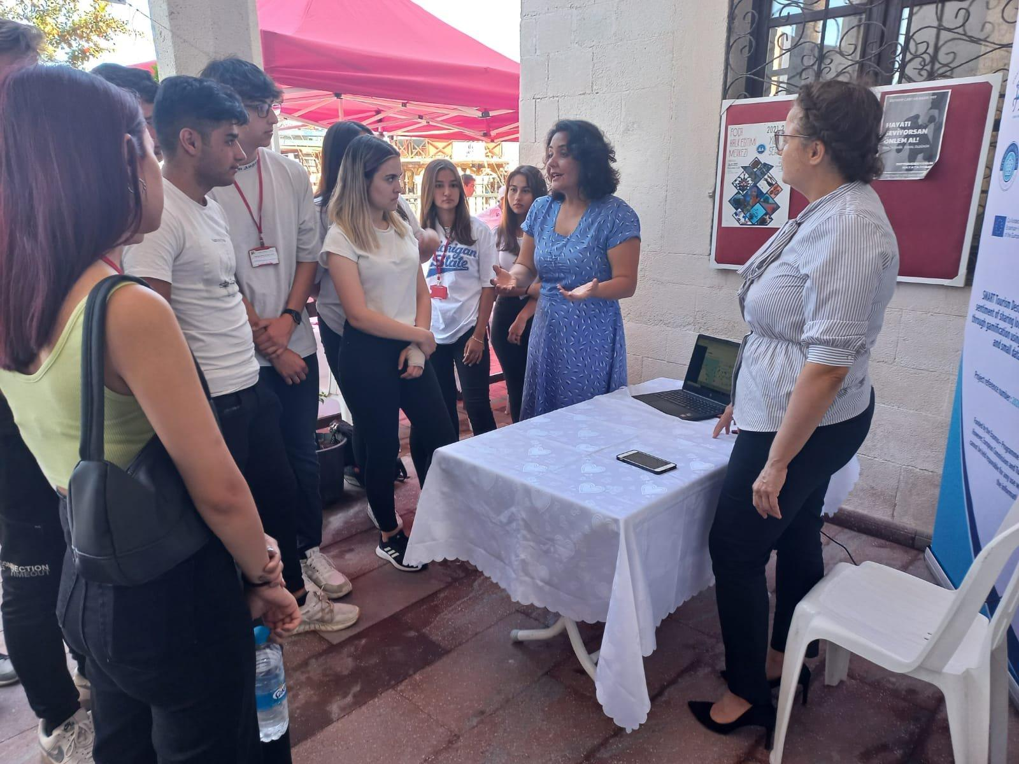
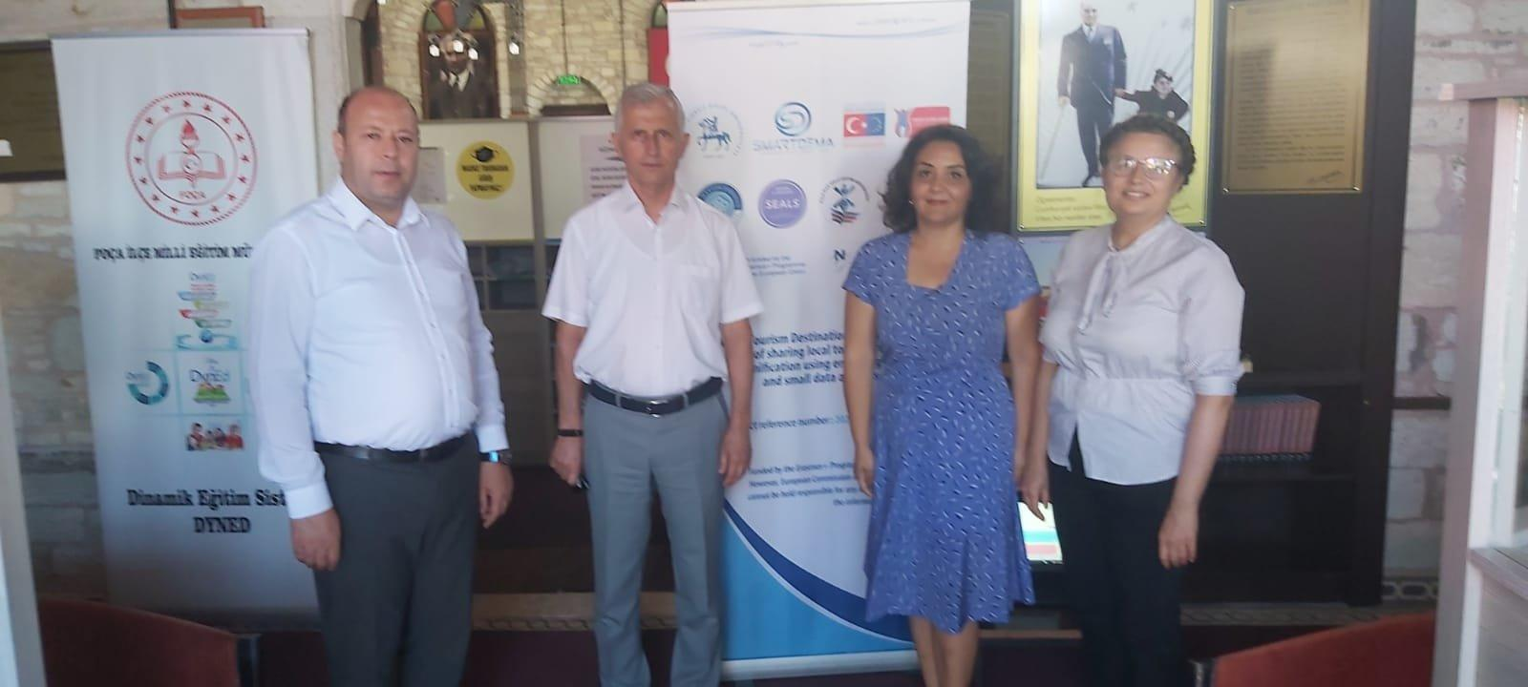

In addition, an exibition of the competition was held. All the works participating in the competition were exhibited in the Foça district national education directorate building.

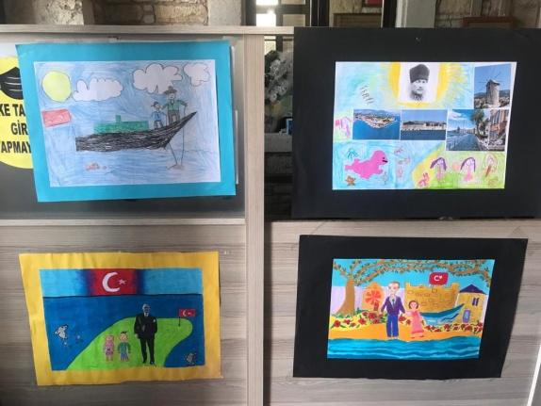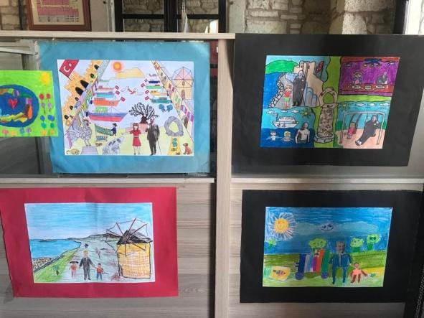
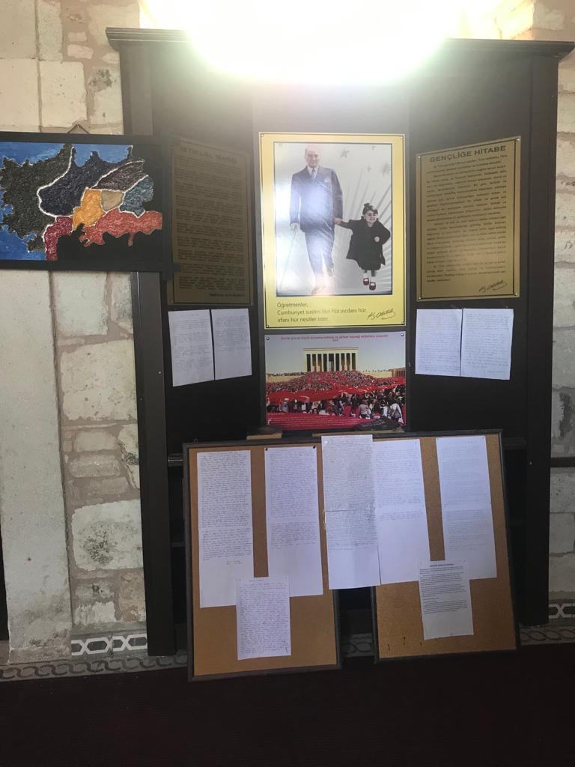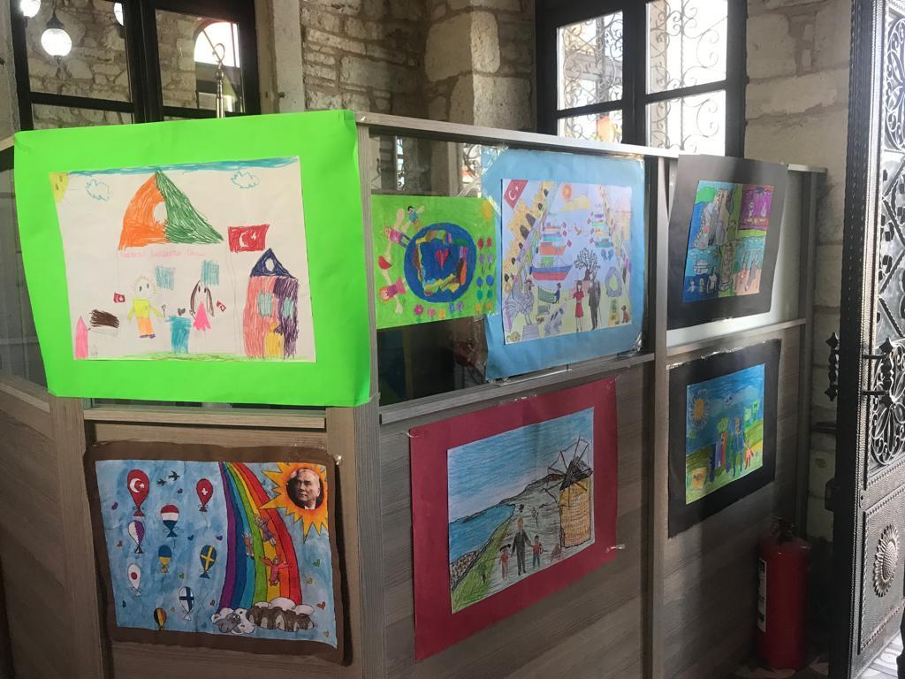

Healthy Chef

Foça's local dishes were categorized as vegan, vegetarian, gluten-free, and restaurants serving this purpose were determined.Then these restaurants were visited to have information about their meals and deserts. Video shoots were made about the food and desserts they prepared.

Videos

